

LECTURE NOTES

ON

STRUCTURAL DESIGN-l

Compiled by

Mr. GURU PRASAD PATRO

Sr. Lecturer in Department of Civil Engineering
GANDHI ACADEMY OF TECHNOLOGY AND ENGINEERING

CONTENT

Chapter No. | TopicName | PageNo.
2 | WorkingStressMethodofDesign | 5to14
3 | PhilosophyofLimitStateMethod(LSM)of Design | 15to20
4 | AnalysisanddesignofSinglyanddoubly Reinforced Members ) | 21to28
5 | Shear,Bond,DevelopmentLength | 44to59
6 | AnalysisanddesignofT-BeaminLimitState  Method | 60to76
7 | AnalysisanddesignofSlabsandstaircase Limit State  Method | 77to95
8 | DesignofAxiallyLoadedshortcolumns and footing(LSM) | 96to111

CHAPTER-1 WORKINGSTRESSMETHODOFDESIGN

GeneralConcept
Working stress method is based on the behavior of a section under the load expected to be encountered by it during its service period. The strength of concrete in the tension zone ofthememberisneglected although the concrete does have some strength for direct tension and flexural tension (tension due to bending). The material both concrete and steel, are assumed to behave perfectly elastically, i.e., stress is proportional to strain.The distribution of strain across a section is assumed to be linear. The section that are planebefore bending remain plane after bending.Thus, the strain, hence stress at any point is proportional to the distance ofthe point from the neutral axis. With this a triangular stress distribution in concrete is obtained, ranging fromzeroat neutral axisto amaximum at thecompressivefaceofthesection. It isfurther assumed inthismethod that there is perfect bond between the steel and the surrounding concrete, the strains in both materials at thatpointaresameandhencetheratioofstressesinsteelandconcretewillbethesameastheratioofelastic moduli of steel and concrete. This ratio being known as ‘modular ratio’, the method is also called ‘ModularRatio Method’.
In this method, external forces and moments are assumed to be resisted by the internal compressive forces developed in concrete and tensile resistive forces in steel and the internalresistivecouple due to the above two forces, in concrete acting through the centroid of triangular distribution of the compressive stressesand in steel acting at the centroid of tensile reinforcement. The distance between the lines of action of resultant resistive forces is known as ‘Lever arm’.
Moments and forces acting on the structure are computed from the service loads. The section of the component member is proportioned to resist these moments and forces such that the maximum stressesdeveloped in materials are restricted to a fraction of their true strengths. The factors of safety used in getting maximum permissible stresses are as follows:
Material FactorofSafety
For concrete3.0 ForSteel 1.78

Assumptionsof WSM
TheanalysisanddesignofaRCCmemberarebasedonthefollowingassumptions.

    - Concreteisassumedtobehomogeneous.
    - Atanycrosssection,planesectionsbeforebendingremainplaneafterbending.
    - Thestress-strainrelationshipforconcreteisastraightline,underworking loads.
    - Thestress-strainrelationshipforsteelisastraightline,underworkingloads.
    - Concreteareaontensionsideisassumedtobeineffective.
    - Alltensilestressesaretakenupbyreinforcementsandnonebyconcreteexceptwhenspecially permitted.
    - Thesteelareaisassumedtobeconcentratedatthecentroidofthesteel.
    - Themodularratiohasthevalue280/3σcbcwhereσcbcispermissiblestressincompressiondueto bendinginconcreteinN/mm2as specifiedincode(IS:456-2000)
MomentofResistance

      - For Balanced section: When the maximum stresses in steel and concrete simultaneously reach their allowable values, the section is said to be a ‘Balanced Section’. The moment of resistance shall be provided by the couple developed by compressive force acting at the centroid of stress diagram on the area of concrete in compression and tensile forcebacting at the centroid of reinforcementmultipliedby the distancebetweentheseforces.Thisdistanceisknownas‘lever arm’.
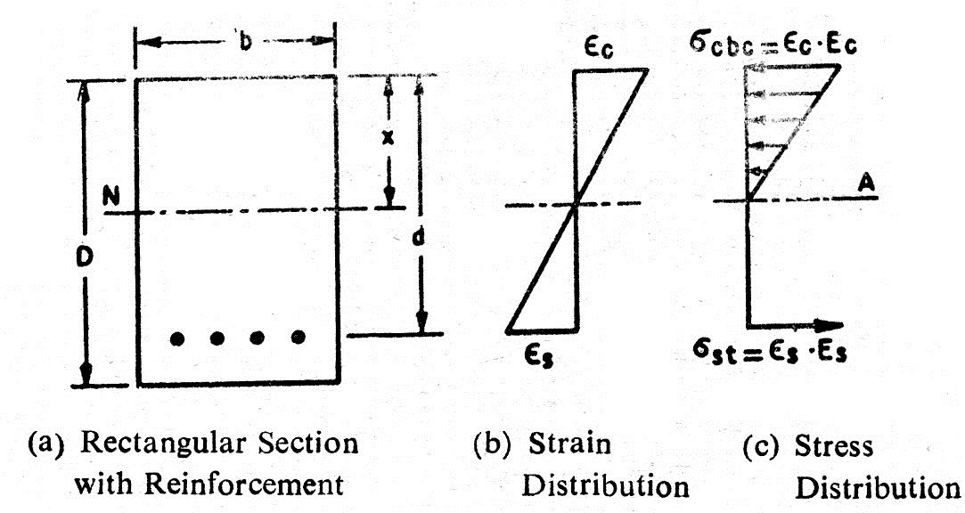
Fig.2.1(a-c)

LetinFig.2.1(a-c):b=widthofsection
D=overalldepthof section
d=effectivedepthofsection(distancefromextremecompressionfiberto the centroid of steel area,
As=areaoftensilesteel
ϵc=Maximumstraininconcrete,
ϵs=maximum strainatthecentroidofthesteel,
σcbc=maximumcompressivestressinconcreteinbending
σst=Stressin steel
Es/Ec=ratioofYong’smodulusofelasticityofsteeltoconcrete
=modularratio‘m’
Sincethestrainsinconcreteandsteelareproportionaltotheirdistancesfromtheneutralaxis,
εc=xord−x=εs
εs d−x x εc

d−1 =σ
stEc
=σst 1

x Esσcbc σcbcm

Or d=1+σst
or x = 1 .d =k.d

x m.σcbc
- +σst
m.σcbc

Wherek=neutralaxisconstant= 1
1+σst
m.σcbc
Totalcompressiveforce=b.s.acbc
2

Totaltensileforces=act.Ac
Z=Leverarm=
d−x=d −k.d =d⎛1
−k⎞=j.d

3
Wherejiscalledtheleverarmconstant.
b.x
⎜ ⎟
3 ⎝ 3⎠
kd.j 1

Moment of resistance = MR= .σ
- cbc
. jd = .σ
2 cbc
.b.d=
.k.j.σ
2 cbc
.b.d²=Q.b.d²

Where Qiscalledmomentofresistance constantandisequalto1.k.j.a
2 cbc

      - Underreinforcedsection

When the percentage of steel in a section is less than that required for a balanced section, the section is called ‘Under-reinforced section.’ In this case (Fig.2.2) concrete stress does not reach its maximum allowable value while the stress in steel reaches its maximum permissible value. The position of the neutral axis willshiftupwards, i.e., the neutral axis depth willbe smaller than that in the balanced section as showninFigure2.2.The momentof resistanceof such a section willbe governedby allowable
tensilestressinsteel.
σ ⎛ x⎞ ' ' k'
Momentofresistance =st.As.⎜d−3⎟=σstAs.jd where j =1 −3
⎝ ⎠

Since
p=A_{s}.×100
b.d

Momentofresistance
b.d
σ. p. j ' σ. p. j '

=σst
.p.

100
.j'×d= ^{st} .b.d²=Q'.Bb.d²

100
whereQ'=^{st}
100

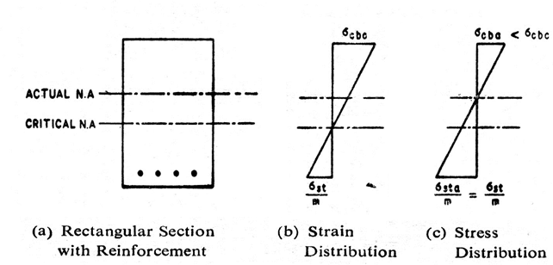
Fig.2.2(a-c)

      - Overreinforcedsection:

When the percentage of steel in a section is more than that required for a balanced section, the section is called ‘Over-reinforced section’. In this case (Fig.2.3) the stress in concrete reaches its maximum allowable value earlier than that in steel. As the percentage steel is more, the position of the neutral axis will shift towards steel from the critical or balanced neutral axis position. Thus the neutral axisdepthwillbe greaterthanthatin caseof balanced section.

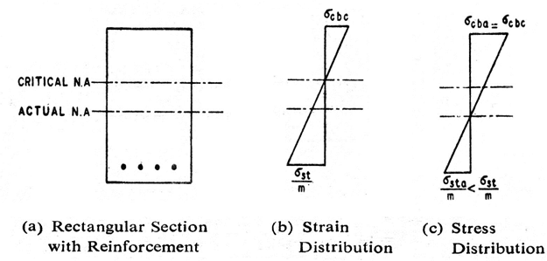
Momentofresistanceofsuchasectionwillbegovernedbycompressivestressin concrete,
Fig.2.3(a-c)

1⎛ x⎞ σ ⎛ k'⎞
Momentofresistance=b.x.σcbc..⎜d−⎟= ^{cbc}.b.x.d.⎜1− ⎟
2⎝ 3⎠ 2 ⎝ 3⎠
=σcbc.b.x.d.j'=1.σ .k'.j'.b.d²=Q'.b.d² whereQ'=σcbc.k'.j'=Constant
2 2 cbc 2

Basicconceptofdesignofsinglereinforcedmembers
Thefollowingtypesofproblemscanbeencounteredinthedesignofreinforcedconcretemembers.

- DeterminationofAreaofTensileReinforcement

Thesection,bendingmomenttoberesistedandthemaximumstressesinsteelandconcretearegiven.

Stepstobefollowed:

  - Determinek,j.Q(orQ’)forthegivenstress.
  - Findthecriticalmomentofresistance,M=Q.b.d²fromthedimensionsofthebeam.
  - ComparethebendingmomenttoberesistedwithM,thecriticalmomentofresistance.
    - IfB.M.islessthanM,designthesectionasunderreinforced.
M =σ ⎛ x⎞
−
st.As.⎜d ⎟
⎝ 3⎠
TofindAsintermsofx,takemomentsofareasaboutN.A.
b.x.x=m.A .(d−x)

2 s
b.x² σ.b.x² ⎛ x⎞
∴ ⎜

A_{s}=

2(m)(d−x)
M=^{st} d−

2.m.(d−x)⎝
⎟=B.M. tobe resisted
3 ⎠

Solvefor‘x’,andthenAscanbecalculated.

    - IfB.M.ismorethanM,designthesectionasover-reinforced.
M=σcbc.b.x.⎛⎜d−x⎞=B.M.toberesisted. Determine‘x’.ThenAcanbeobtainedbytaking
2 ⎝ 3⎟ s
⎠
momentsofareas(compressiveandtensile)aboutusingthefollowingexpression.
b.x²
As =2.m.(d−x)

- DesignofSectionforaGivenloading

Designthesectionasbalancedsectionforthegivenloading.

Stepstobefollowed:
  - Findthemaximumbendingmoment(B.M.)duetogivenloading.
  - Computetheconstantsk,j,Qforthebalancedsectionforknownstresses.
  - Fixthedepthtobreadthratioofthebeamsectionas2to4.
  - FromM=Q.b.d²,find‘d’andthen‘b’fromdepthtobreadthratio.
  - Obtainoveralldepth‘D’byadding concretecoverto‘d’ the effectivedepth.
  - CalculateAsfromtherelation
A=B.M.
σ
^{s} .j.d
st
- ToDeterminetheLoadcarryingCapacityofagivenBeam

Thedimensionsofthebeamsection,thematerialstressesandareaofreinforcingsteelaregiven.

Stepstobefollowed:

  - Findthepositionoftheneutralaxisfromsectionand reinforcementgiven.
  - FindthepositionofthecriticalN.A.fromknownpermissiblestressesofconcreteandsteel.
x = 1 .d1 +σst
σ
m. cbc
  - Checkif(i)>(ii)-thesectionisover-reinforced

(i)<(ii)-thesectionisunder-reinforced

  - CalculateMfromrelation
M= 1 ⎛ x⎞
b.x. .σcbc.⎜d− ⎟forover-reinforcedsection
⎝
2 3⎠

andM=σ ⎛ x⎞ forunder-reinforcedsection.
−
st.As.⎜d ⎟
⎝ 3⎠
  - Iftheeffectivespanandthesupportconditionsofthebeamareknown,theloadcarrying capacity can be computed.

- ToCheckTheStressesDevelopedInConcreteAndSteel
Thesection,reinforcementandbendingmomentaregiven.

Stepstobefollowed:
  - FindthepositionofN.A.usingthefollowingrelation.

b.x2
2
=m.A_{s}.(d−x))

  - Determineleverarm,z=d−x
3
  - B.M.=σst.As.zisusedtofindouttheactualstressinsteelσ_{sa}.
  - Tocomputetheactualstressinconcreteσcba,usethefollowingrelation.
BM=σcba.b.x.z 2

DoublyReinforcedBeamSectionsbyWorkingStressMethod
Very frequently it becomes essential for a section to carry bending moment more than it can resist as a balancedsection.Suchasituationisencountered when thedimensionsofthecross sectionarelimitedbecause of structural, head room or architectural reasons. Althougha balanced section is the most economical sectionbut because of limitationsof size, section has to be sometimes over-reinforced byprovidingextra reinforcement on tension face than that required for a balanced section and also some reinforcement on compression face. Such sections reinforced both in tension and compression are also known as “Doubly Reinforced Sections”. In some loading cases reversal of stresses in the section take place (this happens whenwind blows in opposite directions at different timings), the reinforcement is required on both faces.

MOMENTOFRESISTANCEOFDOUBLYREINFORCEDSECTIONS
ConsiderarectangularsectionreinforcedontensionaswellascompressionfacesasshowninFig.2.4(a-c) Let b = width of section,
d=effectivedepthofsection,
D=overalldepthof section,
d’=covertocentreofcompressivesteel,
M=Bendingmomentortotalmomentofresistance,
Mbal=Momentofresistanceofabalancedsectionwithtensionreinforcement,
Ast=Totalareaoftensilesteel,
Ast1= Area of tensile steel required to develop MbalAst2=AreaoftensilesteelrequiredtodevelopM2Asc= Area of compression steel,
σst=Stressinsteel,and
σsc=Stressincompressivesteel
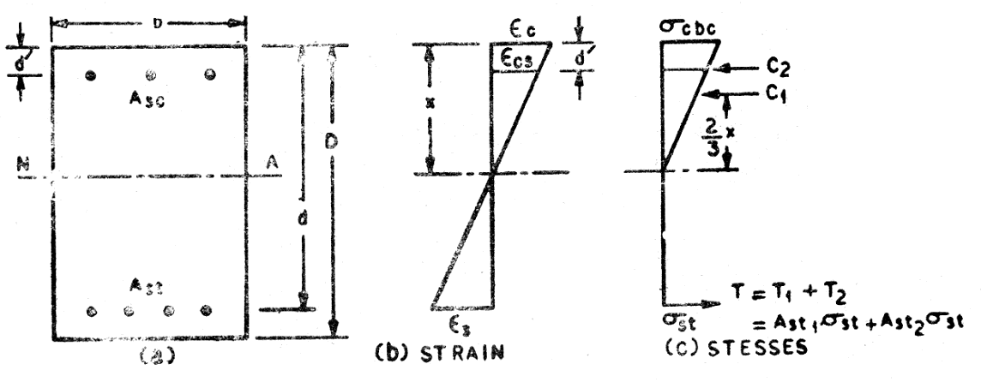
Fig.2.4(a-c) Since strains are proportional to the distance from N.A.,

Strain in topfibreofconcrete = x Strain in CompressionSteel x−d'

σcbc
σsc
EC=

E_{s}
x

x−d'

σcbc.Es= x
σsc Ec x−d'
σ =σ . x .m

sc cbcx−d'

Since

'
σ
cbc

σcbc.
x−d'

x

isthestressinconcreteatthelevelofcompressionsteel,itcanbedenotedas

∴σsc=m.σ'
cbc

As per the provisions of IS:456-2000 Code , the permissible compressive stress in bars , in a beam orslab when compressive resistance of the concrete is taken into account, can be taken as 1.5m times the compressive stress in surrounding concrete (1.5m σ’cbc) or permissible stress in steel in compression (σsc) whichever is less.
σ =1.5mσ'
sc cbc

Totalequivalentconcretearearesistingcompression (x . b-Asc) +1.5mAsc= x .b +(1.5m-1)Asc
Taking moment about centre of tensile steel Moment of resistance M = C1.(d-x/3)+C2(d-d’) WhereC1=totalcompressiveforceinconcrete,
C2=totalcompressiveforceincompressionsteel,
σb.x .(d−) + (1.5m−1)A .σ . .(d−d')=Q.b.d+(1.5m−1)A.σ . (d−d ')
M = cbc x x−d' 2 x−d'
.

2 3
=M₁+M₂
sc cbc x sc cbc x

WhereM₁=Moment of resis tance of the balancedsection=M_{bal} M ₂=Moment of resis tance of the compression steel

Areaoftensionsteel=A
= M1 .

st1
σst
. j.d

Areaof tensionsteel equivalenttocompressionsteel=A

st2
= M₂
σst(d−d')

ThusthetotaltensilesteelAstshallbe:
∴ Ast=Ast1+Ast2

Theareaofcompressionsteelcanbeobtainedas

(1.5m−1)A_{sc}(x−d')=mA_{st2}.(d−x)

DesignConceptofT-Beam
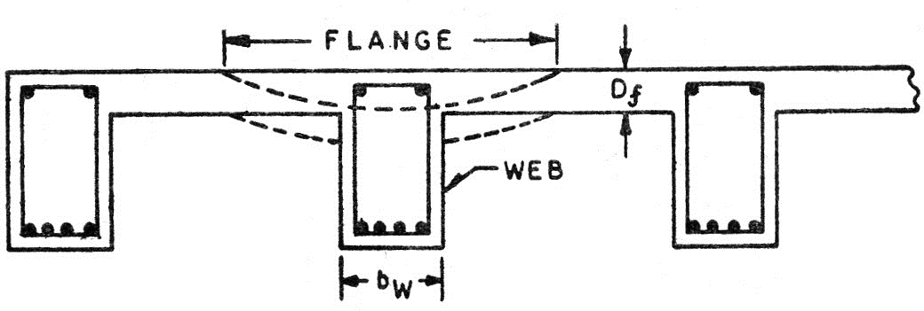
Fig.2.5
Flanged beam sections comprise T-beams and L-beams where the slabs and beams are cast monolithically having no distinction between beams and slabs. Consequently the beams andslabsareso closely tied that when the beam deflects under applied loads it drags along with it a portion of the slab also as shown in Fig.2.5 .this portion of the slab assists in resisting the effects of the loads and is called the ‘flange’ oftheT-beams.Fordesignofsuchbeams,theprofileissimilartoaT-sectionforintermediatebeams.The portion of the beam below the slab is called ‘web’ or ‘Rib’. A slab which is assumed to act as flange of a T-beam shall satisfy the following conditions:
- The slab shall be cast integrally with the web or the the web and the slab shall be effectively bonded together in any other manner;and
- Ifthe mainreinforcementofthe slab is parallelto the beam, transversereinforcementshallbeprovided as shown in Fig.2.6, such reinforcement shall not be less than 60% ofthe main reinforcementat mid- span of the slab.
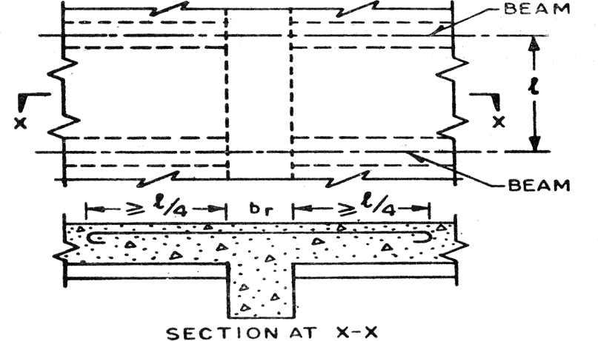
Fig.2.6

CHAPTER- 2 PHILOSOPHYOF LIMITSTATEMETHOD

SAFETYANDSERVICEABILITYREQUIREMENTS
In the method of design based on limit state concept, the structure shall be designed to withstand safely all loads liable to act on it throughout its life; it shall also satisfy the serviceability requirements, such as limitations on deflection and cracking. The acceptable limit for the safetyandserviceabilityrequirements before failure occurs is called a ‘limit state’. The aim of design is to achieve acceptable probabilities that the structure will not become unfit for the use for which it is intended that it will not reach a limit state.
All relevant limit states shall be considered in design to ensure an adequate degree of safety and serviceability. In general, the structure shall be designed on the basis of the most critical limit state and shall be checked for other limit states.
For ensuring the above objective, the design should be based on characteristic values for material strengths and applied loads,which take into account the variations in the material strengths and in the loads tobe supported. The characteristic values should be based on statistical data if available; where such data are not available they should be based on experience. The ‘design values’ are derived from the characteristic values through the use of partial safety factors, one for material strengths and the other for loads. In the absence of special considerations these factors should have the values given in 36 according to the material, the type of loading and the limit state being considered.
LimitStateofCollapse
The limitstate of collapse of the structure orpartof the structure could be assessed from rupture of one or more critical sections and from buckling due to elastic or plasticinstability (includingtheeffectsof sway where appropriate) or overturning. The resistance to bending, shear, torsion and axial loadsat every sectionshall not be less than the appropriate value at that section produced by the probable most un favourable combination of loads on the structure using the appropriate partial safetyfactors.
LimitStateDesign
For ensuring the design objectives,thedesignshouldbe based on characteristicvalues formaterial strengths and applied loads (actions), which take into account the probability of variations in the material strengths and in the loads to be supported. The characteristic values should be based on statistical data, if available. Where such data is not available, they should be based on experience. The design values are derived from the characteristic values through the use of partial safety factors, both for material strengths and for loads.In the absence of special considerations, these factors should have the values given in this section according tothe material, the type of load and the limit state being considered. The reliability of design is ensured byrequiring that
DesignAction≤DesignStrength.

Limitstatesarethestatesbeyondwhichthestructurenolongersatisfiestheperformancerequirements specified. The limit states are classified as
  - Limitstateofstrength
  - Limitstateofserviceability
- The limit state of strength are those associated with failures (or imminent failure), under the action ofprobable and most unfavorable combination of loads on the structure using theappropriatepartialsafety factors, which may endanger the safety of life and property. The limit state of strengthincludes:
  - Lossofequilibriumofthestructureasawholeoranyofitspartsorcomponents.
  - Loss of stability of the structure (including the effect of sway where appropriate and overturning)or any of its parts including supports and foundations.
  - Failurebyexcessivedeformation,ruptureofthestructureoranyofitspartsorcomponents.
  - Fractureduetofatigue.
  - Brittlefracture.
- Thelimitstateofserviceabilityinclude
  - Deformation and deflections, which may adversely affect the appearance or, effective, use of the structure or may cause improper functioning of equipment or services or may cause damages to finishes and non-structural members.
  - Vibrations in the structure or any of its components causing discomfort to people, damages to the structure, its contents or which may limit its functional effectiveness. Special consideration shallbe given to floor vibration systems susceptible to vibration, such as large open floor areas free of partitions to ensure that such vibrations is acceptable for the intended use and occupancy.
  - Repairabledamageduetofatigue.
  - Corrosionand durability.
LimitStatesofServiceability
Tosatisfythelimitstateofserviceabilitythedeflectionandcrackinginthestructureshallnotbe excessive. This limit state corresponds to deflection and cracking.
Deflection
Thedeflectionofastructureorpartshallnotadverselyaffecttheappearanceorefficiencyofthe structure or finishes or partitions.
Cracking
Cracking of concrete should not adversely affect the appearance or durability of the structure; the acceptable limits of cracking would vary with the type of structure and environment. Theactualwidthof cracks will vary between the wide limits and predictions of absolute maximum width are not possible. The surface width of cracks should not exceed 0.3mm.

In members where cracking in the tensile zone is harmful either because they are exposed to the effects of the weather or continuously exposed to moisture or in contact soil or ground water, an upper limit of 0.2 mm is suggested for the maximum width of cracks. For particularly aggressive environment, such as the ‘severe’ category, the assessed surface width of cracks should not in general, exceed 0.1 mm.
CHARACTERISTICANDDESIGNVALUESANDPARTIALSAFETYFACTORS
- CharacteristicStrengthofMaterials
Characteristic strength means that value of the strength of the material below which not more than 5 percent of the testresults are expected to falland is denoted by ƒ.The characteristicstrength of concrete (ƒck) is as per the mix of concrete. The characteristic strength of steel (ƒy) is the minimum stress or 0.2 percent ofproof stress.
- CharacteristicLoads
Characteristic load means that value of load which has a 95 percent probability of not being exceeded duringthelifeof thestructure.Sincedataare not availabletoexpressloads instatistical terms,for thepurpose of this standard, dead loads given in IS 875 (Partl), imposed loads given inIS875 (Part 2),wind loads giveninIS875(Part 3),snowloadas giveninIS 875 (Part4) andseismicforces givenin IS 1893-2002(part-I) shall be assumed as the characteristic loads.
DesignValues Materials
Thedesignstrengthofthematerialsƒdisgivenby

f
ƒd=
γ
m
where
f=characteristicstrengthofthematerial
γm=partialsafetyfactorappropriatetothematerialandthelimitstatebeingconsidered.
Load
Thedesignload,F,isgivenby

F
ƒd=
γ
f
Where,F=characteristicload
andγf=partialsafetyfactorappropriatetothenatureofloadingandthelimitstatebeingconsidered.
ConsequencesofAttainingLimit State
Wheretheconsequencesofastructureattainingalimitstateareofaseriousnaturesuchashugelossoflife
and disruption of the economy, higher values for γf and γm thanthosegivenunder36.4.1and36.4.2maybe applied.

PartialSafetyFactors:
- PartialSafetyFactorγf forLoads

Sr. No. | Load Combination | UltimateLimitState | ServiceabilityLimitState
1 | DL+LL | 1.5(DL+ LL) | DL+LL
2 | DL+WL  - DLcontributeto stability  - DLassists overturning | 0.9DL+ 1.5WL  1.5(DL+WL) | DL+WL DL+WL
3 | DL+LL+ WL | 1.2(DL+ LL+ WL) | DL+0.8LL+0.8WL

- PartialSafetyFactorγmforMaterialStrength

Sr. No. | Material | UltimateLimitState | ServiceabilityLimit State
1 | Concrete | 1.50 | Ec=5000 f_{ck}MPa
2 | Steel | 1.15 | Es=2x10⁵MPa

When assessing the strength of a structure or structural member for the limit state of collapse, the values ofpartial safety factor, should be taken as 1.5 for concrete and 1.15 forsteel.

LIMITSTATEOFCOLLAPSE:FLEXURE
AssumptionsforLimitStateofCollapse(Flexure):
- Plane section normal to the axis remains plane even after bending. i.e. strain at any point on the cross section is directly proportional to the distance from the N.A.
- Maximumstraininconcreteattheoutermostcompressionfibreistakenas0.0035inbending.
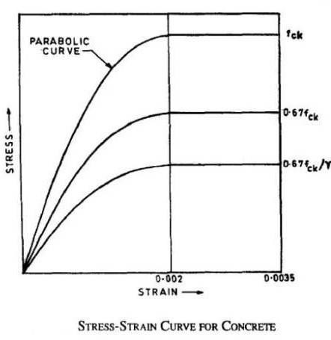
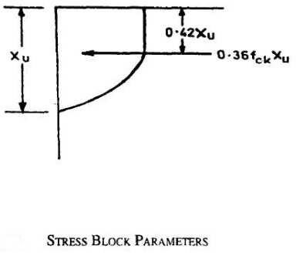
- The relationship between the compressive stress distribution in concrete and the strain in concrete maybe assumed to be rectangle, trapezoid, parabola or any other shape which results in prediction ofstrength in substantial agreement with the results of test. An acceptable stress strain curve is as shown below.

Fordesignpurposes,thecompressivestrengthofconcreteinthestructureshallbeassumedtobe0.67 times the characteristic strength. Thepartial safety factor γm = 1.5 shall be applied in addition to this.
NOTE-Fortheabovestress-straincurvethedesignstressblockparametersareasfollows: Area of stress block = 0.36.fck.xu
Depthofcentreofcompressiveforce=0.42xufromtheextremefibreincompression Where
fck=characteristiccompressivestrengthofconcrete,and xu= depth of neutral axis.
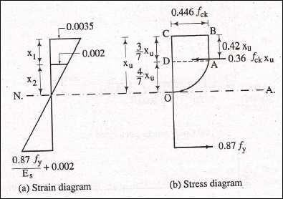
- thetensilestrengthoftheconcreteisignored.
- thestressesinthereinforcementarederivedfromrepresentativestress–straincurveforthetypeof steel used.
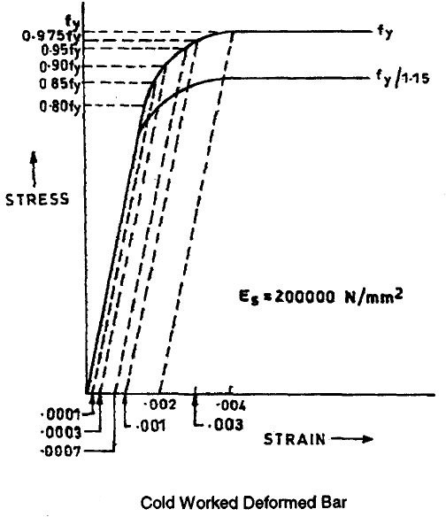

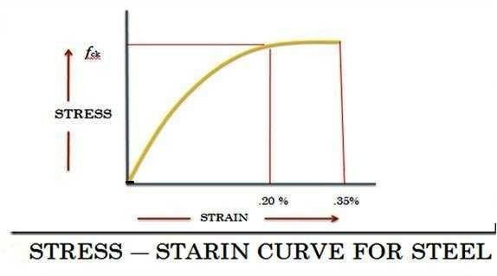

- themaximumstrainintensionreinforcementinthesectionatfailureshallnotbelessthan

f_{y}
1.15E_{s}
+0.002 =0.87 f y+0.002
E_{s}

CHAPTER-3
ANALYSISANDDESIGNOFSINGLYANDDOUBLYREINFORCEDMEMBERS

Limitstatemethodofdesign
  - Theobjectofthedesignbasedonthelimitstateconceptistoachieveanacceptableprobability,thata structure will not become unsuitable in it’s lifetime for the use for which it is intended, i.e. It will not reach a limit state
  - Astructurewithappropriatedegreeofreliabilityshouldbeabletowithstandsafely.
  - Allloads,thatarereliabletoactonitthroughoutit’slifeanditshouldalsosatisfythesubsability requirements, such as limitation on deflection and cracking.
s
  - It should also be able to maintain the required structural integrity, during and after accident, such as fires,explosion& localfailure.i.e.limitsatemustbeconsiderindesigntoensureanadequatedegreeofsafety and serviceability
  - The most important of these limit states, which must be examine in design are as follows Limit state of collapse
    - Flexure
    - Compression
    - Shear
    - Torsion This state corresponds to the maximum load carryingcapacity.
Typesofreinforcedconcretebeams
a) Singlyreinforcedbeam
b) Doublyreinforcedbeam
c) SinglyorDoublyreinforcedflangedbeams
Singlyreinforced beam
Insinglyreinforcedsimplysupportedbeamsorslabsreinforcingsteelbarsareplacednearthebottomofthe beam or slabs where they are most effective in resisting the tensile stresses.
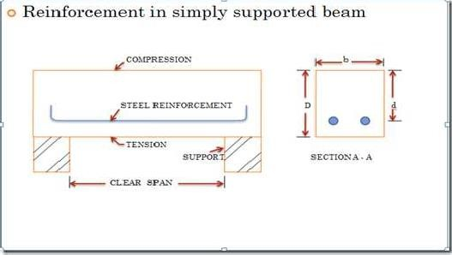

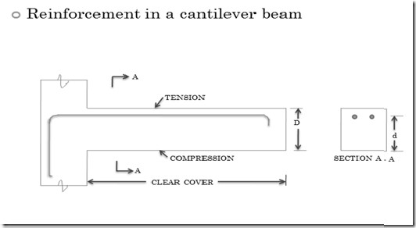
TYPESOFBEAMSECTIONS
Sectioninwhich,tensionsteelalsoreachesyieldstrainsimultaneouslyastheconcretereachesthe failure strain in bending are called, ‘Balanced Section’.
Sectioninwhich,tensionsteelalsoreachesyieldstrainatloadslowerthantheloadatwhich concrete reaches the failure strain in bending are called, ‘Under Reinforced Section’.
Sectioninwhich,tensionsteelalsoreachesyieldstrainatloadshigherthantheloadatwhichconcrete reaches the failure strain in bending are called, ‘Over Reinforced Section’.

Sr.  No. | Types of Problems | DataGiven | DataDetermine
1. | Identify the type of section, balance,under reinforced or overreinforced | Grade of Concrete & Steel, Size of beam &Reinforcement provided | IfXu=Xumax ⇒ Balanced  d d  IfXu˂Xumax ⇒UnderReinforced  d d  IfXu˃Xumax ⇒OverReinforced  d d  Xu=0.87f _{y}.A_{st}  d 0.36b.df_{ck}  ƒ Xumax  y  d  250 0.53  415 0.48  500 0.46

2 | Calculate Momentof Resistance | Grade of Concrete&  Steel,Sizeof beam &  Reinforcement Provided | xu =xu,max,balanced  1)Ifd d  M.R=M= 0.36.xu,max(1−0.42xu,max)b.d².f  u d d ck
2)If Xu˂Xumax UnderReinforced
d d

M.R=Mu=
0.87f.A.d(1−Ast.fy)orM.R=0.87f.A.d(1−0.42xu)

y st b.d.f y st d
ck
3)If
Xu˃Xu max⇒overreinforced,Revisethedepth
d d
3 | Design the beam.Findout the depth of Beam D &Reinforcement required Ast. | Grade of Concrete&  Steel, width of beam&Bending Moment or loading on the beam with the spanofthebeam  Reinforcement Provided | Wehavetodesignthebeamasa‘BalancedDesign’. For finding ‘d’ effective depth use the equation;  x x  M.R=M =0.36.^{u},max(1−0.42^{u},max)b.d2.f  u d d ck  ForfindingAstusetheequation  0.87f.A.d(1−Ast.f y)orM .R=0.87f.A.d(1− 0.42xu )  y st b.d.f y st d  ck

Where

d = effective depth ofbeamin mm. b = width of beam inmm
xu = depth of actual neutral axis im mm from extreme compression fibre. xu,max=depthofcritical neutral axisinmmfromextremecompression fibre.
Ast =areaoftensilereinforcement
ƒck = characteristic strength of concrete in MPa. ƒy = characteristic strength of steel in MPa.
Mu,lim=LimitingMomentofResistanceofasectionwithoutcompressionreinforcement

DoublyReinforcedSectionorsectionswithCompressionReinforcement
Doubly Reinforced Section sections are adopted when the dimensions of the beam have been predetermined from other considerations and the design moment exceeds the moment of resistance of a singly reinforced section. The additional moment of resistance is carried by providing compression reinforcement and additional reinforcement in tension zone. The moment of resistance of adoubly reinforcedsection isthesum of the limiting moment of resistance Mu,limof a single reinforced section and the additional momentofresistance Mu2.
Mu2=Mu– Mu,lim
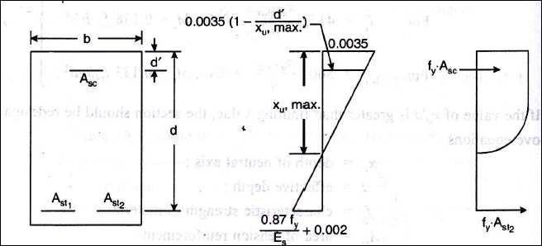
Theleverarmfortheadditionalmomentofresistanceisequaltothedistancebetweenthecentroidsoftension and compression reinforcement, (d – d’).
Mu2=0.87ƒy.Ast2(d–d’)=Asc.(ƒsc–ƒcc)(d–d’)
Where : Ast2= Area of additional tensile reinforcement Asc= Area of compression reinforcement
ƒsc=Stressincompressionreinforcement
ƒcc=Compressivestressinconcreteatthelevelofcompressionreinforcement Since the additiona reinforcement is balanced by the additional compressive force.
Asc.(ƒsc–ƒcc)=0.87ƒy.Ast2
Thestrainatlevelofcompression reinforcement is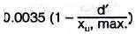Total area of reinforcement shall be obtained by
Ast =Ast1+ Ast2
Ast1=AreaofreinforcementforasinglyreinforcedsectionforMu,lim
Asc(fsc −fcc )

Ast2=

0.87f_{y}

EXAMPLE4.1

CalculatetheareaofsteelofgradeFe415requiredforsectionof250mmwideandoveralldepth500mmwith effective cover 40mm in M20, if the limit state of moment be carried by the section is
a)100 KN b)146KN c)200KN
SOLUTION:

Forƒy=415N/mm²,

M
X
=0.48
u max

d
=0.36. xu,max(1− 0.42xu,max )b.d ².f

u,lim d d ck

=0.36X.48(1-0.42X 0.48)X 250X4602X20
=146X106N.mm

- ForMu=100KN.m˂146KN.m

Areaofsteelrequiredisobtainedfrom,Mu

=0.87 f

y.Ast

.d(1−Ast.fy)
ck
b.d. f

100X10⁶=0.87X415XAstX460(1-
A_{st}X415 )
250 X 460X20

Ast=686or4850mm²,takingminimumsteel686mm²
- Mu=146KN.m=Mu,lim=146KN.m
xu=xu,max

Areaoftensionreinforcementrequired

Xu ,max=

d
0.87f_{y}.A_{st}0.36b.df_{ck}

Ast
=0.48X0.36X20X250X460=1100mm2
0.87X415

- Mu=200KN.m˃Mu,lim=146KN.m
Reinforcementistobeprovidedinthecompressionzonealsoalongwiththereinforcementintensionzone. Mu=Mu,lim=ƒsc.Asc(d – d’)

ƒisstresscorrespondingtostrainof 0.0035(xu,max−d')=0.0035(0.48X460−40)=0.002866

sc x

u,lim

0.48X460

ƒ_{sc}=360.8N/_{mm}2
(200-146)X10⁶=360.8.Asc(460-40)
Asc=356mm²
Ast1=AreaoftensionreinforcementcorrespondingtoMu,lim

146X 106=0.87X 460X 415A

Ast1= 1094mm²
st1(1- AstX415 )
250 X 460X 20

Ast2=Asc.ƒsc/0.87X415 =356mm²
Ast=Ast1+Ast2=1094+356= 1450mm²
EXAMPLE:4.2
Designarectangularbeamwhichcarriesamaximumlimitingbendingmomentof65KN.m.UseM20andFe 415 as reinforcement.
Atbalancedfailurecondition Mu = Mu,lim
M =0.36.xu,max(1−0.42xu,max)b.d².f
u,lim d d ck

Mu,lim =0.36X0.48X20(1-0.42X0.48)bd²
=2.759b d2
Assumingwidthofbeamas250mm

d= =307mm
65X10⁶
2.759 X250

Areaofreinforcement

Xu,max

d
=0.87f_{y}.A_{st}0.36b.df_{ck}

0.87X415XA_{st}

0.48=0.36X20X250X307
Ast=734.66mm²

EXAMPLE:4.3
Find out the factored moment of resistance of a beam section 300mm wide X 450mm effective depth reinforced with 2 X 20mm diameter bars as compression reinforcement at an effective cover of 50mm and 4 X 25mm diameter bars as tension reinforcement. The materials are M20 grade concrete and Fe 415 HYSD bars.
Solution:
Given;
Width=b=300mm
Effectivedepth=d=450mm
Covertocompressionreinforcement=d’=50mm

d=50
d' 450
=0.11,nexthighervalue0.15maybeadopted.

Asc=area compression reinforcement = 2 π 16² = 628mm²Ast= area of reinforcement in tension = 4 x n25²= 1964mm²ƒsc= stress in compression steel=342N/mm²
Equatingtotalforce
0.36ƒck.b.xu+ƒsc.Asc=0.87ƒy.Ast
0.36X20X300xu+628X342= 0.87X415X1964
xu=228.85mm
Butxu,max=0.48dforFe415
xu,max= 0.48 X 450 = 216mm So xu˃xu,max,⇒`overreinforced
Themomentofresistancecanbefoundoutbytakinmomentsofcompressiveforcesaboutcentroidof
tensilereinforcement.
Mu=2160xu(450-0.42xu)+214776(450-50)X10⁻⁶
Puttingxu=216mm Mu= 253.54 KN.m

BEHAVIORSOF‘T’AND‘L’BEAMS(FLANGEDBEAM)

A‘T’beamor‘L’beamcanbeconsideredasarectangularbeamwithdimensions bw.Dplusaflange of size (bf- bw) X Df.Itis shown in the figure beam (a) is equivalent to beam (b) + beam (c).
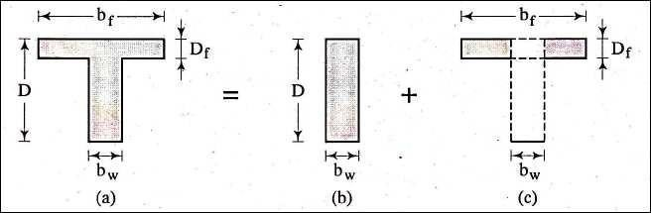
The flanged beam analysis and design are analogous to doubly reinforced rectangular beam. In doubly reinforced beams additional compressive is provided by adding reinforcement in compression zone, whereas in flanged beams, this is provided by the slab concrete, where the spanning of the slab is perpendicular to that of beam and slab is in compression zone.
If the spanning of the slab is parallel to that of the beam,some portion of slab can be made to span inthe direction perpendicular to that of the beam by adding some reinforcement in theslab.
Aflangedbeamcanbealsodoublyreinforced.

The moment of resistance of a T beam is sum of the moment of resistance of beam (a) is the summoment of resistance of beam (b) and moment of resistance of beam (c)

BOND:
CHAPTER-4SHEAR,BOND,DEVELOPMENTLENGTHS

One of the most important assumption in the behavior of reinforced concrete structure is that there is proper ‘bond’ between concrete and reinforcing bars. The force which prevents the slippage between the two constituent materials is known as bond. In fact , bond is responsible for providing ‘ strain compatibility ’ and composite action of concrete and steel. It is through the action of bond resistance that the axial stress ( tensile or compressive) in a reinforcing bar can undergo variation from point to point along its length. This is required to accommodate the variation in bending moment along the length of the flexural member.
When steel bars are embedded in concrete, the concrete, after setting, adheres to the surface of the bar and thus resists any force that tends to pull or push thisrod.The intensity of this adhesiveforce bond stress. The bond stresses are the longitudinal shearing stress acting on the surface between the steel and concrete, along its length. Hence bond stress is also known as interfacial shear. Hence bond stressis theshearstress acting parallel tothereinforcing baron the interface between thebar and the concrete.

TYPESOF BOND:-
Bond stress along the length of a reinforcing bar may be induced under two loading situations, and accordingly bond stresses are two types :
    - FlexuralbondorLocalbond
    - Anchoragebondordevelopmentbond

Flexural bond (τbf) is one which arises from the change in tensile force carried by the bar, along its length, due to change in bending moment along the length of the member. Evidently, flexural bond is critical at points where the shear (V=dM/dx) is significant. Since this occurs at a particular section, flexural bond stress is known as local bond stress [Fig- 5.1(b)].

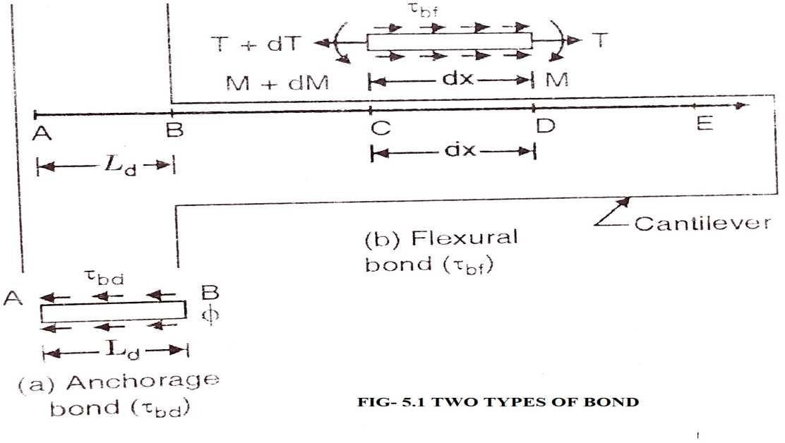

Anchorage bond (τbd) is that which arises over the length of anchorage provided for a bar. It alsoarises near the end or cutoff point of reinforcing bar. The anchorage bond resists the ‘pulling out’ ofthe bar if it is in tension or ‘pushing in’ of the bar if it is in compression. Fig.[8.1 (a)] shows the situation of anchorage bond over a length AB(=Ld). Since bond stresses are developed over specified length Ld, anchorage bond stress is also known as developed over a specified length Ld, anchoragebond stress is also known as development bond stress.
Anchoring of reinforcing bars is necessary when the development lengthof the reinforcementis larger than thestructure. Anchorageis used so that the steel's intended tension load can be reachedand pop-outs will not occur. Anchorage shapes can take the form of 180 or 90 degreehooks.

5.2.ANCHORAGEBONDSTRESS:
Fig- 5.2 shows a steel bar embedded in concrete And subjected to a tensile force T. Due to this force There will be a tendency of bar to slip out and this tendency is resisted by the bond stress developed over the perimeter of the bar, along its length of embedment .
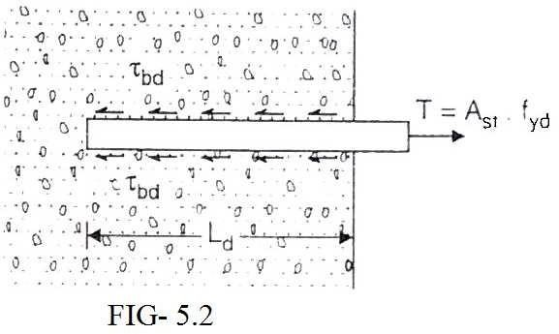

Let us assume that average uniform bond stress is developed along the length. The required length necessary to develop full resisting force is called Anchorage length in case of axial tension or compression and development length in case of flexural tension and is denoted by Ld.

DESIGNBONDSTRESS:-
Thedesignbondstressinlimitstatemethodforplainbarsintensionshallbeasgivenbelow (Table 6.1)
Table-6.1

Gradeofconcrete | M 20 | M 25 | M 30 | M 35 | M40andabove
Designbondstressτbd(N/mm²) | 1.2 | 1.4 | 1.5 | 1.7 | 1.9

Designbondstressesfordeformedbarsintension: FordeformedbarsconformingtoIS1786. These values shall be increased by 60%.
Designbondstressforbarsincompression: Forbarsincompression,thevaluesofbondstressfor in tension shall be increased by 25%.

DEVELOPMENTLENGTHOFBARS(IS456:2000)
The development length is defined asthe length of the bar required on either side of thesection under consideration, to develop the required stress in steel at that section through bond. The development length Ldgiven by
Ld=ϕϬs/4τbd=kdϕ 5.4.1
Where ϕ=nominaldiameterofthebar
Ϭs=stressinbaratthesectionconsideredatdesignload kd= development length factor = Ϭs/4 τbd
Note : The development length includes the anchorage values of hooks in tension reinforcementTaking Ϭs=0.87fyatthecollapsestage,kd=0.87fy/4τbd 5.4.2
For bars in compression, the value of τbdgiven in table 1.1 are to be increased by 25%. Hence developed length (Ldc) for bars in copressio is given by
Lds=ϕϬsc/5τbd 5.4.3

HencethevaluesofkdforbarsIncompressionwillbe=0.87fy/5τbd
Table 6.2 gives the values of development length factor for various gradesofconcrete andthe various grades of steel, both in tension as well as compression. The values have been rounded-off tothe higher side.

TABLE6.2-VALUESOFDEVELOPMENTLENGTH FACTOR

Gradeofconcrete | M 20 |  |  | M 25
Gradeofsteel | Fe 250 | Fe 415 | Fe 500 | Fe 250 | Fe 415 | Fe 500
Barsintension | 46 | 47 | 57 | 39 | 41 | 49
Barsincomp. | 37 | 38 | 46 | 31 | 33 | 39

Gradeof concrete | M30 |  |  | M35 |  |  | M40
Gradeof | Fe 250 | Fe 415 | Fe 500 | Fe 250 | Fe 415 | Fe 500 | Fe 250 | Fe 415 | Fe 500
steel
Barsin | 37 | 38 | 46 | 32 | 34 | 40 | 29 | 30 | 36
tension
Barsin comp. | 29 | 31 | 37 | 26 | 27 | 32 | 23 | 24 | 29

Note : When the actual reinforcement provided is more than that theoretically required, so that the actual stress (Ϭs) in steel is less than the full deign stress (0.87 fy), the development length requiredmay be reduced by the following relation :
ReduceddevelopmentlengthLdr=Ld(Astrequired÷Astprovided)
This principle is used in the design of footing and other short bending members where bond is critical. By providing more steel, the bond requirements are satisfied.
Bars bundled in contact : The development length of each bar bundled bars shall be that for the individual by 10% for two bars in contact,20% for three bars in contact and 33% for four bars in contact.

STANDARDHOOKS&BENDSFORENDANCHORAGEANCHORAGELENGTH

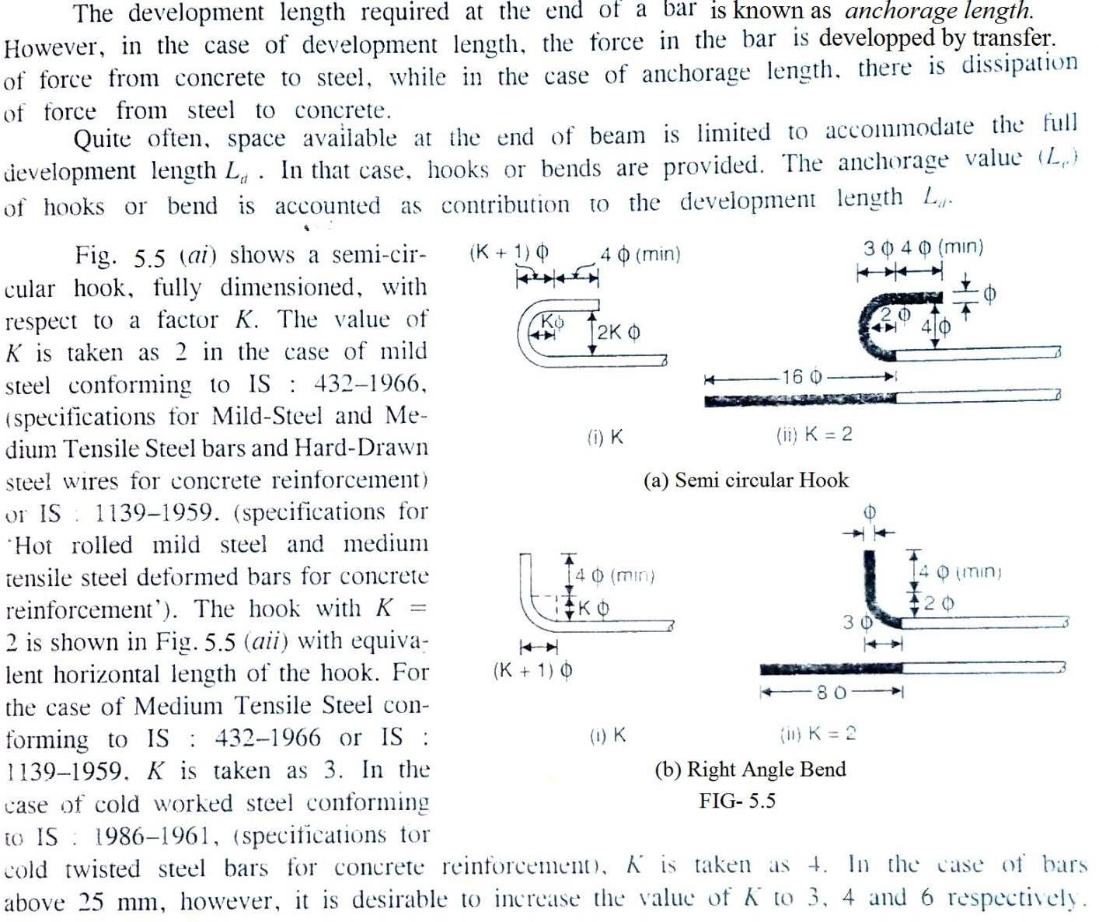

Fig-5.5showsarightangledbend,withdimensionsintermsofK,thevalueofwhichmaybetaken as 2 for ordinary mild steel for diameters below 25 mm and 3 for diameters above 25mm.
Inthecaseofdeformedbars,thevalueofbondstressforvariousgradesofconcreteisgreaterby 60% than the plane bars. Hence deformed bars may be used without hooks, provided anchorage requirements are adequately met with.

CODEREQUIREMENTSFORANCHORINGREINFORCINGBARS(IS456:2000)
    - Anchoring Bars in Tension :- Deformed bars may be used without end anchorages provideddevelopment lengthrequiredis satisfied.Hooksshouldnormally be provided for plain bars in tension. The anchorage value of bend shall be taken as 4 times the diameter of the bar for each 45° bend subject to a maximum of 16 times the diameter of the bar.The anchorage value of a standardU-type hook shall be equal to 16 times the diameter of the bar.
    - Anchoring Bars in Compression :- The anchorage length of straight bar in compression shall be equal to the development length of bars in compression. The projected length of

hooks, bendsand straightlengthsbeyondbendsif providedfor abarincompression, shall be considered for development length.

AnchoringShearReinforcement:-
Inclined bars :- The developments length shall be as for bars in tension ; this length shall be measured as under : (1) in tension zone from the end of the sloping or inclined portion of the bar and (2) in the compression zone, from mid depth of thebeam.
Stirrups :- Notwithstanding any of the provisions of this standard, in case of secondary reinforcement , such as stirrups and traverse ties, complete development lengths and anchorageshallbedeemedtohavebeenprovidedwhenthebaris bentthroughanangleof atleast 90° round a bar of atleast its own diameter and is continued beyond the end of the curve for a length of atleast eight diameters, or when the bar is bent through an angle of 135° and is continued beyond the end of curve for a length of atleast six bar diameters or when the bar is bent through an angle of 180° and is continued beyond the end of the curve for a length atleast four bar diameters.

CHECKINGDEVELOPMENTSLENGTHOFTENSIONBARS:-
As stated earlier, the computed stress (Ϭs) in a reinforcing bar, at every section must be developments on both the sides of section. This is done by providing development length Ldto both sides of the section. Such a developments length is usually available at mid-span location where positive (or sagging) B.M. is maximum for simply supported beams. Similarly, such a developments length is usually available at the intermediate support of a continuous beam where negative (or hogging) B.M. is maximum. Hence no special checking may be necessary in such locations. However special checking for developments length is essential at the following locations :
- Atsimplesupports
- Atcantileversupports
- Inflexuralmembersthat haverelativelyshortspans
- Atpointsofcontraflexure
- Atlapsplices
- Atpointsofbarcutoff
- Forstirrupsandtransverselies.

5.8.DEVELOPMENTSLENGTHREQUIREMENTSATSIMPLESUPPORTS: DIAMETER OF REINFORCING BARS :-

Thecodestipulatesthatatthesimplesupports(andatthepointofinflection),thepositivemoment tension reinforcement shall be limited to a diameter such that
Ld≤M1/V+Lo 5.8.1
WhereLd=developmentslengthcomputedfordesignstressfyd(=0.87fy)fromEq^{n}
M1= Moments resistance of the section assuming all reinforcement at the sectiontobestressed to fyd(= 0.87 fy)

V=Shearforceatthesectionduetodesignloads
Lo= sum of anchorage beyond the centre of supports andthe equivalent anchorage value ofany hook or mechanical anchorage at the simple support ( At the point of inflexion, Lois limited to dor 12ϕ which ever is greater).
The code further recommends that the value of M1/V in eq^{n} - 5.8.1 may be increased by 30% when the ends of the reinforcement are confined by a compressive reaction. This condition of confinement of reinforcing bars may not be available at all the types of simple supports.
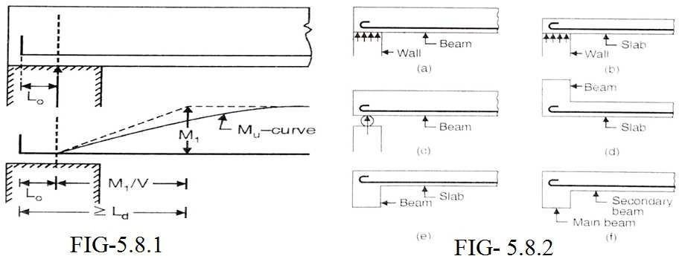

Four type of simple supports are shown in fig-5.8.2. In fig- 5.8.2 (a) , the beam is simply supported on a wall which offers a compressive reaction which confines the ends of reinforcement. Hence a factor 1.3 will be applicable. However in fig-5.8.1 (c) and (d) though a simple support is available , the reaction does not confine the ends of the reinforcement, hence the factor 1.3 will not be applicable with M1/V term.Simillarly for the case of a slab connected to a beam Fig- 5.8.2€ or for the case of secondary beam connected to a main beam [Fig-5.8.2(f)]
Tensilereactionisinducedandhenceafactor1.3willnotbeavailable.
Thusatsimplesupportswherethecompressivereactionconfinestheendsofreinforcingbarswehave Ld ≤1.3 M1/V+ L0 5.8.2

ComputationoftheMomentofResistanceM1ofbarsavailableatsupports:
Ineqn5.8.1,M1=MomentofResistanceofthesectioncorrespondingtotheareaofsteel(Ast) continued into the support and stressed to design stress equal to design stress equal to 0.87fy.

M1=0.87fy.Ast(d-0.416Xu) 5.8.3
WhereXu=0.87fy.Ast/0.36fckb 5.83(a)

ComputationofLength(L0) :
ForthecomputationofL0,thesupportwidthshouldbeknown.Fig-5.8.3(a)and(b)showabeam with end support with a standard hook and 90⁰ bend respectively.
LetXbethesidecovertothehook(Orbend)andX0bethedistanceofthebeginningofthehook( Or Bend) from the center line of the support.
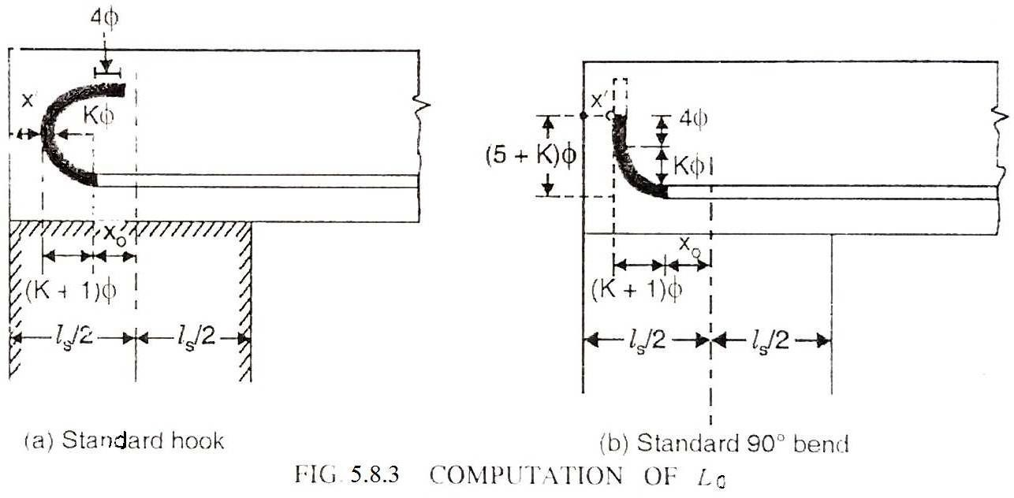

(a) Case-I : Standard Hook at the end [Fig-5.8.3(a)]:- The dark portion showsthe hook which has an anchorage value of 163 ( IS 456: 2000) for all types of steel. The distance of the beginning of the hookfrom its apexof the semicircleisequal to(K+1)3.Formildsteel bars K=2 and for HYSD bars, K=4, Hence the distance 3 for mild steel and 53 for HYSD bars. Let l be the width of thesupport.

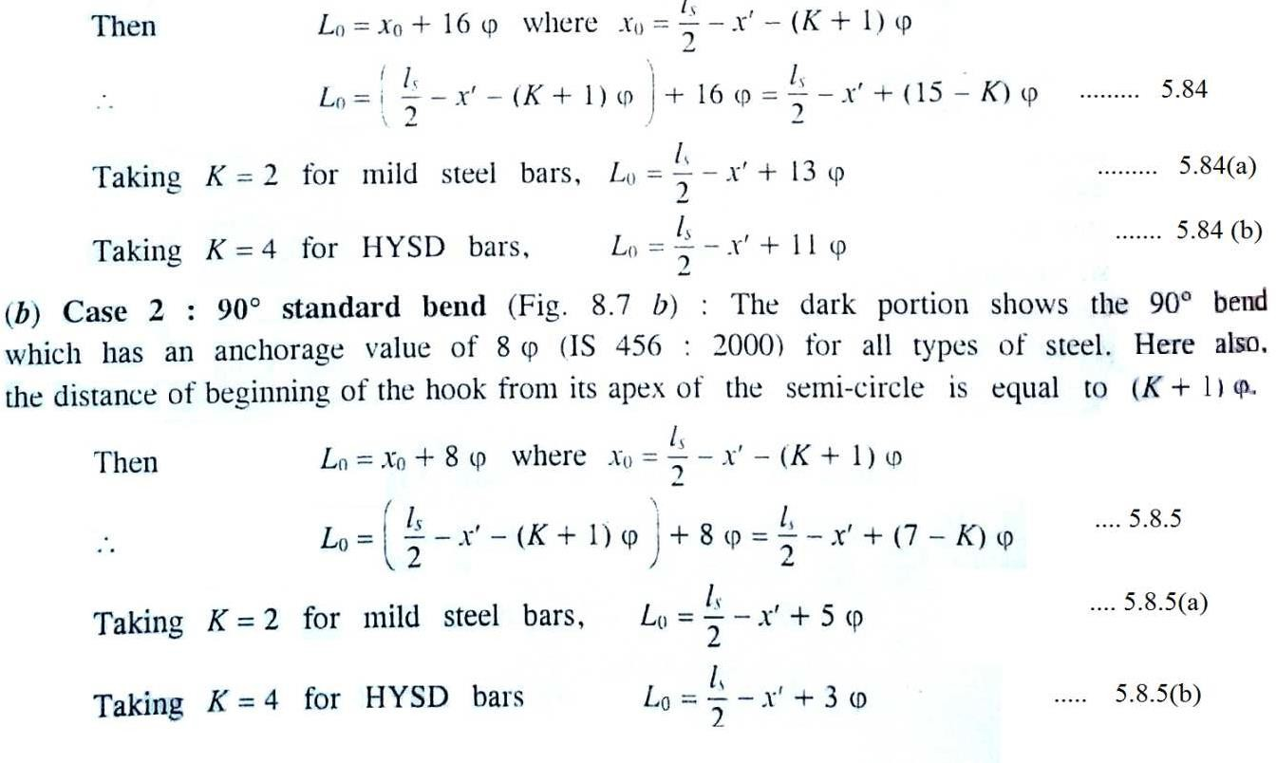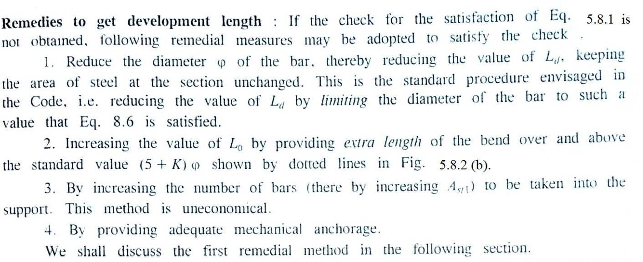

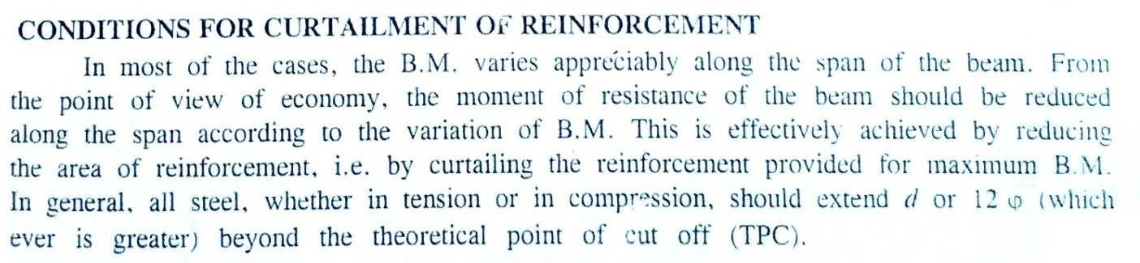

Conditionsforterminationoftensionreinforcementinflexuralmembers:

Curtailment of Flexural tension reinforcement results in the loss of shear strength in the region of cutoffandhenceitisnecessarytomakeprovisiontoguardagainstsuchloss.Flexuralreinforcement shall not be terminated in a tension zone unless any one of the following condition is satisfied.
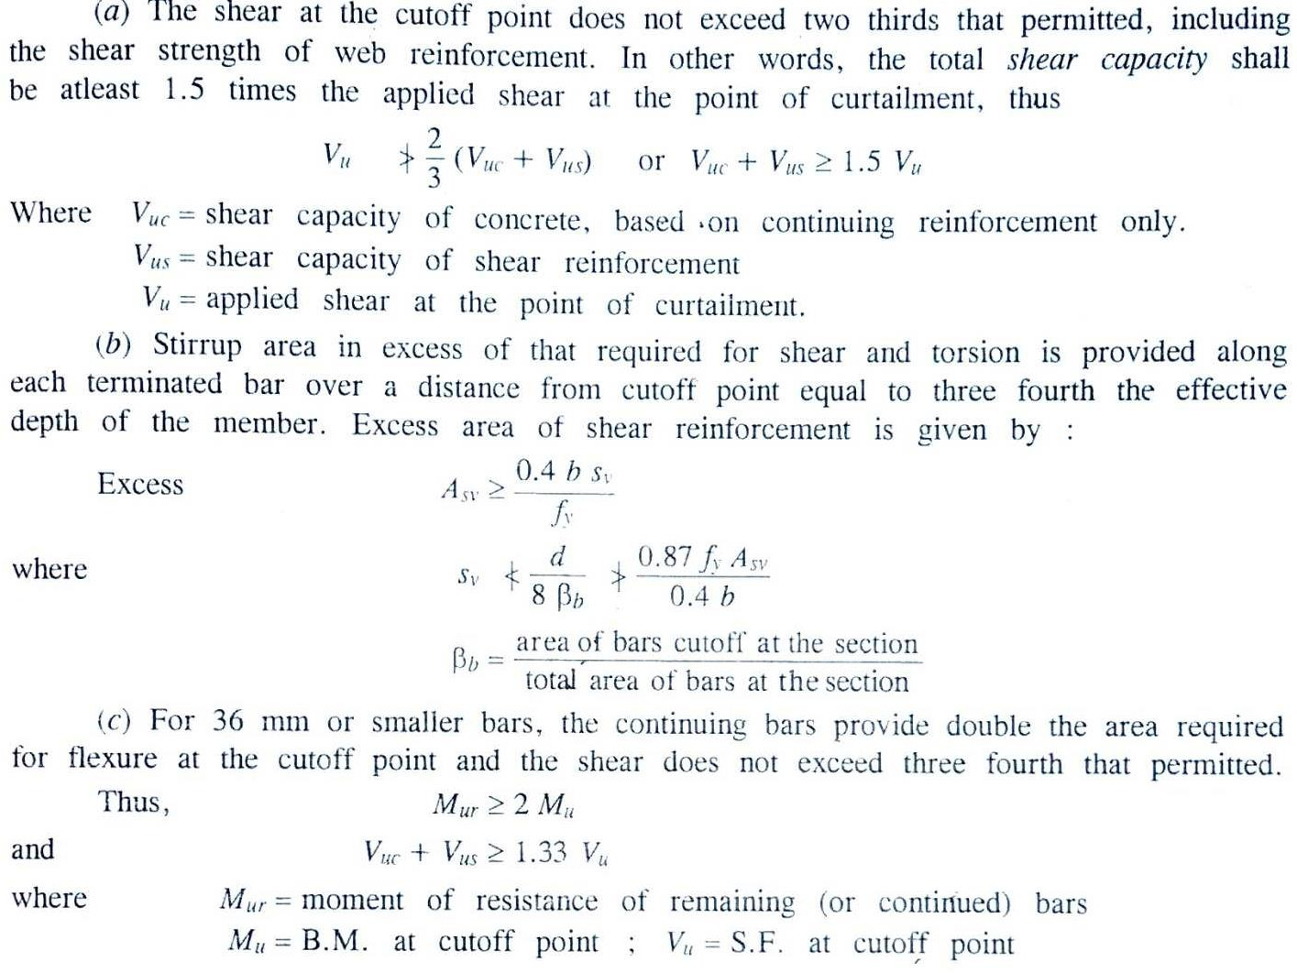

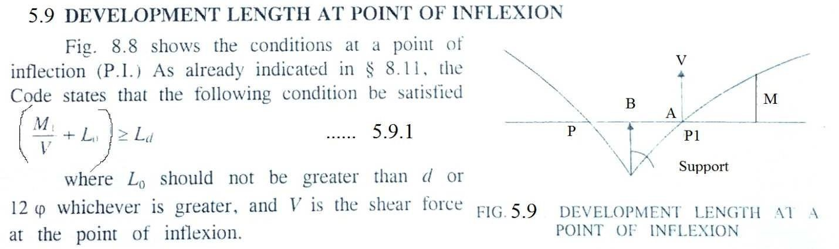

5.10 SPLICING:
(a)Thepurposeofsplicingistotransfereffectivelytheaxialforcefromtheterminatingbartothe connecting bar with the same line of action at the junction. [Fig-5.10 (a)].
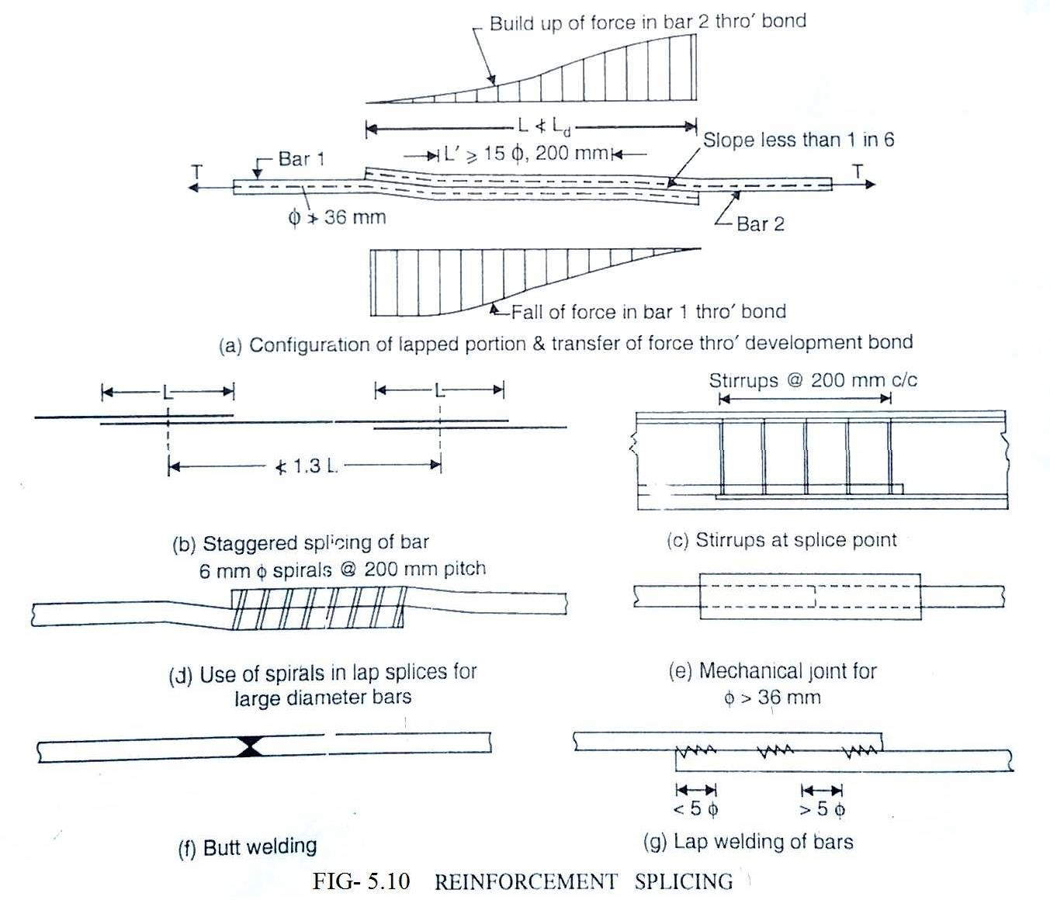

Slicing of a bar is essential in the field due to either the requirements of construction or nonavailability of bars of desired length. The Figures given are as per the recommendation of the IS 456 : 2000.
- Lap slices shall not be used for bars larger than 36 mm. For larger diameters bars may be weld. In casewhereweldingisnot practicable,lappingofbarslargerthan36mmmaybe permitted,inwhich case additionalspiral should be providedaroundthe lappedbars [Fig-5.10(d)].
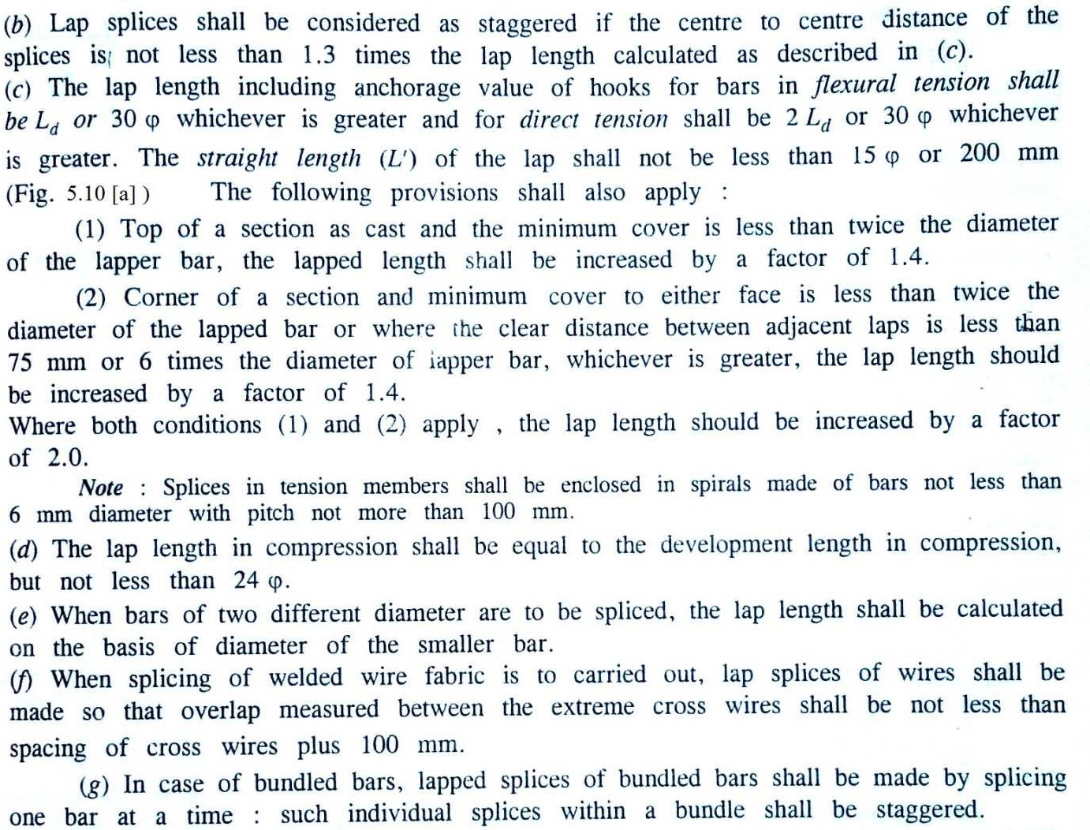

StrengthofWelds:
Thefollowingvaluesmaybeusedwherethestrengthofweldhasbeenprovedbyteststobeatleastas great as that of the parent bars.

Splicesincompression:
Forweldedsplicesandmechanicalconnection,100percentofthedesignstrengthofjoined bars.

Splicesintension:
    - 80%ofthedesignstrengthofweldedbars(100%ifweldingisstrictlysupervisedandifat any c/s of the member not morethan20% of the tensile reinforcement iswelded)
    - 100%ofthedesignstrengthofmechanicalconnection.
End Bearing Splices: End bearing splices should be used only for bars in compression. These are of square cut and concentric bearing ensured by suitable devices.

EXAMPLE-6.1
A SIMPLYSUPPORTED IS 25 cm X50cm and has 2– 20 mm TOR bars going into the support. Ifthe shear force at the center of the support is 110 KN at working loads, determine the anchorage length.assume M20 mix and Fe 415 grade TOR steel.

Solution:-
Foraloadfactorequalto1.5,thefactoredSF=1.5x110=165kN. Assuming 25 mm clear cover to the longitudinal bars
Effectivedepth=5000-25–20/2=465mm.
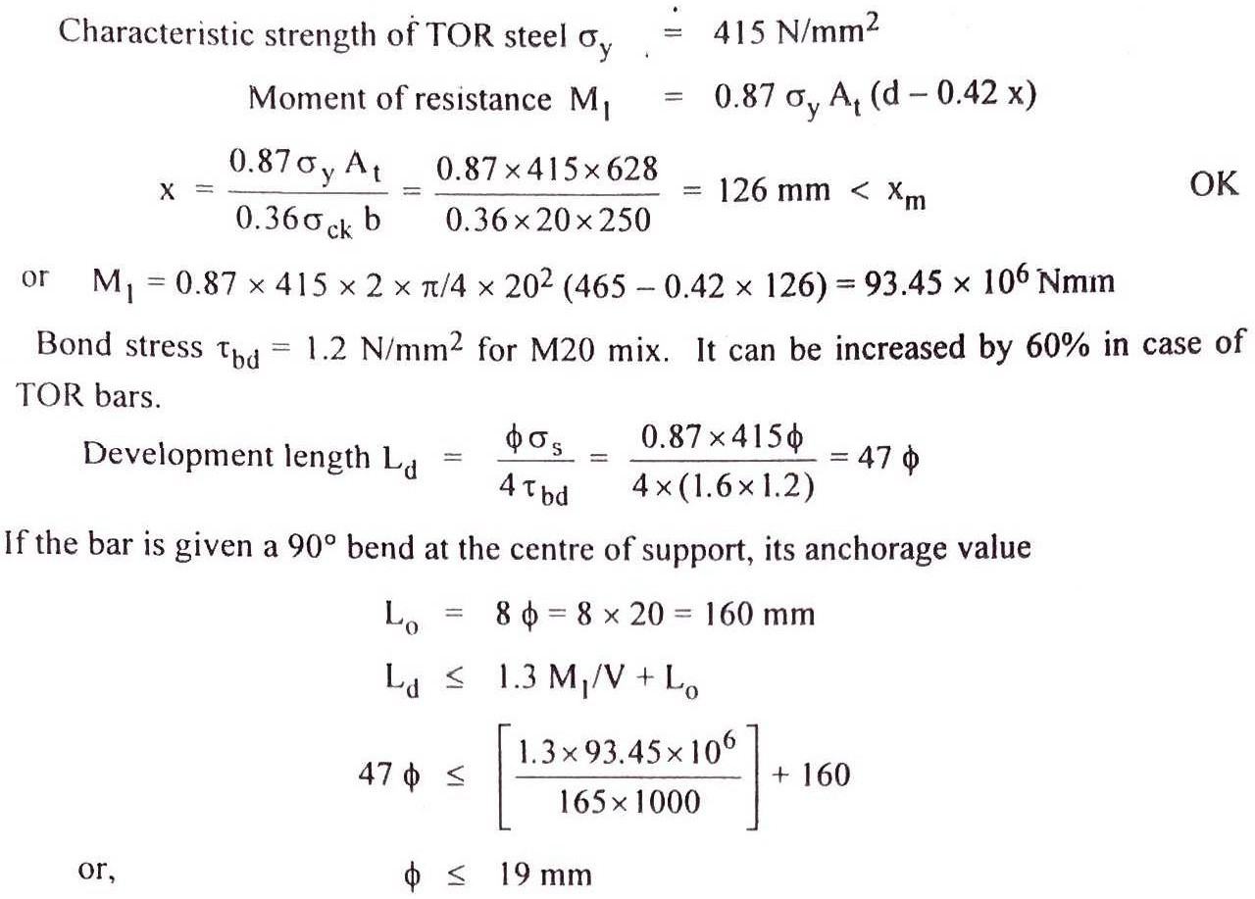

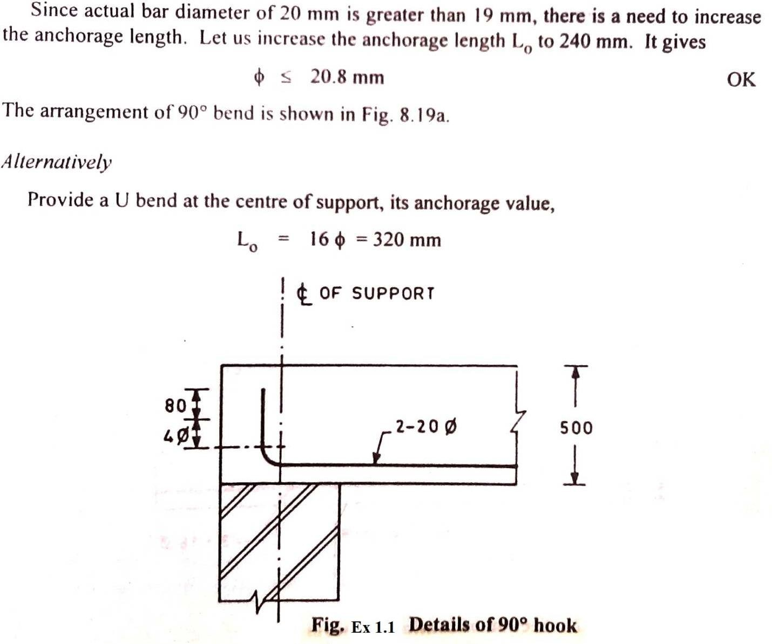

Ld≤1.3M1/V+L0.
47∅≤[1.3X93.45X106]+320

165X 1000

Or. ∅≤22.47mm
Actual bar diameter provided is 20 mm < 22.47 mm. ThearrangementofU-BendisshowninFig-Ex1.2.
InHighstrengthreinforcedbarsU-Bendshouldbeavoidedasfaraspossiblesincetheymaybe brittle and may fracture with bending.

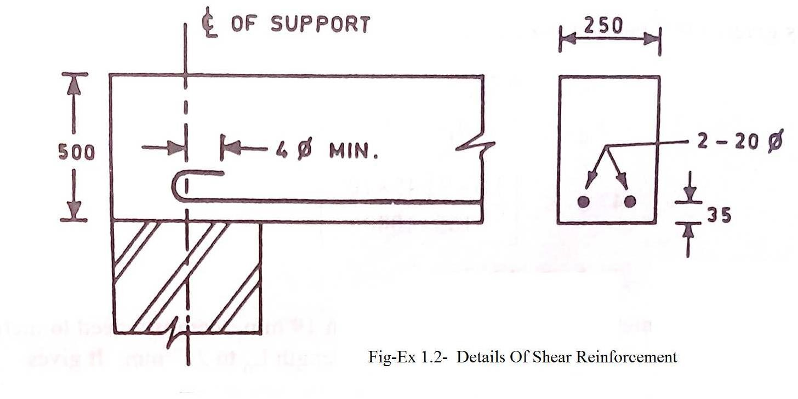

Example5.2:
Acontinuousbeam25cmX40cmcarries3-16mmlongitudinalbarsbeyondthepointofinflection in the sagging moment region as shown in Fig.Ex 1.3,.If the factored SF at the point of inflection is150 KN, a_{ck}= 20 N/mm² and a_{y}= 415 N/mm², check if the beam is safe in bond?
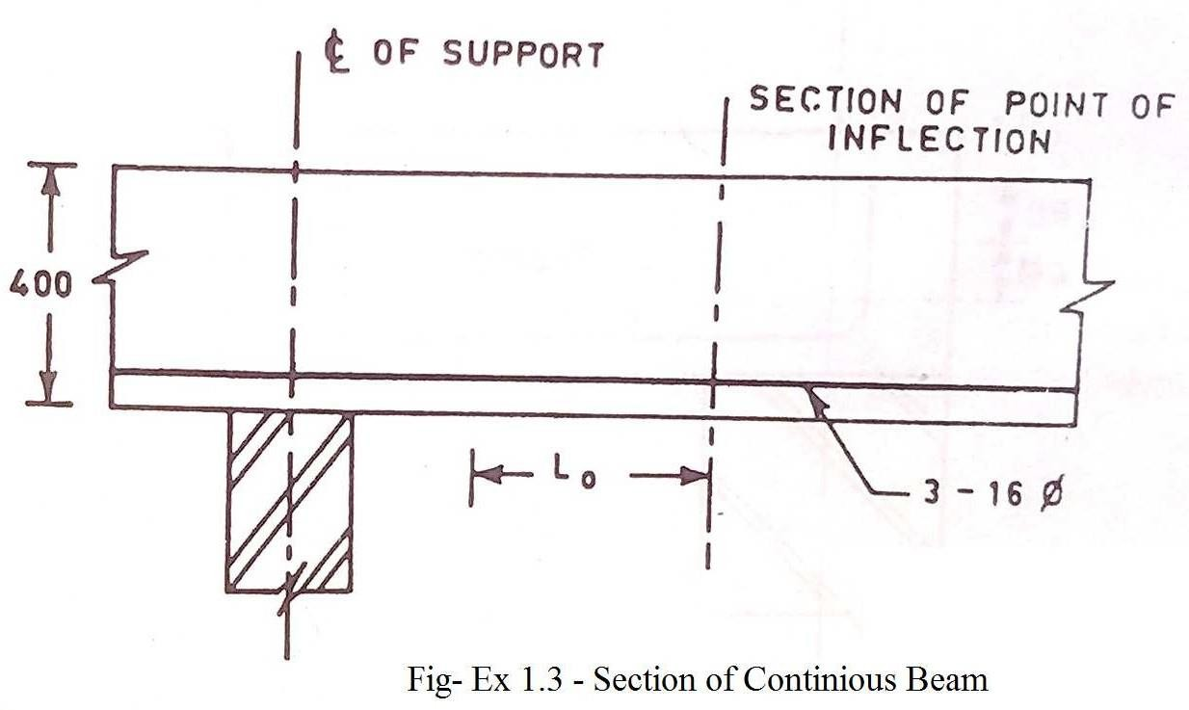

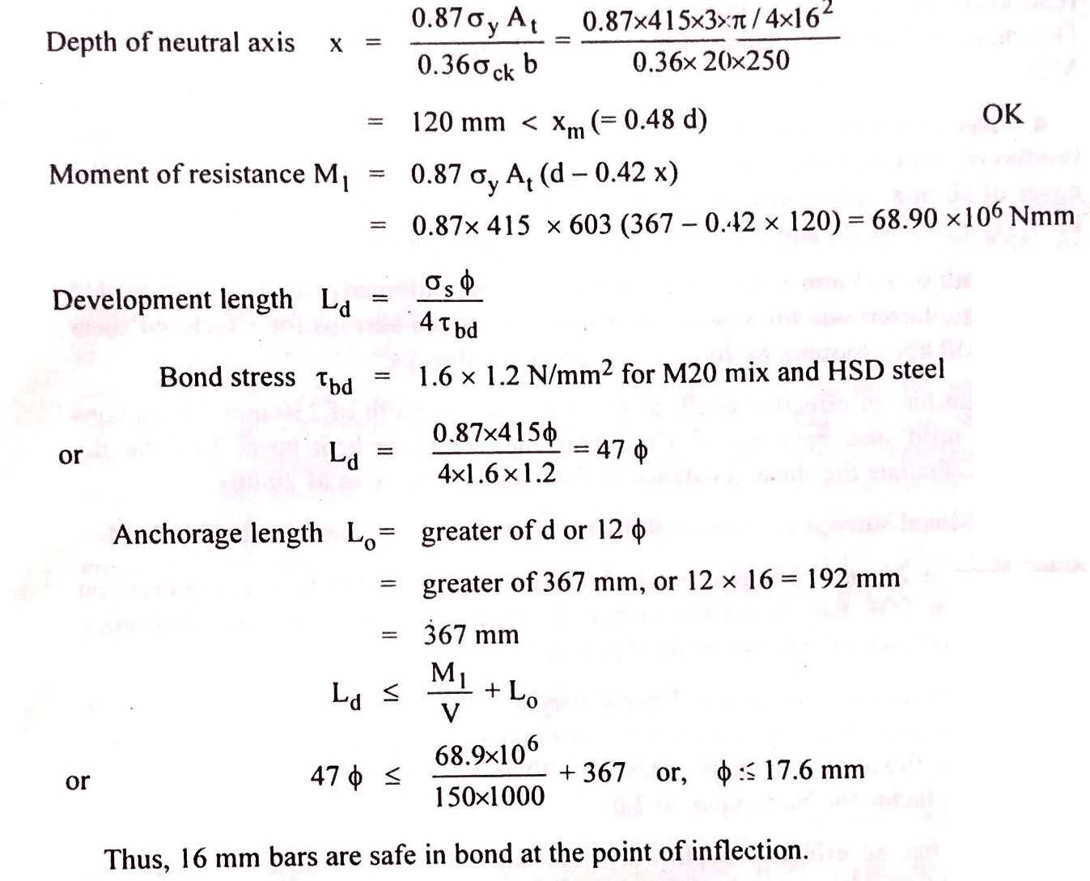

CHAPTER06

ANALYSISANDDESIGNOFT-BEAMINLIMITSTATEMETHOD

Beams(LSM)
ControlofdeflectionandensuringlateralstabilityinbeamsasperClause23.2&23.3ofIS-456.

Design of singly reinforced rectangular beams, Design of doubly reinforced beamsas per IS456/SP- 16 for bending and shear
DesignofTbeamsasperIS456forbendingandshear

CourseObjectives:
ControlofdeflectionandensuringlateralstabilityinbeamsasperClause23.2&23.3ofIS-456.

Introduction
Structures designed by limit state of collapse are of comparatively smaller sections than those designed employing working stress method. They, therefore, must be checked for deflection and width of cracks.Excessive deflection of a structure or part thereof adversely affects the appearance and efficiency ofthe structure, finishes or partitions. Excessive cracking of concrete also seriously affects the appearance and durability of the structure. Accordingly, cl. 35.1.1 of IS 456 stipulates that the designer should consider all relevant limit states to ensure an adequate degree of safety and serviceability.Clause 35.3 ofIS456 refers tothe limit state of serviceability comprising deflection in cl. 35.3.1 and cracking in cl. 35.3.2. Concrete is said tobedurable whenit performs satisfactorilyintheworkingenvironment during its anticipatedexposure conditions during service. This lesson discusses about the different aspects of deflection of beams and the requirements as per IS 456.Inaddition,lateral stabilityof beams is also takenup whileselectingthe preliminary dimensions of beams.

Short-andLong-termDeflections
Short-term deflection refers to the immediate deflection after casting and application of partial or full service loads, while the long-term deflection occurs over a long period of time largelyduetoshrinkageandcreepof thematerialsThefollowingfactorsinfluencetheshort-termdeflectionof structures:
- magnitudeanddistributionofliveloads,
- spanandtypeofendsupports,
- cross-sectionalareaofthemembers,
- amountofsteelreinforcementandthestressdevelopedinthereinforcement,
- characteristicstrengthsofconcreteandsteel,and
- amountandextentofcracking
.

Thelong-termdeflectionisalmosttwotothreetimesoftheshort-termdeflection.Thefollowing are the major factors influencing the long-term deflection of thestructures.
- Humidityandtemperaturerangesduringcuring,
- ageofconcreteatthetimeofloading,and
- type and size of aggregates, water-cement ratio, amount of compression reinforcement, size of members etc., which influence the creep and shrinkage of concrete.

Control of deflection and ensuring lateral stability in beams as per Clause 23.2 & 23.3 of IS-456.
Clause23.2ofIS456stipulatesthelimitingdeflectionsundertwoheadsasgivenbelow:
- The maximum final deflection should not normally exceed span/250 due to all loads including the effects of temperatures, creep and shrinkage and measured from the as-cast level of the supports of floors, roof and all other horizontal members.
- The maximum deflection should not normally exceed the lesser of span/350 or 20 mm including the effects of temperature, creep and shrinkage occurring after erection of partitions and the application of finishes.
Itisessentialthatboththerequirementsaretobefulfilledforeverystructure.

SelectionofPreliminaryDimensions :

The two requirements of the deflection are checked after designing the members. However, the structural design has to be revised if it fails to satisfy any one of the two or both the requirements. In order to avoid this, IS 456 recommends the guidelines to assume the initial dimensions of the members which will generally satisfy the deflection limits.Clause 23.2.1 stipulatesdifferentspan to effective depth ratiosandcl. 23.3 recommends limiting slenderness of beams, a relation of b and d of the members, to ensure lateral stability. They are given below:

  - Forthedeflectionrequirements
Differentbasicvaluesofspantoeffectivedepthratiosforthreedifferentsupportconditionsareprescribed for spans up to 10 m, which should be modified under any or all of the four different situations:
    - forspansabove10m,
    - dependingontheamountandthestressoftensionsteelreinforcement,
    - dependingontheamountofcompressionreinforcement,
    - forflanged beams.

Forlateralstabilityasperclause23.3ofIS-456

The lateral stability of beams depends upon the slenderness ratio and the support conditions. Accordinglycl. 23.3 of IS code stipulates the following:
    - Forsimplysupportedandcontinuousbeams,thecleardistancebetweenthelateralrestraintsshallnot
2
exceedthelesserof60bor250b/d,wheredistheeffectivedepthand bisthebreadthofthecompression face midway between the lateral restraints.
    - Forcantileverbeams,thecleardistancefromthefreeendofthecantilevertothelateralrestraintshall
2
notexceedthelesserof25bor100b/d.

Span/depthratiosandmodificationfactors
Sl. No. | Items | Cantilever | Simply supported | Continuous
1 | Basicvaluesofspantoeffectivedepth ratio for spans up to 10 m | 7 | 20 | 26
2 | Modificationfactorsforspans>10m | Not applicable as deflection calculationsareto be done. | Multiplyvaluesofrow1by 10/span in metres.
3 | Modificationfactorsdependingonarea and stress of steel | Multiplyvaluesofrow1or2withthemodification factor from Fig.4 of IS 456.
4 | Modificationfactorsdependingasarea of compression steel | Furthermultiplytheearlierrespectivevaluewiththat obtained from Fig.5 of IS 456.
5 | Modificationfactorsforflangedbeams | (i) Modify values of row 1 or 2 as per Fig.6 of IS 456. Further modify as per row 3 and/or 4 where reinforcement percentage to be used on area of section  equalto bd.  f

Design of singly reinforced rectangular beams, Design of doubly reinforced beams as per IS 456/SP-16 for bending and shear
Design of singly reinforced rectangular beams as per IS 456/SP-16 for bending and shear

Typesof Problems
Twotypesofproblemsarepossible:(i)designtypeand(ii)analysistype.
In the design type ofproblems, the designer has to determine the dimensionsb, d, D, Astand other detailing of reinforcement, grades of concrete and steel from the given design moment of the beam. In the analysistypeof the problems, all the abovedatawillbe knownand the designerhasto find out the moment of resistance of the beam
Designofthesinglyreinforcedbeamfor bending

Type1:Todesignasinglyreinforcedrectangularsectionforagivenwidthandappliedfactored moment

dbaS
=JMu
QliNXb

    - Assume 5% larger effective depth ford≤500more&10%largerdepthfor1000mm≥500mm
    - Assumeonelayerof20mmdiameterfor(case1)&twolayersof20mmdiameter,bars(case2)
    - Iftheclearcovertomainreinfis30mmEffectivecover=30+10(Assume1–Layer20ø)=40mm
=40+20(Assume2Layers20ø)
    - OveralldepthDoverall=d+40Doverall=d+60
    - Nowd=Doverall–40mm(case1) D overall – 60 mm (case-2)
    - DetermineMu,p,Ast,Ast
bd2 t lim
    - SelectthebarsizeandnumbersuchthatAst>Astrequired&alsoAst<Astlim

Type2:-Tofindthesteelareaforagivenfactoredmoment

Weknowd_{baS}
=JMu
QliNXb
(Assumeb)

Foragivenfactoredmoment,width&depthof Section,final

mulim=Qlimxbd2
Mu<Mulim,designasunderreinforcedSection Mu= Mulim, design as balanced Section
Mu>Mulim,designasdoublyreinforcedSection

Designofthesinglyreinforcedbeamforshear

ShearreinforcedInbeams
The shear reinforcement shall be provided by the reinforcement which cross the cracks. These shear reinforcement.minimizethesizeofdiagonaltensioncrack&carrydiagonaltensionstressfromoneside of crack to the other. The provision of shear reinforcement is made by the followingforms.
      - VerticalStirrups
      - InclinedStirrups
      - BentupbarsalongwithStirrups

DesignforShear
        - FindtheMaximumS.F
        - FindthefactoredS.F(Vu)
        - Findthenominalshearstressv=^{Vu}
v
bd
        - Obtain the design shear strength of concrete corresponding to percentage of tensile reinforcement provided for flexure from table 19,pg-73 IS 456.
Design shear strength(vc) :- It is thecapacityof concretealong withtensilereinforcement.Totake the amount of shear force without providing any reinforcement for shear.
        - Find the excess shear force for which shear reinforcement. is required to be provide i.e. Vus. Vus= Appliedshear–shearforcetoberesistedbyconcretewithoutanyshearreinforcement. Vuc= Vu− vcbd
        - Todeterminethequantityofshearreinforcementintermsofstirrupspacingasunder.

          - Forverticalstirrups
0.87fyÆcv×d

V_{uc}=
Sv
Vus =Exces S.F to be resisted Asv=Areaofshearreinforcement. SV = Spacing of strirrups

Sv=0.87fyAsv
d
Vus

          - Forinclinedstirrups

Vuc
=0.87fyÆcv×d(cinα+cocα) Sv

Or
Sv0.87fy Æcvd(Sinα+Cocα) Vuc

          - ForBent upbars

V_{uc}=0.87fyA_{sv}.sinα

IS456saysthecontributionofbentupbarstowardsshearresistanceshallnotexceedhalfoftheshear resistance.
α=anglebetweenbentuptheinclinedstirrupsorbentupbarandtotalaxisofmembernotlessthan45º

Minimumshearreinforcement.

Spacingofshearstirrupsshouldnotexceedthefollowing.
Asv≥

0.4

- S=0.87fyÆcv
v
0.4b
- 0.75d(d=Effectivedepth)
- 300mm c/cdistance
bSv
0.87fy

Example1
A simply supported rectangular beam of 4 m span carries a uniformly distributed characteristic load including self-weight of 20 kN/m. The beam section is 230 mm x 450 mm overall. Design the beam for bending and shear. The materials are grade M20 concrete and HYSD reinforcement of grade Fe 415. The beam is suspended from the upper floor level.
PG356fig 9.5
Solution:
Pu= 1.5 x20 = 30kN/m
2

Mu,max=30 x ⁴
8
=60kNmandV =30x⁴=60kN.
u,max 2

- Momentsteel

Thesectionis230mmx450mmoverall.Assumingone layerof16mmdiameterbars, effective depth shall be
d=450–30(cover)-8(centreofreinforcement)=412 mm.

Depthrequiredforsinglyreinforcedsection
J60s106
=
2.76×230

= 308mm< 412mm

Designas singlyreinforcedsection.
Mu 60s106
bd2=230s412s412=1.54
FromSP16table no2Pt= 0.474

Act
=0.474×230×412=449mm2
100

Minimumsteelrequired

A=^{0.205}×230×412=194NN2
c 100
A =0.96=230×412=910NN2
cbaS 100

194 mm²< Ast,provided< 910 mm². Provide4no.12mm#=4x113=452mm² Let 2 bar be bent at 1.25 D
=1.25X450=562.5mm,say600mm,fromthefaceofthesupport
Checkforshear:
As support Vu=60k N
60s103
τv= =0.633 N/mm².
230s412
100Æc=2s113s100=0.238
bd 230s412
.vc=0.332N/mm²<0.633N/mm².

Shear design is necessary

Notethatthecriticalsectionforcheckingtheshearstressinthiscaseisthefaceofthesupport(andnotat distance d from the face of the support ) because the reaction at support induces tension in end region.
Assupport2bentbrascanbeusedtocarryshearstress.Thesegiveashearresistanceof sin 45ºx 2 x 113 x 0.87 x 415 x 10⁻³ = 57.69 kN.
tcbd=0.332x230x412x10⁻³=31.46kN. Vus= Vu- τcbd = 60 – 31.46 = 28.54 kN.
Bent bars share 50% = 14.27 kN. Stirrupsprovide50%=14.27kN.

Using6mmøtwoleggedM.S.stirrups,spacingcanbegivenby

WhereAsv=2x28 = 56mm²
0.87×250×56× 412
0.87fy.Æcv.dVuc

Sv= =351mm (1)
14.27103

Atdistanceof550mmfromsupport,wheretwobarsarebent Vu= 60 –(0.55 x 30 )= 43.5 kN
Vus=43.5–31.46=12.04kN
Thiswillgivelargerspacingthanabove. Minimum shear reinforcement .

Spacingofshearstirrupsshouldnotexceedthefollowing.
Asv≥

0.4

- S=0.87fyÆcv
v
0.4b
- 0.75d(d=Effective depth)
- 300mm c/cdistance
bSv
0.87fy

Using2legged6mmømildsteelstirrupSv=
0.87×250×56
0.4×232 = 132.4mm

For230 mmwidebeam minimumshearreinforcementis6mmøabout130mmc/c (2)
From (1) and (2) minimum shear reinforcement shall be provided, i.e., 6 mm ø about 130 mm c/c. DesignofdoublyreinforcedbeamsasperIS456/SP-16forbendingandshearDOUBLY REINFORCEMENT BEAMS
When the applied moment is greater than M.R of a singly reinforced section, then steel reinforcement is added in compression zone to increase the M.R of the section, then this is known as doubly reinforced section
Therearethree alternatives
- Increasethedimensionsofthesectioni.e.depth
- HighergradesofconcretecanbeincreasedtoincreasetheM.Rofthesection.
- Steelreinforcement.maybeaddedincompressionzonetoincreasetheM.Rofthesection.

Designofdoublyreinforcedbeams
Type-1:Tofindoutreinforcementforflexureforagivensection&factoredmoment.

  - FindoutMulim&reinforcementAstlimforagivensectionbyusingtheequation Mulim = Qlim xbd2

=0.36f_{ck}b.x_{uNas}(d−0.42x_{uNas})

&Astlim
= MuliN
0.81fy(d–0.42suNas)

087xA.stxfy(d-0.42Xumax)
  - ObtainmomentMu2=Mu-Mulim
  - FindoutcompressionsteelfromequationM_{u2}=Asc(f_{cc}.f_{c})(d−d′)

Neglectingfcc,A_{cc}=
Mu2 fcc(d–du)

  - CorrespondingAstTensilestepAst2canbefoundoutfrom

Act2
=Æccfcc
0.87fy

(v)Act=ActSiN+Act2

(vi)Providethereinforcement
Example2
Design a simply supported rectangular beam of size 230 mm x 600 mm overall for a super-imposed load of 46 kN/m. Span of the beam is 5 m. The materials are M 20 grade concrete and HYSD reinforcement of grade Fe415.
Solution:
Selfweightofbeam=0.3x0.60x25=3.45kN/m

Super-imposedload=46.00kN/N
TotaS49.45kN,
N
Factorload=1.5x50=75 kN/m
2
M=5x75=243.4kNm
u 8
Say50kN/N

V= 5x75=187.5kN
u 2
Momentsteel:
Assuming2layersof20mmdiameterbars D = 600 – 30 – 20 -10 = 540 mm
Mu=243.4.s106bd2 230s540
₂=3.63>2.76

Doubly reinforced section
Mu,lim=2.76x230x540²x10⁻⁶=185.10kNm

Mu2=243.4–185.10=58.3kNm.
Letthecompressionreinforcementbeprovidedataneffectivecoverof40mm

d′=40=0.07,consider
′
d= 0.1

d 545 d
Stressincompressionsteel,fsc=353N/mm2(refertotablefofS.P-16)

Acc
= Mu2
fcc(d–d′)
=58.3s106
353(540–40)

=330mm2

Correspondingtensionsteel
A =Æccfcc=330×353=323mm2
ct2 0.87fy0.87×415

Ast1

=Ast,lim

=Pt,lim
×bd
100

=0.96×^{230×540}=1192mm2
100
Ast=Ast1+Ast2=1192+323mm2=1515mm2Asc = 2-16 # = 402 mm2
Ast=5-20#=1570mm2(allstraight).Provide3barsinfirstlayersand2barsinsecondlayer. For designed section, equating total compression and total tension
0.36fckbxu+Ascfsc=0.87 fyAst
0.36x20 x230 xu+ 402x353=0.87x 415x 1570
xu=256.6mm
xu,max=0.48d=0.48x540=259.2mm xu˂ xu,max
Hencethebeamisunderreinforced section.
- Checkforshear:
3
v=187.5s10=1.51N/mm2<2.8 N/mm2
v 230s540

100Æc=100s5s 314=1.26
bd 230s540

vc=0.672N/mm²
Astheendsareconfinedwithcompressivereaction,shearatdistancedwillbeusedforcheckingshearat support. At 540 mm, shear is equal to

Using8mm#twoleggedstirrups,spacingcanbegivenby

WhereAsv=2x50 =100mm²
0.87fy.Æcv.dVuc

Sv=
0.87×415×100×540
63.5×103 =307mm (1)

Atdistanceof550mmfromsupport,wheretwobarsarebent Vu= 187.5 –(0.540 x 75 )= 147 kN
Vus=147–0.672x230x540x10⁻³=63.5kN

Thiswillgivelargerspacingthanabove. Minimum shear reinforcement .

Spacingofshearstirrupsshouldnotexceedthefollowing.
Asv≥

0.4

- S=0.87fyÆcv
v
0.4b
bSv
0.87fy

- 0.75d(d=Effectivedepth)=0.75x540=405mm

- 300mm c/cdistance

Using2legged8mm#stirrupSv=
0.87×415×100
0.4×230
= 392.4mm

For230mmwidebeamminimumshearreinforcementis8mm # about 300 mm c/c (2)
Henceprovidemm#about300mm c/cthroughoutthebeam.

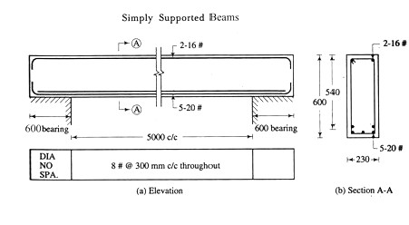
7.3:Design
ofTbeamsasperIS456forbendingandshear

DESIGNOFTBEAM
Case-1:Todesignthebeamforagivenloadingcondition
  - Fixethewidthofthebeamusingarchitecturalconsideration.Alsothewidthshallbesufficientto accommodate the reinforcement satisfying the requirement of spacing ofbars

  - EffectivewidthofflangeforTbeam=b_{ƒ}
=^{S0}+bw+6Dƒ
6

  - AssumeoveralldepthDequalto1/12thto1/10ofthespanandsubtractingeffectiveconcretecover from overall depth, find out the effective depth d
  - Assumeleverarm Z=d-Df/2
  - FindoutthereinforcementAct= Mu
0.87×ƒy×Z
  - Providethereinforcementasperrequirement.

  - Thenfindoutbf
bw
andDƒ
d
thenfromtable58ofS.P16findoutthevalueofM
ulim.T.Andcheck

whetherunderreinforcedoroverreinforcementassumingthepositionofneutralaxis If the moment of resistance is less than the applied moment,revise thesection.
WhenD≤3x
f 7u

Mu=0.36ƒb.x
ck u
WhenD≥3x
f 7u
Mu=0.36ƒb.x
(d —0.42x)+0.446ƒ(b —b)×D(d—^{ƒD})
u ck ƒ w ƒ 2
(d —0.42x)+0.446ƒ(b —b)×D(d—^{ƒF})

ck u u ck ƒ w ƒ 2
WhereYf=0.15xu+0.65Dƒ

DesignforShear
        - FindtheMaximumS.F
        - FindthefactoredS.F(Vu)
        - Findthenominalshearstressv=^{Vu}
v
bd
        - Obtain the design shear strength of concrete corresponding to percentage of tensile reinforcement provided for flexure from table 19,pg-73 IS 456.
Designshearstrength(vc):-It isthecapacityofconcretealongwithtensilereinforcement.Totake the amount of shear force without providing any reinforcement for shear.
        - Find the excess shear force for which shear reinforcement. is required to be provide i.e. Vus. Vus= Appliedshear–shearforcetoberesistedbyconcretewithoutanyshearreinforcement. Vuc= Vu− vcbd
        - Todeterminethequantityofshearreinforcementintermsofstirrupspacingasunder.

  - Forverticalstirrups
0.87fyÆcv× d

V_{uc}=
Sv
Vus =Exces S.F to be resisted Asv=Areaofshearreinforcement. SV = Spacing of strirrups

Sv=0.87fyAsv
d
Vus

  - Forinclined stirrups

Vuc
=0.87fyÆcv×d(cinα+cocα) Sv
Or
0.87fyÆcvd(Sinα+Cocα)
Sv

Vuc

  - ForBent upbars

V_{uc}=0.87fyA_{sv}.sinα
IS456saysthecontributionofbentupbarstowardsshearresistanceshallnotexceedhalfoftheshear resistance.
α=anglebetweenbentuptheinclinedstirrupsorbentupbarandtotalaxisofmembernotlessthan45º e Minimum shear reinforcement .
Spacingofshearstirrupsshouldnotexceedthefollowing.

Asv≥ bSv
0.4

0.87fy

S_{v}
= 0.87fyÆcv
0.4b

- 0.75d(d=Effectivedepth)
- 300mm c/cdistance

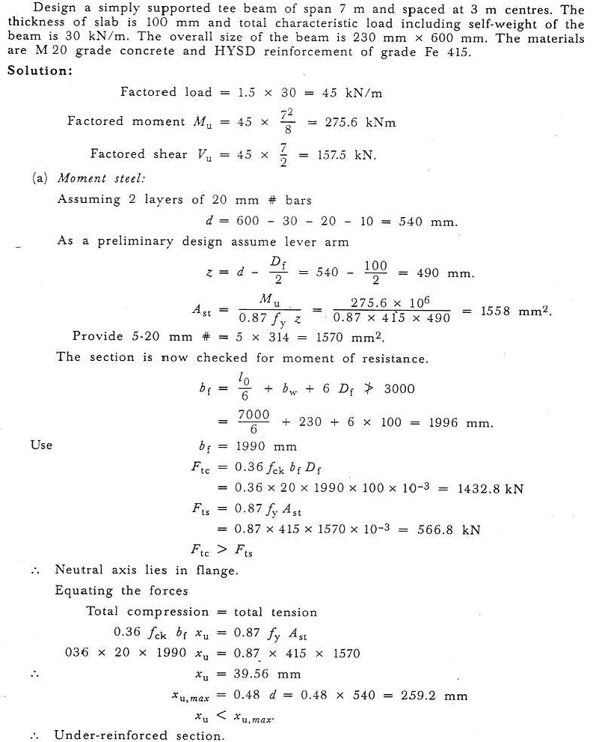

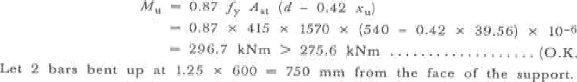
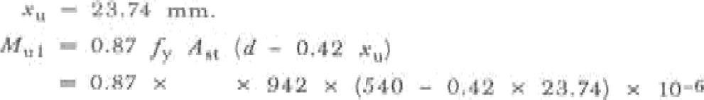

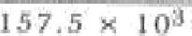

Asshaend arecorif'lned
uneJRR(h6âupport.
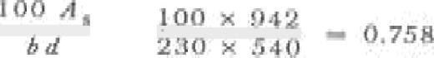

•’• tshear dealqfi\srzeceaxery.
2•2OPbarassn rasi‹teyheurnf
- i‹s.c-o,.ssi•c;9•sio• io-•-s« to@

Brnt b«r»thare 6tl - ‘dI.7kN
Stirrups 9hcresU9t- .1\.7 kif.

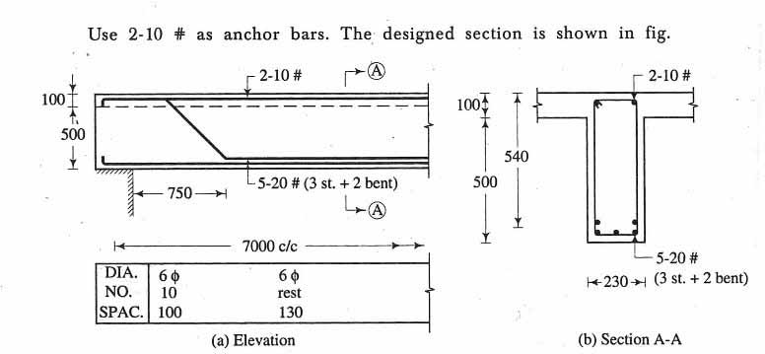

CHAPTERO7
ANALYSISANDDESIGNOFSLABSANDSTAIRCASEBYLIMITSTATEMETHODSLABS
: Onewayslab& twoway slab
: Oneway& cantileverslabsasperIS-456forbending& shear.
: Explaintheactionoftwowayslabswithdefectedshape.
: ProvisionfortwowayslabasperIS-456-2000
: Middlestrip&edgestrip
: B.MCo-Efficient
: Torsionreinforcement
: DesignoftwowayslabasperIS-456-2000&SF-16handhook
: Checkfordeflection,developmentlength&reinforcement.Requirement&spacingasperSp-16&IS-456
Slabs:Slabsareplateelements&carryloadsprimarilybyflexure.TheyusuallycarryVerticalloads Classification of Slab:
      - Onewayspanningslab
      - Two-wayspanningslab
      - Flatslab
      - Gridslab
      - Circularandothershapes
      - Ribbedslab
Onewayspanningslab:Theslabsupportedontwooppositesupportsisaonewayspanningslab.
Ontheotherwayaslabwhichtransferisloadononeofthesetoftwooppositeedgesupportsiscalledone- way slab. In this case ly/lx is greater than two.
TwowayspanningSlab:TheSlabwhichissupported onallfouredgesandifly2lxslabsbendin both
directions.Suchslabsarecalledtwowayspanningslab.
SySs
<2
8.2 Oneway&cantileverslabsasperIS:456forbending&shear. One way spanning slab
- Effective Span = ClearSpan+Effectivedepth or
CentretocentreofSupportwhicheverisless
Moment Steel: ThereinforcementInthedirectofspanisknownasmomentsteel.Themomentsteel is known as main reinforcement.

Distribution Steel: Thereinforcementperpendiculartothemainreinforcement.Isknownasdistribution steel&placedinsecondlayer.Thisreinforcementresiststemp&shrinkagestresses, keeps the main reinforcement in position and distributes the concentrated or non uniform loads throughout the slab.
Foracontinuousslabatsupport,topreinforcementisprovidedasmainsteeltoresistnegativeB.M.

Spacingofslabbar= areaofonebar s1000
2
requiredareainNNperNeter
MainStep
Distributi
l
D
d
DistributionSteel
onStep
MainSteel
(Simplysupportedonewayslab)
MainSteel
l
l
DistributionSteel
l
- Reinforcementrequirement
  - Minimum reinforcement:- The reinforcement in either direction in slabs shall not be less than 0.15% of the total c/s area. For HYSD bars, it shall not be less than 0.12%. thus in slabs, minimumreinforcementlessthan0.85/fyis permissible .
  - Maximum diameter: The diameter of reinforcing bar shall not exceed 1/8ththe total thickness of slab.
  - Minimumdiameter:For mainbars,minimumdiameter shall be10mmforplain bars& 8 mm for deformedbarfordistributionbars,the minimumdiametershall be6mm
ShearStress:

Design shear strength = K vccmaxNominal shear stress 0.5 vcmaxThis shall be checked
Deflection:Itshallbecheckedasperbeam

Cracking:

- The horizontaldistancebetweenparallel mainreinforcement.shallnotbemore than 3 times the effectivedepth of a solid slabor 300mmwhichever is smaller.
- The horizontaldistance betweenparallel reinforcementbarsagainstshrinkage& temperature shallnot be more than 5 times the effectivedepth of a solidslabor450mmwhicheverissmaller.
Cover:Formildexposure,clearover=20mm When ø 12 mm clear cover = 15mm
Ø>12mm,clearcover=20mm Development Length:
0.15L50%
50%,0.15L
Beam
l
(W outBentbars)
(Typicaldetailsofsimplysupportsslab)
Thebarscanbebentuporcurtailedonlyifcontinuingbarsprovideminimumreinforcement.&checkfor development length is satisfied.
ith

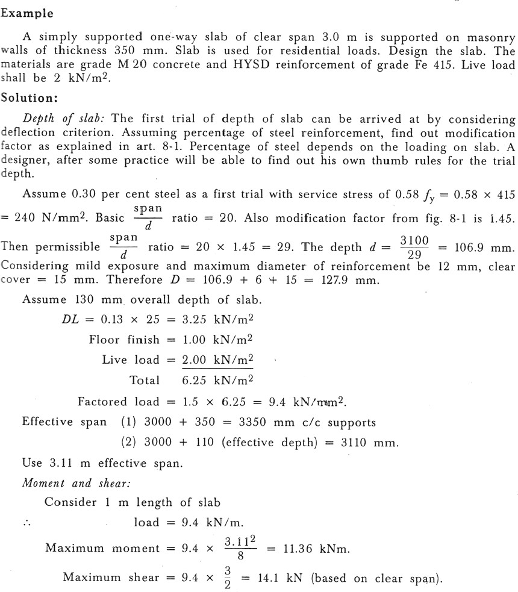

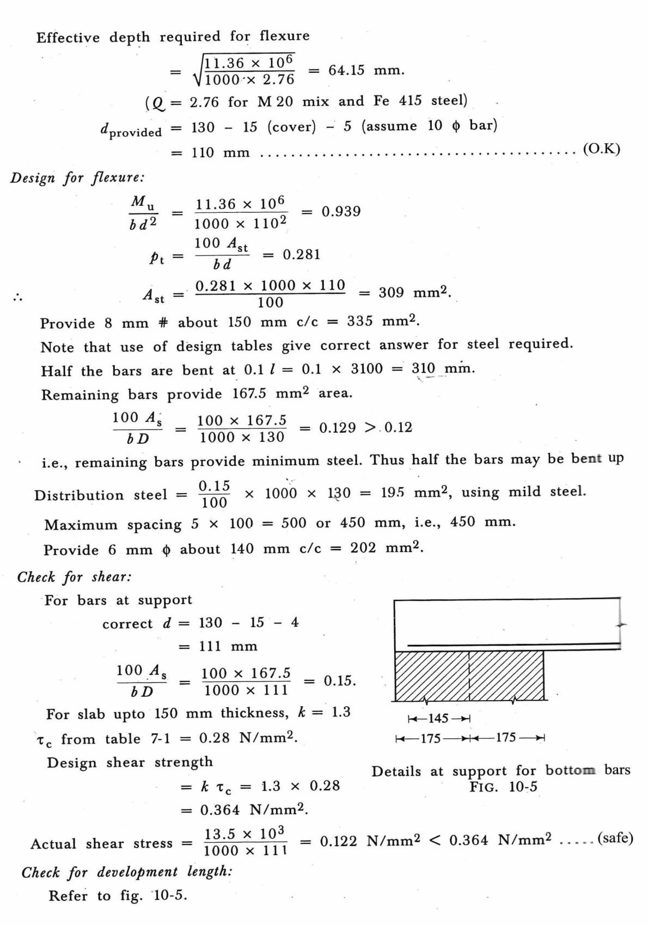Lx

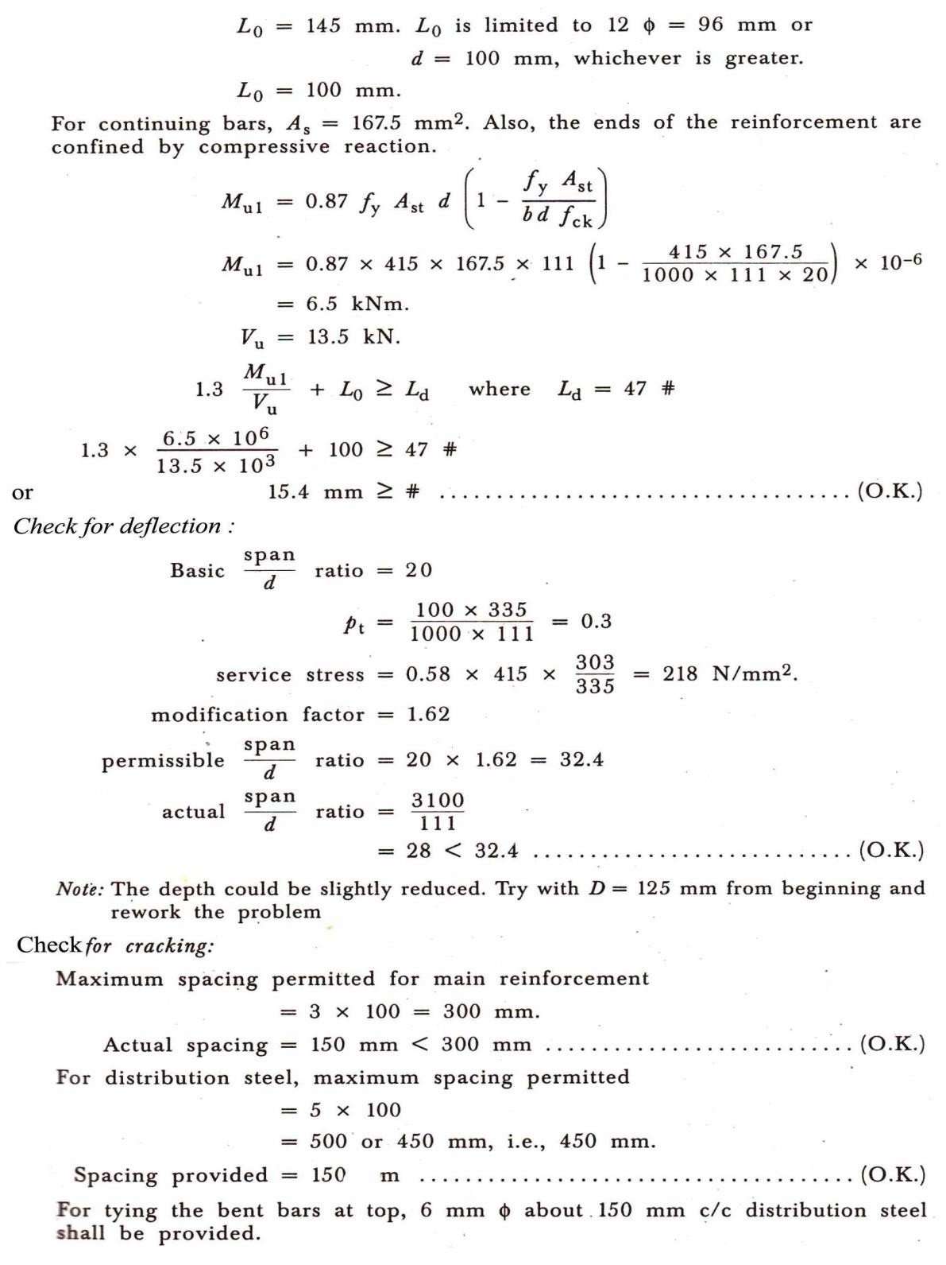

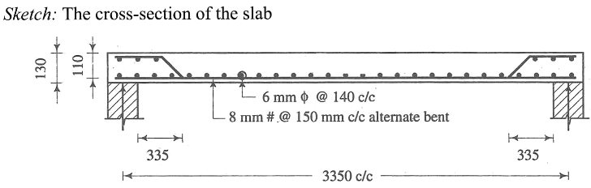

DesigntheslabS2–S1ofabovefigure,ifitistobeusedforresidentialpurposeatthefreeendofslabS1 there is a concrete parapet of75mm thick and1 m high. The materials are M20 grade concrete andHYSD reinforcement of grade Fe 415 . Use IS:875 for live loads.
Solution
Estimationofloads:
ForslabS2liveloadshallbe2kN/m2.Forslabs1whichisabalconyslabliveloadshallbe3kN/m2.Assume 120 mm thick slab.

SlabS2: Selfload=0.12X25 = 3+0kN/m²
Floor finish =1+0kN/m2Live load = 0 + 2 kN/m2Total = 4+ 2kN/m2
Pu =1.5(4+2)
=(6+3)kN/m2
Slab1: Self load =3 +0kN/m²Floorfinish = 1+ 0kN/m2
Liveload =0+ 3kN/m²
Total =4+ 3kN/m2
Pu =1.5(4+3)
=6+4.5kN/m2
Weightof parapet
0.075×25×1=1.875kN/m.
pu=1.5×1.875=2.8kN/m.

Analysis:
Consider1mlong strip.
- To get maximum positive moment in slab s2 only dead load on slab s1 and total load on slab s2 shall be considered.Theparapetloadisadeadloadbutwillnotbeconsideredassometimestheownerofthebuilding or architect may change his mind and would provide simply a railing.
Consideringabovefigure

2
Cantilevermoment=1.2
2

×6 =4.32kNm.

ReactionatA=9×3−^{4.32}=12.06kN
2 3

PointofzeroshearfromA=12.06=1.34m.
9
2
Maximumpositivemoment=12.061.34–1.34×9
2

=16.16–8.08kNm.
TocheckshearanddevlopementlengthatA,shearmaybeconsideredas12.06kN.Notethatforthe cantilever, clear span is considered
- TogetmaximumnegativemomentandmaximumshearatB,theslabisloadedwithfullloads

2
Maximumnegativemoment=1.2
2

×10.5+1.2 ×2.8

=7.56+ 3.36=10.92kNm.
MaximumshearatB, V,BA=9×3+ ^{10.92}=13.5+3.64=17.14kN
u 2 3
Vu,BC=10.15×1.2+2.8=15.4kN.
C)Momentsteel:
Maximummoment=10.92 kN.

drequired
=J10.92×106
1000×2.76
=62.9NN

dprovided=120–15–5(assume10#bar)
=100mm (O.K)

Mubd2
(+)= 8.08×106
1000×100×100

Pt=0.236
=0.81

Ast(+)=0.236×1000×100=2.36NN2
100

Mubd2

(−)= 10.92×106
1000×100×100

Pt=0.324

=1.09

Ast(−)=0.324×1000×100=324NN2
100

For positive moment provide 8 mm # about 170 mm c/c giving 294 mm2alternate bent up and for negative momentprovide8mm#about340mmc/c(bentbarextended)+10mm#340mmc/cgiving378mm2area. The arrangement of reinforcement is shown in the below figure.
Notethatatsimplesupport,thebarsarebentato.1Lwhereasatcontinuityofslabitisbentat0.2L.

Minimumsteel=^{0.12}×1000×120=144NN2.
100

RemainingpositivemomentbarsgiveAs=294=147mm2Thusbarcanbebentup.
2

Distributionsteel=^{0.15}×1000×120=180NN2.
100

Provide 6 mm about150mmc/c=187mm². For negative moment reinforcement
Ld= 47#

Ld = 47×⁽⁸⁺¹⁰⁾= 423mm.
2

The bars must be anchored upto 423 mm. also they should be extended upto 12 # beyond the poin of contraflexure,whichmaybefoundout.Alternativelyasathumbrule,abarshallbegivenananchorageequal to the length of the cantilever. Adopting this, carry the top bars upto 1200 mm in the internal span. This is shown in above figure.

- CheckforDevelopmentlength:

AtA,Mul=0.87fy

Act

(d−fyÆct)
bfck

415×417

=0.87×415×147(100−

= 5.15 kNm. Vu=12.06kN.

1000×20
)×10–6

ConsiderL0=8 #

Then 1.3^{Mul}+L≥L
Vu o d
5.15×106
1.3×12.06×10 3+8#≥47#
AtB,Mul=5.15kNm.
Nearpointofcontraflexure,i.e.0.15LfromB Vu = 17.14 – 0.45 x 9 = 13. 09kN.
1.3x(5.15x106/13.09x103)+8#≥47#
#≤13.11 mm CheckforShear
SpanAB:AtA,Vu,AB=12.06KN
At B,shear at point of contraflexure=13.09 kN Hence Vu=13.09 KN
Shearstress τv=13.09x10³/1000x100=0.131N/mm²
100Æc=100x147/1000x100=0.147
bd
τc=0.28
kxτc=0.28x1.3=0.364N/mm2>τv Span BC
:,Vu,=17.14KN
Shearstressτv=17.14x10³/1000x100=0.171N/mm²
100Æc=100x378/1000x100=0.378
bd
τc=0.28
kx τc=0.421x1.3=0.547N/mm2>τv
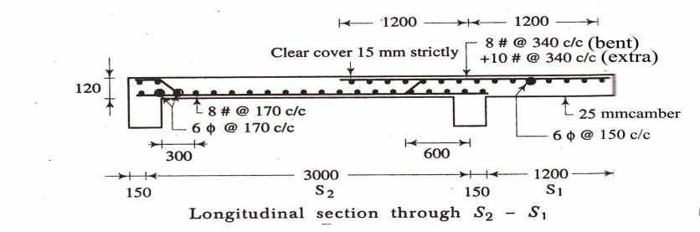

Twoway Slabs:
Thetwowayspanningslab
Occurswhentheslabis supported
Ly
Onallfour edges

WhenSy<2,itiscalledtwowayslab.
Ss

Design

B1
Lx=
y =L
L
B2 B2
B1

rside side
Membrane Support
hort
S
onger

Mx = &x.w.Lx2 Mx,My=Momentsonstripsofunitwidth My = &y.w.ly2 spanning Lx & Ly respectively.
= &x, dy=Co-efficient
=Lx,Ly=Lengthsofshorterspan&Longerspan Respectively
W=Totaldesignloadperunitarea.IS-456alsostatesthatatleast50%ofthetensionreinforcement.Provided at mid span intend to within 0.1 Lx or 0.1 Ly of the support.
1M LoadshearatSupport

BeamA

Loadcarried bybeam‘A’
45º

45º

45º

Forslabsspanningintwodirection,theshorteroftwospansshouldbeusedforcalculatingthespanto effective step ratios. beam“B” Load carried by beam “B”
Fortwowayslabsforspanupto3.5withmildsteelreinforcement.cpan=35forsimplysupportedslabs
d

cpan=40forcontinuousslabforHYSDofgradeFe415,therevaluesaremultipliedby0.8.
d

ProvisontwowayslabasperIS456:2000

MiddleStripandedgestrip

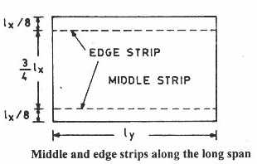
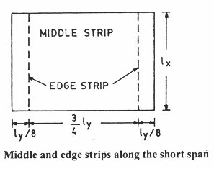

BendingmomentCoefficientswithtorsionreinforcement

Table8.6Maximumbending momentsofProblem8.2For | Shortspan |  |  | Long span
 | ax | M(kNm/m)  x | αy | M(kNm/m)  y
Negativemomentatcontinuous edge | 0.075 | 18.6 | 0.047 | 11.66
Positivemomentatmid-span | 0.056 | 13.89 | 0.035 | 8.68

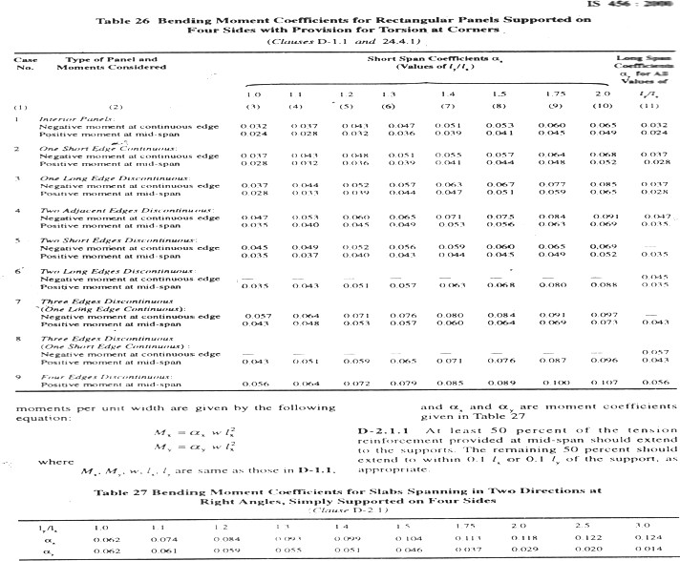

Problem1:
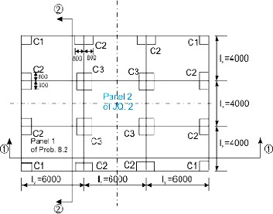

Step1:Selectionofpreliminarydepthofslab
The span to depth ratio with Fe 415 is taken from cl.24.1,Note 2 of IS 456 as 0.8 (35 + 40) / 2 = 30. This givestheminimumeffectivedepthd=4000/30=133.33mm,say135mm.ThetotaldepthD isthus160mm.
Step2:Designloads,bendingmomentsandshearforces
2
Deadloadofslab(1mwidth)=0.16(25)=4.0 kN/m

2
Deadloadoffloorfinish(given)=1.0kN/m
2
Factoreddeadload=1.5(5)=7.5 kN/m
2
Factoredliveload(given)=8.0kN/m
2
Totalfactoredload=15.5kN/m
ThecoefficientsofbendingmomentsandthebendingmomentsMandMperunitwidth(positiveand
x y
negative)aredeterminedaspercl.D-1.1andTable26ofIS456forthecase4,“Twoadjacentedges
discontinuous”andpresentedinTable8.6.Thel/lforthisproblemis6/4=1.5.
y x
Table8.6MaximumbendingmomentsofProblem8.2

For | Shortspan |  |  | Long span
 | xα | M(kNm/m)  x | yα | M(kNm/m)  y
Negativemomentat continuous edge | 0.075 | 18.6 | 0.047 | 11.66
Positivemomentatmid- span | 0.056 | 13.89 | 0.035 | 8.68
MaximumshearforceineitherdirectionisdeterminedfromEq.8.1(Fig.8.19.1)as
V=w(l/2)=15.5(4/2)=31kN/m
u x
Step3:Determination/checkingoftheeffectivedepthandtotaldepthofslab
Usingthehighervalueofthemaximumbendingmomentsin xandydirectionsfromTable8.6,wegetfrom Eq.3.25 of Lesson 5 (sec. 3.5.5):
2
M =Q bd
u,lim lim
6 3 1/2
ord=[(18.6)(10)/{2.76(10)}] =82.09mm,
2

where2.76N/mmisthevalueofQ
retaind=135mmandD=160mm.

,lim
Since,thiseffectivedepthislessthan135mmassumedinStep1, we

Step4:Depthofslabforshearforce
2
Table19ofIS456givesthevalueof τc=0.28 N/mmwhenthelowestpercentageofsteel isprovidedinthe slab.However,thisvalueneedstobemodifiedbymultiplyingwithkofcl.40.2.1.1ofIS456.Thevalueofk
2
forthetotaldepthofslabas160mmis1.28.So,thevalueofτcis1.28(0.28)=0.3584N/mm.
2 2
Table20ofIS456givesτcmax=2.8N/mm.Thecomputedshearstressτv=V/bd=31/135=0.229N/mm.
u

Since,τv<τc<τcmax,theeffectivedepthoftheslabas135mmandthetotaldepthas160mmare safe.
Step5:Determinationofareasofsteel
The respective areas of steel in middle and edge strips are to be determined. It has been shown that the areas of steel computed from Eq.3.23 and those obtained from the tables of SP-16 are in good agreement. Accordingly, the areas of steel forthisproblem are computed from the respective Tables 40 and 41of SP-16 and presentedinTable 8.7. Table 40 of SP-16isfor theeffective depthof 150mm,whileTable41of SP-16isfor the effectivedepthof 175mm.Thefollowingresultsare,therefore,interpolatedvalues obtainedfrom thetwo tables of SP-16.
Table8.7ReinforcingbarsofProblem8.2
Particulars | Shortspan l  x |  |  |  |  | Longspanl  y
 | TableNo. | M  x  (kNm/m) | Dia. &spacing | TableNo. | M  y  (kNm/ m) | Dia.&spacing
Topsteelfor negative | 40,41 | 18.68 | 10mm@ | 40,41 | 12.314 | 8mm@ 200
moment |  | >18.6 | 200mmc/c |  | >11.66 | mm c/c
Bottomsteelforpositive | 40,41 | 14.388 | 8mm@ | 40,41 | 9.20 | 8mm@ 250
moment |  | >13.89 | 170mmc/c |  | >8.68 | mm c/c
Theminimumsteelisdeterminedfromthestipulationofcl.26.5.2.1ofIS456andis
2 2

A=(0.12/100)(1000)(160)=192mm
s
and8mmbars@250mmc/c(=201mm)isacceptable.Itisworth

mentioningthattheareasofsteelasshowninTable8.7aremorethantheminimumamountofsteel.
Step6:Selectionofdiametersandspacingofreinforcingbars
TheadvantagesofusingthetablesofSP-16arethattheobtainedvaluessatisfytherequirementsofdiameters of bars and spacing.However,they are checked as readyreference here.Needless tomentionthat this steel may be omitted in such a situation.
Maximum diameter allowed, as given in cl. 26.5.2.2 of IS 456, is 160/8 = 20 mm, which is more that the diameters used here.
Themaximum spacing of main bars, as given in cl. 26.3.3(1) ofIS456, is the lesser of 3(135) and 300 mm.This is also satisfied for all the bars.
Step7:Determinationoftorsionalreinforcement
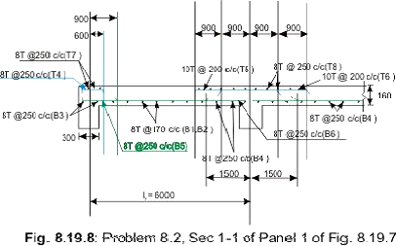

Torsional reinforcing bars are determined for the three different types of corners as explained in sec. 8.19.6 (Fig.8.19.4). The length of torsional strip is 4000/5 = 800 mm and the bars are to be provided in fourlayers. Each layer will have 0.75 times the steel used for the maximum positive moment. The C1 type of corners will have the full amount of torsional steel while C2type of corners will have half of the amount provided inC1type. The C3 type of corners do not need any torsional steel. The results are presented in Table 8.8 and Figs.8.19.10 a, b and c.
Table8.8TorsionalreinforcementbarsofProblem8.2

Type | Dimensionsalong |  | Bardiameter&spacing | No.of bars along | Cl.no.ofIS 456
 | x (mm) | y (mm) |  |  | x | y
C1 | 800 | 800 | 8mm@  200mmc/c | 5 | 5 | D-1.8
C2 | 800 | 1600 | 8mm@  250mmc/c | 5 | 8 | D-1.9
C2 | 1600 | 800 | 8mm@  250mmc/c | 8 | 5 | D-1.9
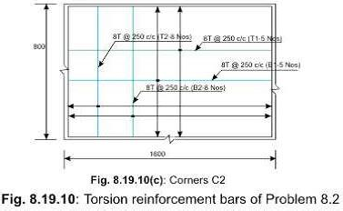

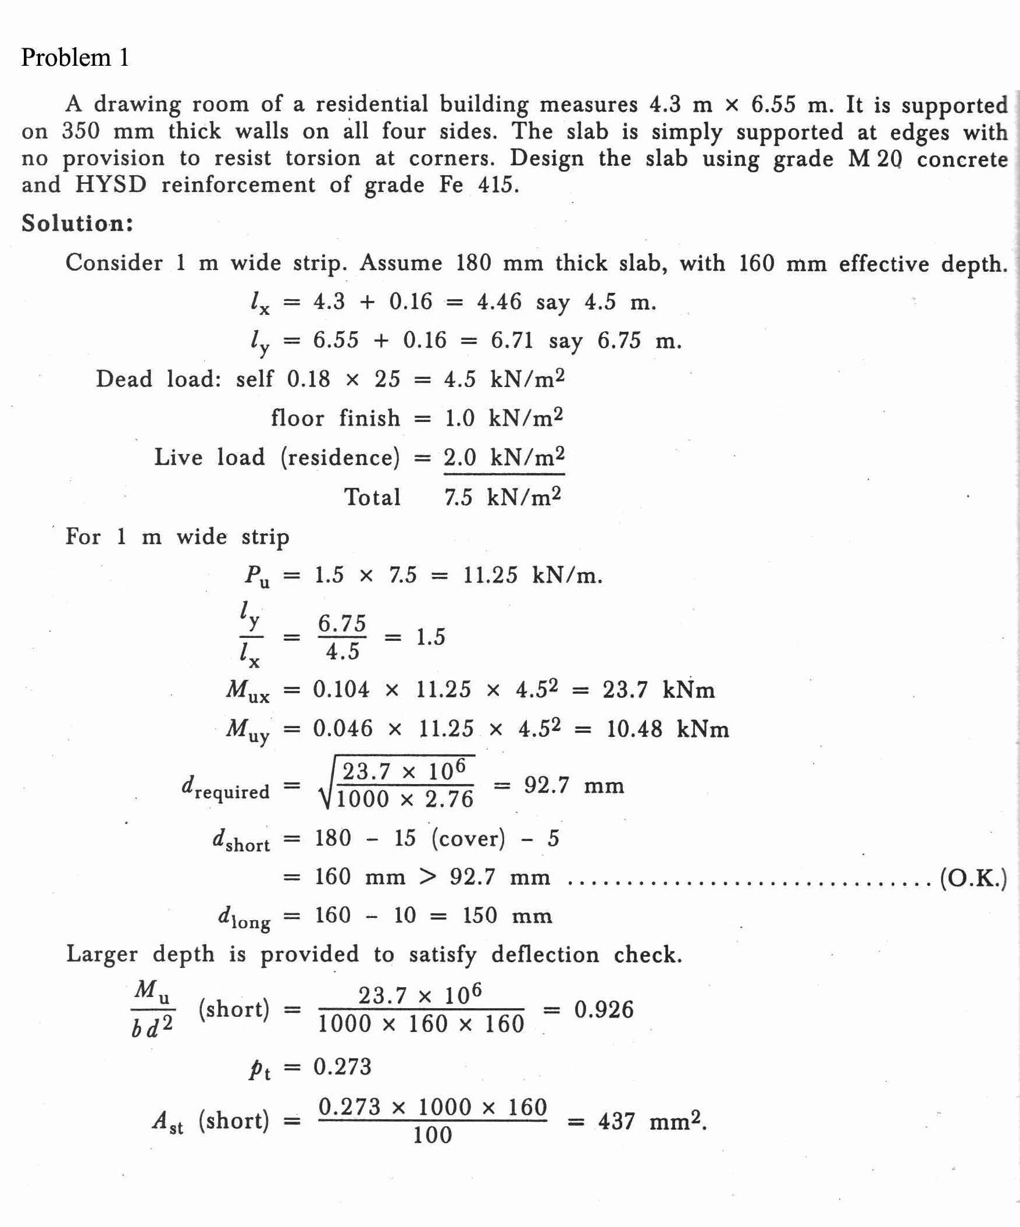
ProblemNo2

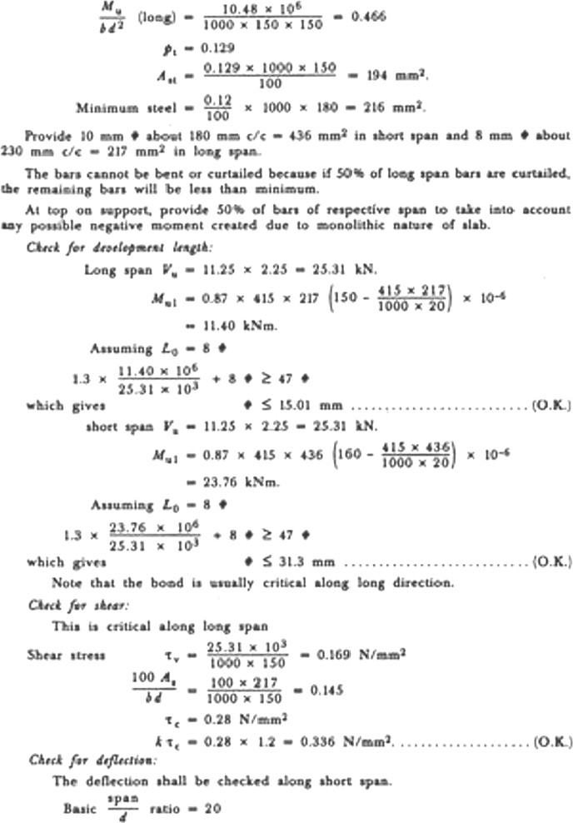

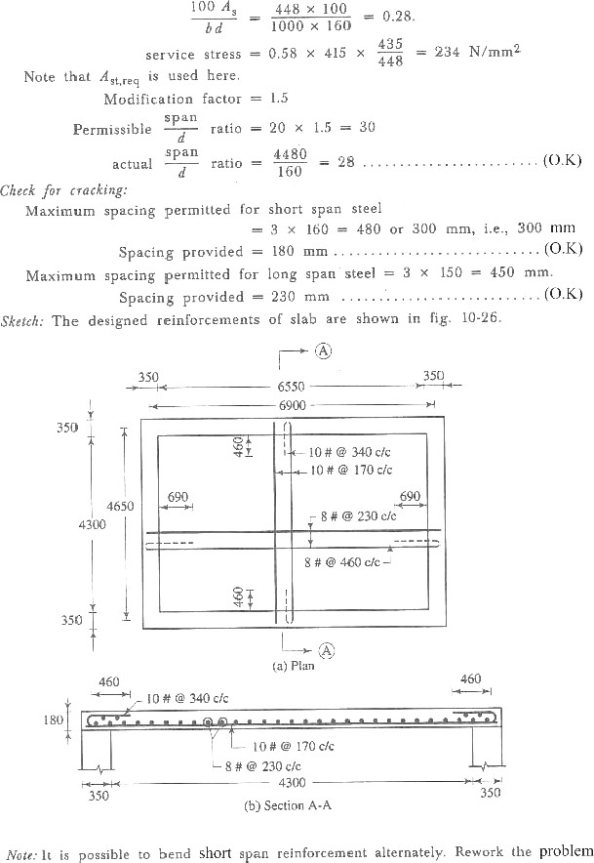

CHAPTER–8

DESIGNOFAXIALLYLOADEDCOLUMNSAND FOOTINGS

Introduction–

A column may be defined as an element used primarily to support axial compressive loads and with a height of at least three times its least lateral dimension. All columns are subjected to some moment which maybe due to accidental eccentricity or due to end restraint imposed by monolithically placed beams or slabs. The strengthofacolumndependsonthestrengthofthematerials,shapeandsizeofthecross-section,lengthand the degree of the positional and directional restraint at its end.

A column may be classified as short or long column depending on its effectiveslenderness ratio.Theratio of effective column length to least lateral dimension is referred to as effective slenderness ratio. A short column has a maximum slenderness ratio of 12. Its design is based on the strength of the materials and theapplied loads. A long column has a slenderness ratio greater than 12. Its design is based on the strength of the materials and the applied loads. A long column has a slenderness ratio greater than 12. However , maximum slenderness ratio of a column should not exceed 0. A long column is designed to resist the applied loads plus additional bending moments induced due to its tendency to buckle.
ASSUMPTIONS-
Thefollowingassumptionsaremadeforthelimitstateofcollapseincompression.
- Planesectionsnormaltotheaxisremainplaneafterbending.
- Therelationshipbetweenstress-straindistributioninconcreteisassumedtobeparabolic.The maximum compressive stress is equal to 0.67 ðck/ 1.5 or0.446ðck.
- Thetensilestrengthofconcreteisignored.
- Thestressesinreinforcementarederivedfromtherepresentativestress-straincurveforthetypeof steel used.
- Themaximumcompressivestraininconcreteinaxialcompressionistakenas0.002.
- Themaximumcompressionstrainatthehighlycompressedextremefibreinconcretesubjectedto axialcompressionandbending,butwhenthereisnotensiononthesection,istakenas0.0035minus
0.75timesthestrainattheleastcompressedextremefibre.
- The maximum compressive strain at the highly compressed extreme fibreinconcretesubjectedto axial compression and bending, when part of the section is in tension, is taken as0.0035.inthe limiting case when the neutral axis lies along one edge of the section, the strain variesfrom 0.0035 atthe highly compressed edge to zero at the opposite edge.

Thetypesoffailurestothecolumns–
Columns,whencentrallyloaded,failsinoneofthethreefollowingmodes,dependingontheslendernessratio. Fig.
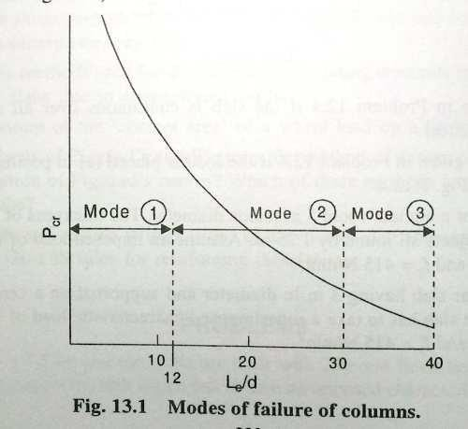

Mode:1Purecompressionfailure
The columns fails under axial loads without undergoing any lateral deformation. Steel and concrete reach the yield stress values at failure. The collapse is due to material failure.
Mode:2Combinedcompressionandbendingfailure
Short columns can be subjected to direct load (P) and moment (M). slender columns evenwhenloaded axially undergo deflection along their length as beam columns, and these deflection produce additional moments in the columns. When material failure is reached under the combined action of these direct loads and bending moment. It is called combined compression and bendingfailure.
Mode:3Failurebyelastic instability
Very long columns can become unstable even under small loads well beforethematerialreachesyield stresses. Under such cases the member fails by lateral ‘ elastic bulking’ .
failure by third mode is unacceptable in practical construction. R.C.C members thatmay failby this type of failure is prevented by the codal provision that columns beyond a specified slenderness should not be allowed in structure.
Bracedandunbracedcolumns:
The columns in a building are classified as braced orunbraced according to the method applied to providethe lateral stability of the building.
- Bracedcolumn : In braced frames, the lateral loads like wind , earthquake etc. are resisted by some special arrangements like shear walls , bracings or special supports.Inother words, the sidesway or joint translation is not possible in such columns. Sidesway or jointtranslation means that one or boththe ends of a column can move laterally with respect to each other. The columns occurring in braced buildings are called braced columns.

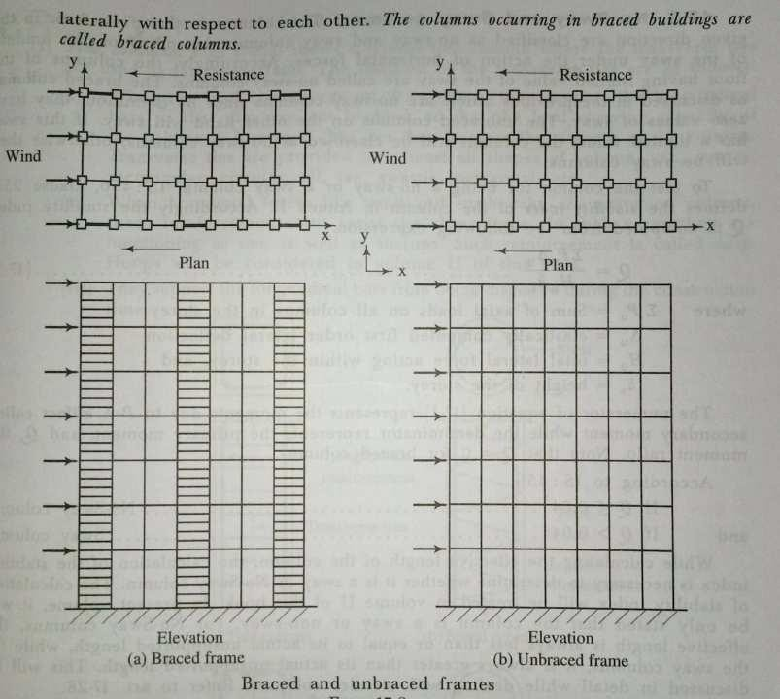

- Unbraced columns :A unbraced frames no specialbracingsystemsareprovidedtoresist horizontal forces. In other words the sidesway or joint translation do occur in such columns. Thecolumns shall have to be designed to resist the lateral loads. The column those occur in the buildings where the resistance to lateral loads is provided by the bending in the columns and beams in that plane are called unbraced columns.
Effectivelengthofcolumns:
The unsupported length or heightof a column (Lo) is generally taken as the clear heightofthe columns. It is defined in IS 456, clause 25.1.3 for various cases of constructions. The effective length of column is different from unsupported length. Effective length (L_{e}) is dependent on the bracing and end conditions. It should be noted that for braced columns the effective column height is less than the clearheight between restraints , whereas for unbraced and partially braced columns theeffectiveheightis greater than the clear height.
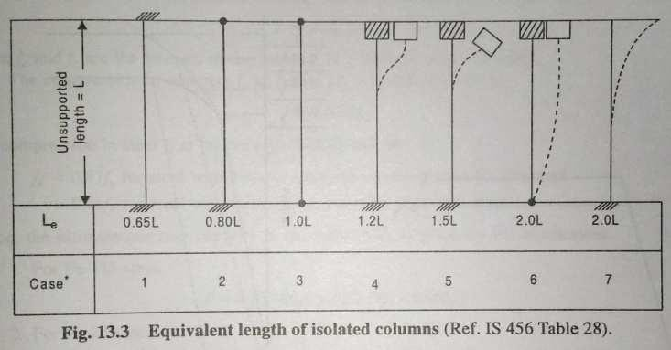

DesignformulaforShortcolumn–
A rectangular column section bearing pure axial load.The design stress in mild steel at strain of 0.002is 0.87 ƒ_{y},however for , HYSD bars it is not so. The stressescorresponding to 0.002 strain in HYSD barsare as follows.

F_{e}415 0.79ƒ_{y}
F_{e}500 0.75ƒ_{y}
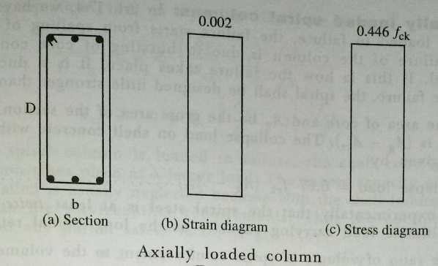
Thecodeadoptsthecriticalvalueof0.75ƒyforallgradesofsteelforfindingoutthepureaxialloadcarrying capacity of the column. Accordingly
P_{uz}=0.446 f_{ck}A_{c}+0.75f_{y}A_{cc}
Thisisapproximatedas
P_{uz}=0.446 f_{ck}A_{c}+0.75f_{y}A_{cc}
Puz=Pureultimateaxialloadcarryingcapacityofcolumn. f_{ck}= Characteristic compressive strength of concrete. f_{y} = Characteristic strength of reinforcement.
Ac=Areaofconcreteincolumn section.
A_{cc}=Areaofreinforcementincolumnsection.
Axiallyloadedpracticalcolumnsaresubjectedtomomentsduetominimumeccentricity.thusallthecolumns
,evenifthedesignloadisaxial,shallbedesignedformoments also.
Thecodesimplifiestheworkforthecolumnsinwhichminimumeccentricitye_{Nin}≤0.05D.Thus,whene_{Nin}
≤0.05D,theaboveequationismidifiedas
Pu=0.4fckAc+0.67fyAcc………
Itcanbeseenthat,theloadcarryingcapacityofthecolumnisreducedbyabout10percentwhene_{Nin}≤0.05
D. however ife_{Nin}≤ 0.05 D , the column shall be designed for moment also. Theaboveequationcanwrittenas–

Pu=0.4fck
(Ag
-PÆg100
+0.67fy
PÆg100

Where Ag=Grossareaofcrosssection

P =Percentageof reinforcement.
DividingbothsidesbyAg
PÆg P
Pu=0.4ƒ (1- )+0.67f
Æg ck 100 y100

=0.4fck P
100
(0.67fy–0.4fck)….

Thecompressioninsteelfcatfailure(€c=0.002)willbe
f_{c}=0.87f_{y}forsteelwithbilinearstress-straincurveasinFe250steel.
=0.75fyforsteelwithstress-straincurveasin Fe415steel.
Hence,theultimatecarryingcapacityofthecolumne_{u}isgivenbytheexpression
- ForFe415steel,P=Ac(0.45fck)+Ac(0.75fy-0.45fck)
- ForFe250steel,P=A_{c}(0.45f_{ck})+A_{c}(0.87f_{y}-0.45f_{ck})
However it is never possible to apply the load centrally on a column. Accidental eccentricities are bound to happen. Indian and British codes allow an accidental eccentricity of 5 percent of the lateral dimension of the columnintheplaneof bending( 0.05 D) inthestrengthformulaitself.Forthispurpose theultimateloade_{u}for Fe 415 steel reduces to
Pu=0.9(0.45fckAc+0.75fyAc)
P_{w}=0.4f_{ck}A_{c}+0.67f_{y}A_{c}asgiveninIS456,clause38.3 WithFe250steelthecorrespondingexpressionwillbe
P_{u}=0.4f_{ck}A_{c}+0.75f_{y}A_{c})
Itshouldbeclearlynotedthesesformulaalreadytakeintoaccountamaximumaccidentaleccentricityof(0.05 D) or ( 0. 05b) in theses columns.
CheckforMinimumEccentricity
Minimumeccentricitiesarecausedbyimperfectionsinconstruction,inaccuracyinloadingetc.TheBScode 8110 (1985) Cluase 3.8.2.4 assumes that its value will be equal to 0.05 D, but not more than 20mm.

IS456,Cluase25.4givesanexpressionforthepossibleminimumeccentricityaseNin
=L0
500
+ ^{D}butnot
30

lessthan 20mm.
Where L0=theunsupportedlength
D =lateraldimensionsintheplaneofbending.
Forsectionsotherthanrectangular,theExplanatoryhandbookSP24recommendsavalueofL_{e}/300,where
Leistheeffectivelengthofthe column.
Thusforexample,foracolumn600x450ofunsupportedheight3m,consideringthelongdirection according to IS formula,

eNin
=L0
500
+D=3000/500+600/30=26mm.
30

As26mmisgreater thantheminimumspecified20mm,usee_{Nin}
=26mm.then^{e}Nin
D
=26/600=0.043

Consideringtheshortdirection,wehave
e_{Nin}=3000/500+450/30=21mm > 20mm.

Hencee
b
=21/450=0.047.

Boththesevalues arelessthanthespecifiedratioof0.05,andhencethesimplecolumnformulaisapplicable to the above column. If the eccentricities are more, then the column has to bedesigned as subjected to directload P and moment Pe.
MinimumLongitudinalandTransversereinforcement–
Thereinforcementrequirementsaresetoutinclause26.5.3ofIS456.
- LongitudinalReinforcement:
  - The cross sectional area of longitudinal reinforcement shall be not less than 0.8 percent of grosscross sectional area of the column.
The minimum area of the reinforcement is specified to avoid the sudden non-ductile failure of the column, to resist creep and shrinkage and to provide some bending strength to the column.
  - In any column that has a larger cross sectional area than that required to support the load, the minimum percentage of steel should be based upon the area of concrete required to resist the direct stress and not upon the actual area.
Because of the architectural or the other reasons, sometimes the columnsaremadelargerin section than that required to resist the load. In such a case , according to this criteria , the minimum percentage of steel is based on concrete area required to resist the direct load. A concrete pedestal used to transfer the load from steel stanchion to the foundation in an industrial building is a typical example for this case. In this case , the size of the pedestal is governed by the size of the base plate under the steel column.
  - The cross sectional area of longitudinal reinforcement shall be not more than 6 percent of the gross cross sectional area of the column.
The use of 6percent reinforcement may involve practical difficulties in placing and compacting of concrete, hence lower percentage is recommended where bars from the columns below have to be lapped with those in the column under consideration, the percentage of steel usually should not exceed 4 percent.for the column with more than 4 percent steel, the laps may be staggered.
  - The minimum number of longitudinal bars provided in a column shall be four in rectangularcolumns and six in circular columns.
  - Thebarshallnotbelessthan12mmindiameter.
  - A reinforced concrete column having helical reinforcement shall have at least six bars oflongitudinal reinforcement within the helical reinforcement.

  - In a helical reinforced column , the longitudinal bars shall be in contact with the helical reinforcement and equidistant around its inner circumference.
  - Spacingoflongitudinalbarsmeasuredalongtheperipheryofthecolumnshallnotexceed300
mm.thisisacrackingrequirement.
  - In case of the pedestals in which the longitudinal reinforcement is not takenintoaccountin strength calculation, nominal reinforcement not less than 0.15 percent of the cross sectional areashall be provided.
- TransverseReinforcement:
  - General : a reinforcement concrete compression member shall have transverse or helical reinforcement so disposed that every longitudinal bar nearest to thecompression face has effective lateral support against bulking subject to provisions in (b). The effectivelateralsupport is given by transverse reinforcement either in the form of circular rings capable oftaking up circumferential tension or by polygonal links (lateral ties) with internal angles not exceeding 135 degree. The ends of the transverse reinforcement shall be properly anchored.
  - Arrangementoftransversereinforcement:
    - If the longitudinal bars are not spaced more than 75mm on either side, transverse reinforcement need only to go round the corner and alternate bars for the purpose of providing effective lateral supports.
    - Ifthelongitudinalbarsspacedatadistanceofnotexceeding48timesthediameterofthe tie are effectively tied in two directions,additional longitudinal bars inbetweentheses bars need to be tied in one direction by open ties.
    - Where the longitudinal reinforcing bars in a compression member are placed in more than one row, effective lateral support to the longitudinal bars in the inner rowsmaybeassumed to have been provided if-
      - Transversereinforcementisprovidedforoutermostrowinaccordancewith(b)and
      - No bar of the inner row is closer to the nearest compression face than three times the diameter of the largest bar in the inner row.
    - Wherethe longitudinal barsinacompression memberaregrouped and each group adequetly tied transverse reinforcement in accordance with the above requirements, the transverse reinforcement for the compression member as a whole may be provided on the assumption that each group is a single longitudinal barforpurpose of determining thepitch and diameter of the transverse reinforcement in accordance with above requirements. The diameter of such transverse reinforcement need not, however exceed20mm.
  - Pitchanddiameteroflateraltie:

    - Pitch : the pitch of transverse reinforcement shall be not more than the least of the following distances:
      - Theleastlateraldimensionofthecompressionmember.
      - Sixteentimesthesmallestdiameterofthelongitudinalreinforcementbartobetied.
      - 300mm.
    - Diameter : the diameter of the polygonal links or ties shall be not less than one fourth of the diameter of the largest longitudinal bar and in no case less than 6mm.
  - Helicalreinforcement:
    - Pitch : Helical reinforcement shall be of regular formation with the turns ofthehelix spaced evenly and its ends shall be anchored properly by providing one and a half extraturns of the spiral bar. Where an increase load on the column on the strength of the helical reinforcement is allowed for, the pitch of helical turns shall be not more than 75 mm, nor more than one-sixth of the core diameter of the column, nor less than 25mm, nor less than there times the diameter of the steel bar forming thehelix.
    - Fiameter:thediameterofthehelicalreinforcementshallbeasperlateralties.
  - Cover : the longitudinal reinforcing bar in a column shall have concrete cover, not less than 40mm, nor les than the diameter of such bar. This requirements gives a fire protection of 0.5 hto 4h (h = hour) and is suitable for moderate exposure assuming a maximum of10mm diameter tie. However the cover to the ties may be governed by exposure conditions.Inthecase of columns the minimum dimensions of 200 mm or under, whose reinforcing bars do not exceed 12mm, a cover of 25mm may be used.
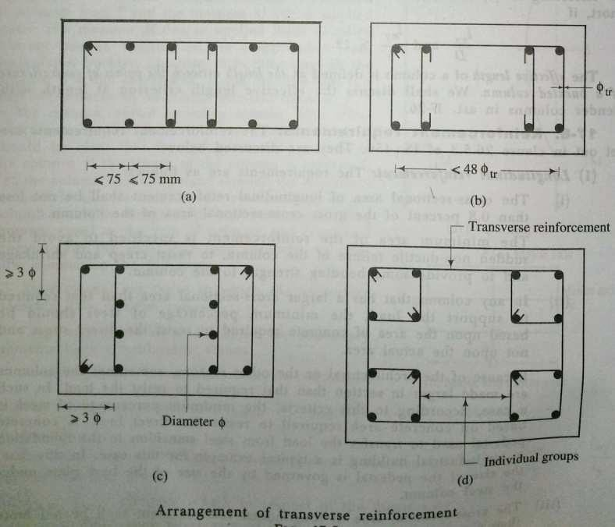

DesignofshortcolumnbyIS456andSP16 –
Charts24to26oftheISpublicationdesignaidsSP16canbeusedforroutineofficedesignofshort columns. These charts are made from the column formula
P_{u}=0.4f_{ck}A_{c}+0.67f_{y}A_{cc} A_{g}= area of cross section
P=eercentageofsteel=100Æc
Æg
Tℎe area of steel and concrete are given by A = P Æg
c 100
Ac=Ag-Ac=Ag(1 -P)
100
Rewrittingtℎeequationwitℎabovequantities,weobtain
Pu=0.4f (1-P)+0.67f ^{P}

Æg ck
P=[0.4f ^{P}
100
(0.67f
y
-0.4f

100
]A

u ck 100 y ck g

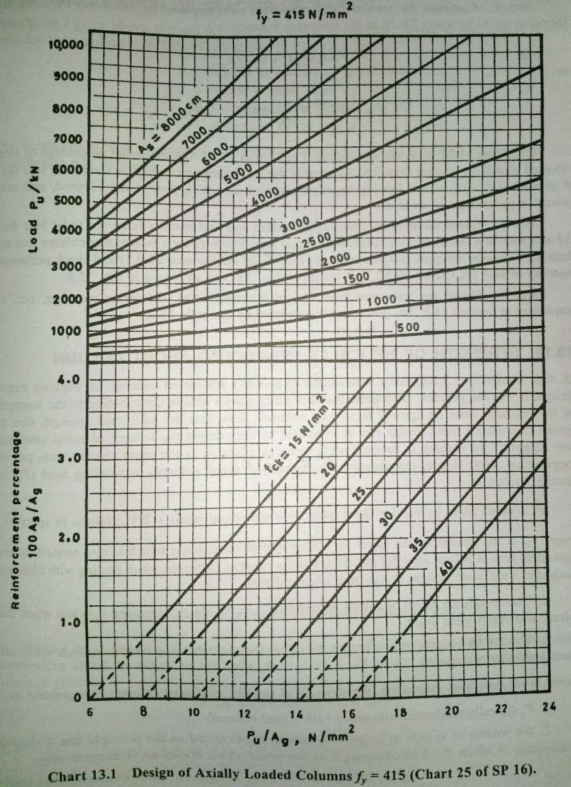

Chart 24 to 26 of SP 16 have been prepared from these formula forFe 250 , Fe415 and Fe 500 andƒ_{ck}= 15, 20, 30, 35, and 40.
To use design chart , choose the value of the factored design load Pu, and proceed horizontally till the Agcorresponding to the size of the column selected is reached. The value of percentage of steel required for the adopted value of f_{ck}is read off from the lower half of chart 13.1.
Procedurefordesignofcentrallyloadedshortcolumn:
The step-by-step procedure for design of a centrally loaded column can be arranged as follows: Step 1 : compute the factored load on the column.
Step 2 : Choose a suitable size for thecolumn,depending on the size of the beamthat has to be placed on it and the architectuerral requirements. Usually the beams are accommodated inside the column. Check also the minimum eccentricity.

Step3:Determinetheeffectivelengthlengthandslendernessofthecolumnabouttheprincipalaxes.Ifitis less than 12, it can be can be considered as a short column. If it is 12 or more, it is to be designed as a long column.
Step 4 : compute the area of the longitudinal steel requiredby either(a) by using theformula or (b)by using SP 16 in the following manner.

P_{u}=0.4f_{ck}A_{c}+0.67f_{y}A_{cc}

or P=[ 0.4f ^{P}100
(0.67f_{y}-0.4f_{ck}]A_{g}

The minimum percentage of steel adopted should be greater than 0.8. As regards the maximum percentage , it should be less than 4 in normal designs where lapping becomes essentials. Where lapping is not adopted, onemay accept a percentage of up to 6.
u ck
Step 5: Detain the steel by choosing a suitable size and number (size not to be less than 12mm and for a symmetrical arrangement with at least four bars for a rectangular column and six bars for a circular ciolumn). Adopt a suitable cover to teh steel ( clause 26.4.1) and check perimeter spacing of bars(IS clause 26.5.3.1) isnot more than 300mm.
Step6:Detailthetransversesteel.Adoptasuitablesize,determinespacings,etc.
Strengthofhelicallyreinforcedshortcolumn:
IS 456, clause 26.5.3.2(d) deals with design of helically reinforced column. In working stress design, it was practice to consider the strength of spirals also in contributing to the strength of the column. Tests on spirally reinforced reinforced columns show that the additional strength due to spirals in working stress design can be estimated by considering the volume of spiral steel per unit height of the column is approximately twice as effective as the same volume were put as longitudinal steel.Hence the equation forstrength of spiral columnsin working load (Pc) is usually written as
Pc=(Loadtakenbycore)+(loadtakenbylongitudinalsteel)+2(Vch)(stressin spiral)
Where Vchis the volume of the spiral per unit length of the column which is also termed as the equivalent areaofhelical steel perunitheightofthecolumn.However when dealing withultimateloadsandlimitstatedesign, it has been observed that
- Thecontainingeffectofspiralsisusefulonlyintheelasticstageanditislostwhenthespiralsalso reach yield point.
- Thespiralsbecomefullyeffectiveonlyaftertheconcretecoveroverthespiralsspallsoffafter excessive deformation.
Henceinultimateloadestimation,thestrengthofspirallyreinforcedcolumnsisexpressedby
- Pu(spirallyreinforcedcolumn)=1.05Pu(tiedcolumn)
- Thevolumeofspiralstobeprovidedwhichiscalculatedontheprinciplethatitshouldbeadequateto offset the loss of strength of the cover which cracks up at ultimatestage.

Calculationofspacingofspirals:
S=Pitchorspacingofspiralsused. a = area of spiral steel .
D=diameterofthecolumn.
Dk=diameterofthecore.
Theconditionisthatthelossofstrengthduetospallingofcovershouldbeequaltothecontributiondueto spirals.
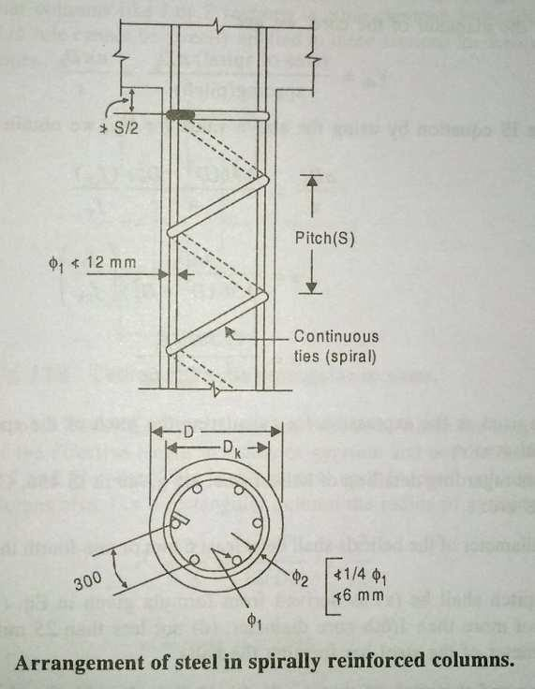
TakingA_{k}astheareaofthecoreandA_{g}astheareaofcrosssectionandusingthesameassumptionaboutthe action of the spiral as is used in the elastic design, the relationship at failure is given by
2V_{ch}(0.87ƒ_{y})=0.63ƒ_{ck}(A_{g}- A_{k})
V_{ch}=0.36 (A_{g}-A_{k})(ƒck)
ƒy
WhichcanbereducedtotheformgiveninIS456,clause38.4.1as
Vch=0.36( Æg -1) (ƒck)
Æk Æk ƒy
WhereAg=grossareaof section
A_{k}=areaofcore.
Thisexpressiongivestheratioofthevolumeofthehelicalreinforcementrequiredforthevolumeofthecore per unit height of the column.
Simplifyingthisexpressionfurther,onecanwrite
V_{ch}=(Volumeofthespiralinonering)x(No.Ofringsperunitlength) Taking D_{k}as the diameter of the core , we get

Vch
=(areaofcpriaS)nDkSpacing(pitch)
=anDkc

RewritingtheISequationbyusingtheabovevalueforVch,weget
aDk 0.36(D2–D2) fck
= k
c 4 fy

S = 4aDk)
0.36(D2–D2)
k
S= 11.1aDkfy)
fck(D2–D2)
k
fyfck

. (1)

Whichcanbeusedastheexpressionforcalculatingthepitchofthespiralsforagivensteelofcrosssection area a.
TherulesregardingdetailingofhelicalsteelaregivenIS456,clause26.5.3.2.themainconsiderationsare:
- Thediameterofthehelicalsshallbeatleast6mmoronefourththediameteroflongitudinalsteel.
- The pitch shall be (a) as derived from formula equation (1) (b) not more than 75mm, (c) not more than 1/6thcore diameter , (d) not less than 25mm, (e) not less than three times the diameter of the steel bar forming the helix.
Ifthediameterandthepitchofthespiralsdonotcomplywiththeaboverules,thestrengthistobe taken as only that of a tied column of similar dimension.
Problem 1:
Acolumnof400x400mmhasanunsupportedlengthof7mandeffectivelengthof4.5m.Canitbedesigned as a short column under axial compression , if the load placed centrally onit?
Solution:
Step1:Slendernessratioconsideration
Le=4500/400=11.25 (IS456Cl.25.1.2)
D
Ascolumnswithslendernesslessthan12canbeconsideredasshort,thecolumnisshort. Step 2: Eccentricity considerations
500 30

eNin
=L0+Dnot lessthan20mm. (IS456Cl.25.4)
=7000/500+ 400/30
= 14+ 13.3
mmisgreaterthan 20mm. Adopt27.3mm

TheeccentricityforwhichshortcolumnformulaisapplicableidD/20 D/20 = 400/20 = 20mm ( IS 456 Cl.39.3)
eNin>D/20
HenceforNulaforaxialloadisnotaeelicable.
Column should be designed as subject to axial load and moment due to e_{Nin}. (M = P eNin)

Problem–2
Designanaxiallyloadedtiedcolumn400x400mmpinnedatbothendswithanunsupportedlengthof 3m for carrying a factored load of 2300 KN. Use grade 20 concrete and Fe 415 steel.
Solution:
Step1:Factoredloadoncolumn
Pu= 2300KN
Stee2:Sizeofcolumnand checke_{Nin} (IS456Cl.25.4)
SizeofcoluNn=400x400,D/20=20mm

eNin
=^{L0}+^{D}=3000/500+400/30=19.33<20mm

e_{Nin}lessthanD/20isassumedintheformula.Henceshortcolumnformulaforaxial loadcanbeused.
500 30
Stee3:Calculationofslenderness (IS456Cl.25.1.2)
Le=1.0L= 3000mm
Le=3000/400=7.5 <12
b
Stee4:Findareaofsteelandcheckpercentage
    - By formula,P_{u}=0.4 f_{ck}A_{c}+0.67 f_{y}A_{cc} (IS456Cl.39.3) 2300 x 10³ = 0.4 x 20 x ( 400² - Ac) + 0.67 x 415 x Ac
A_{c}=3777mm²,P=3777/400²x100=2.36%
TℎisisNoretℎan0.8%andlesstℎan6%.ℎenceo.k
    - BySP16,Ag=1600cm²,P= 2300KN.P=2.4% (SP16chart25)
A_{c}=(2.4x400x400)/100=3840mm² (Use8T-25/3927mm²)
Stee 5 ∶ Detail the longitudinal steel Use cover = 40mm (Cl.26.4.2.1)
Steelspacing=(400–40–40 -25)/2= 147.5
Clearspacingbetweenbars=147.5–25=122.5<300(Cl.26.5.3.1g) Step 6: Design transverse steel
Diameteroflinks:notlessthan25/4or6mm. Use 10mm
Spacingleastof [Cl.26.5.3.2(c)]
- Dimensionofcolumn=400mm
- 16timesØ oflongsteel=16x25=400mm
- 300mmadopt300mm. Use Fe250 steel for ties.

(a)S= 11.1aDkfy)
fck(D2–D2)
k
=(11.1x28x400x145)/(57600x 30)
=30mm Cl. 39.4.1

(b)
(c)
(d)
(e)
Spacingnotmorethan75mm
Spacingnotmorethan320/6= 53.3mm Spacing not less than 25
Spacingnotlessthan6x3=18mm Choose 30mm spacing.

(Designhelicallyreinforcedcolumns) Problem 1 :
Designacircularpinendedcolumn400mmdiaandhelicallyreinforced,withanunsupportedlengthof4.5m to carry a factored load of 900 KN. Assume M30 concrete and Fe 415steel.
Solution:
Step1:Factoredload,Pu=900Kn.
Step2:SizeofcolumnD=400mm,cover=40mm
D_{core}= 320mm D/20=400/20=20mm.

emin
=L0
500
+400
30
=4500
500
+400
30
=22.3mm>20mm.

Asemin >D/20,theoreticallyshortcolumnformulaforcentrallyloadedcolumnisnotapplicable.However the column is designed as centrally loaded, as the moment to be considered issmall.

Step3:Slendernessof column
Le=4500/40=11.25<12.(centrallyloadedShortColumn)
D
Step4:Areaoflongitudinalsteel
P_{u}=1.05(0.4f_{ck}A_{c}+0.67f_{y}A_{c} (IS456Cl.39.4)
A =n x 400² / 4 = 125.6 x 10 ³ mm², P =900= 857 KN.
c 1.05 1.05
857x10³= [.4x30x (125600-A_{c})+0.67x415A_{c}]
=1507x10³+Ac(278–12)
Concreteitselfcancarrymorethantherequiredload.
Henceprovideminimumsteel.
Ac(min)=0.8%(ofarearequiredtocarryP) IS456Cl26.5.3.1(a)(b)

AtoresistgivenP=900s10³
c
1.05s0.4s30
= 71428mm²

Ac(min)
=0.8100
x(71428)=571.4mm².

Provide6nos.Of12mmbarsgivingarea678mm²asminimumnumberofbarsallowedis6nos. Step 5: Design Spirals CL.26.5.3.1(c)
Choose6mm,a=28mm²(area),s=pitch.

Detailingatjunctionswithreinforcementfooting–
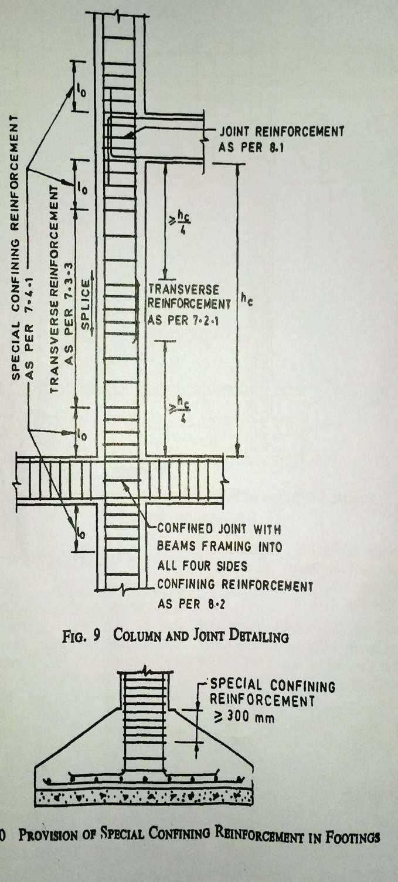

Referencebook:
Designofreinforcedconcretestructures
By:N.Subramanian Fundamentalsofreinforcedconcrete
By:N.C.Sinha,S.K.Roy Reinforced Concrete
By:H.J.Saha Reinforcedconcretestructure
By:pillai&menon

LECTURE NOTES

ON

ESTIMATION & COST EVALUATION-2

Compiled by

Mr. Guru Prasad Patro
Sr.Lecturer, Department of Civil Engineering,
GANDHI ACADEMY OF TECHNOLOGY AND ENGINEERING

CONTENTS

Sl.No | ChapterName | Page No
1 | Detailedestimateofculvertsand bridges | 3-12
2 | Estimateofirrigationstructures | 13-18
3 | Detailedestimateofroads | 19-21
4 | Detailedestimatesofmiscellaneous works | 22-23
5 | PWDaccountsworks | 24-30

CHAPTER-1

CulvertandBridge:–

According to I.R.C. specification, a culvert isone which hasa liner waterway upto6mandstructureshavingalinearwaterwayabove6mbutbelow30mareMinor Bridgesandstructureshavingsalinearwaterwayof30mormoreareMajorBridges.
As a general rule, a minimum of 6m of linear waterway should be provided per 15.km of the road for efficient drainage.
SomeCommonterms–

- Abutment :-It isamasonryororiented concerned willthat constitutestheend supportofbridgesorsimilar structuresbywhich itjoinsthebank of waterway.
- Wingwall:-Wingwallisaretainingwallwhichsustainstheembankments of the approaches where they join the bridge.

- Return wall :- A return wall is retaining wall built parallel to the centre line of a road to retain the embankment.
- Curtain walls :- Cross walls are built across the stream on the up-stream or down- stream in order to protect the structure from erosion due to strong current of water induced by the restriction of free passage of water through the water way.
Process of calculations of earth work for (1) Abutment, (2) Wing and (3) Curtain walls (when provided) :-
- Abutments2nos.=2xAreaABCDxdepthofexcavation.
- Wingwalls4nos.=4xAreaBEFGxdepthofexcavation.
- Curtainwalls2nos.=2xAreaMNPQxdepthofexcavation.

CurtainwallsatthetwoendsofAbutmentwallsarenotalwaysprovided.

Processofcalculationstoestimatequantitiesofearthwork,concreteworkand
masonryworkfor(1)Abutments,(2)Wingwallsand(3)Returnwallsofa
3
ESTIMAIONs&plCaOyeSTdECVuAlLvUeArTtIoOrNB-2ridge:-
(1)Abutments:-Foreachorconcretework:-

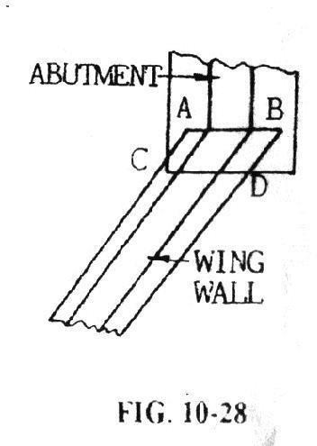
When the inside the face of Abutment is continued to wing wall the extra bottom length due to batter may be considered as if includedinthe wing wall i.e.thetwo wallsjoinonaverticalplane.
(a)Length=Road width+2 parapet thickness.

When the width of Abutment at the ends is not equal to the inclined width of the wing wall joining with abutment-1s as shown in fig 10-28.
Length=½ (Toplength+ Bottomlength).

Bottomlength–Toplength+2xoffsetduetoinnerbatterfaceof Abutment.

- Wing walls :- The thickness and height of the wall is maximum at the junction with its abutment and both the dimensions are gradually reduced to the section as that at return
wallwithwhichitjoins.

Forearthor correctwork

FollowingFig.10-29considertheendofexcavationsisupto thelineR.S. We have to find out the quantity for the are ADSR.
  - Length=Y+ offsetsfromtheouteredgeofreturnwall
  - Breadth=½+(AD+RS);

AD is the inclined trench width of wing wall parallel to the centre line of the road and generally the trench width of the abutment. If not equal, the offset (as shown in Fig. 10-28) is mentioned.
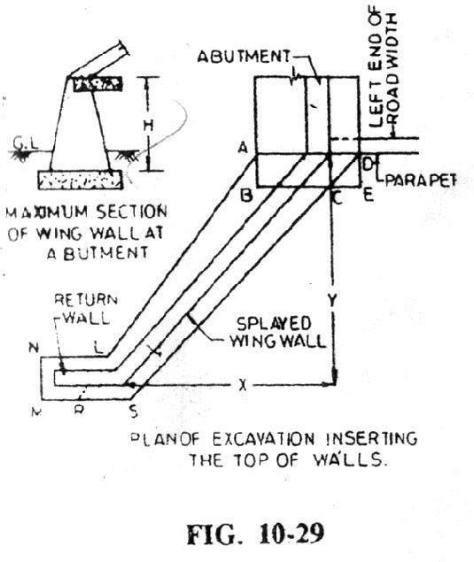

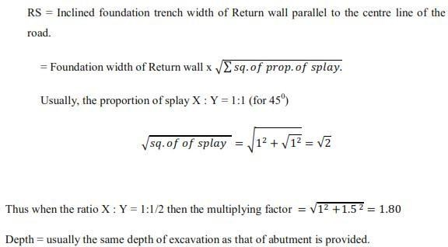

Deductionforendoffsetof Abutment:-

During excavation for Abutment the portion ABCD (see fig. 10-29) has alreadybeen excavated. Therefore, the volume of work for this portion should be deducted from the volume of work for the wing wall : Now AD = Foundation width
BC =AD-CE;CE-DExX/Y
..DeductionforAbutmentoffset=½+[trenchwidth+(trenchwidth–offsetxX/Y)] x depth.
Forconcreteworkthedepthofconcreteinsteadof depthearthworkshallbeconsidered.

Formasonry work belowG.L.

    - Length= Y+ offsetofmasonryinfoundationofreturnwall
    - Breadth= sameprocessas thatofearthwork
    - Depth= thicknessofthefooting.

The construction of wingwall may be with its battered inner and outer faces starting from the top of the foundation concrete up to top. In such cases the whole mass shell be calculated in one operation considering this as Frusta of Pyramid, erected vertically on AD as base.

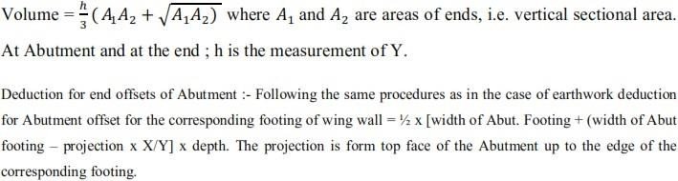

Formasonrywork aboveG.L.

Wing walls above G.L. may have the following shapes :- (i) Inside face vertical orbattered but at the outer face with offsets; (ii) Both the faces
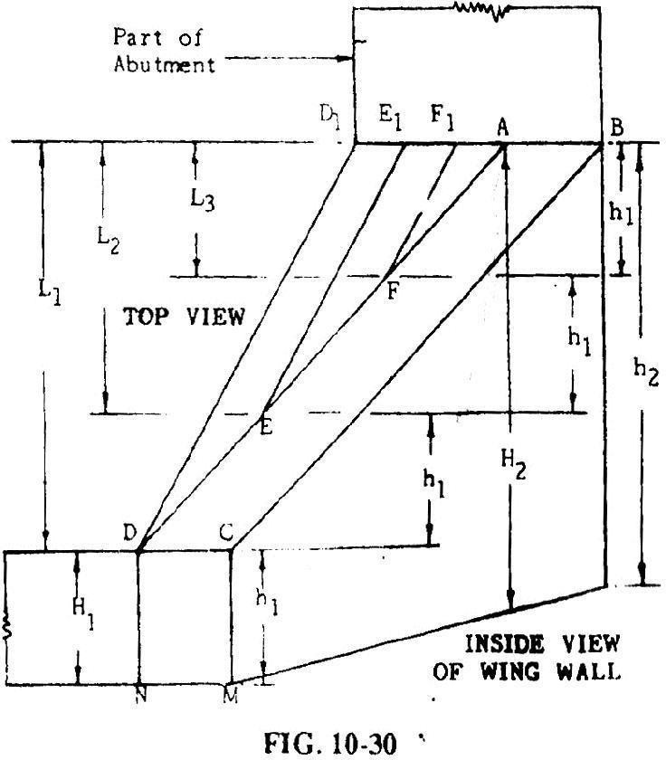
are battered.

(i) Inside face vertical with offsets at the outer face :- Before starting the estimate, let us clarify howoffsets are provided at the outside face of the wing wall. Let the topplanofwallisABCDwiththree offsets,D1D,E1EandF1Fof
lengths L1, L2and L3respectively as shown in Fig . 10-30.

Theheightofthewingwallish1attheendandh2atAbutment.
ThetopofABCDofthewingwallisslopeddownwarduniformlyfromABtoDC.

To have a clear picture regarding the shape of the outside offsets suppose we are to reach the inclined levelAF of thefrom the left side ground level.
For this purpose three numbers steps ADD1, AEE1 and AFF1 are constructed with uniform rise h1, when h2 = 4h1
ThesecondstepAEE1isconstructedoverthefirststepADD1andsimilarlythethird

stepAFF1over AEE1. Nowby crossingthe threestepsfrom the left wehave reached to the height of F = 3h1. The difference of level between the points F and A is also h1.
But, actually these triangular steps are known as offsets of the wing wall. The projections are shown on plan and height on elevation drawn by the side of section of the Abutment. The purpose of these offset is to strengthen the core part ABCD of the wing wall.
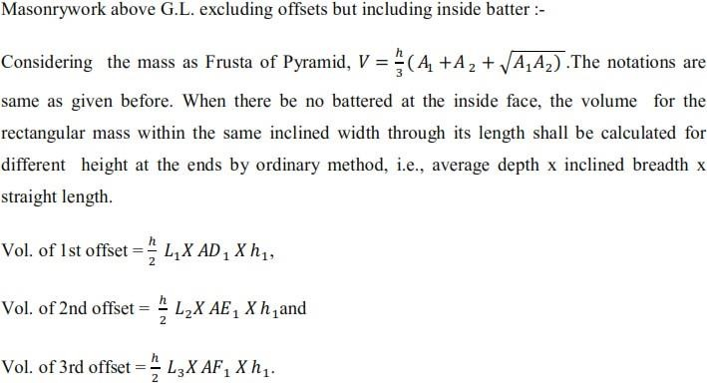

Deductionof Abutmentoffset:-

When the width of Abutment at the ends is not equal to the inclined width of the wing wall as the well as the inside face of the Abutment is battered then the length of the Abutment includes the offsets at the end. In thiscase deduction for the offset projection is made from the volume of wing wall.

Returnwall:-

Length=AveragelengthfortheRMNL=½(RM+NL) RM =MS
NL= RM+MNx.MNis thetrenchwidth.

EstimationofmaterialsinCulvertsandbridges

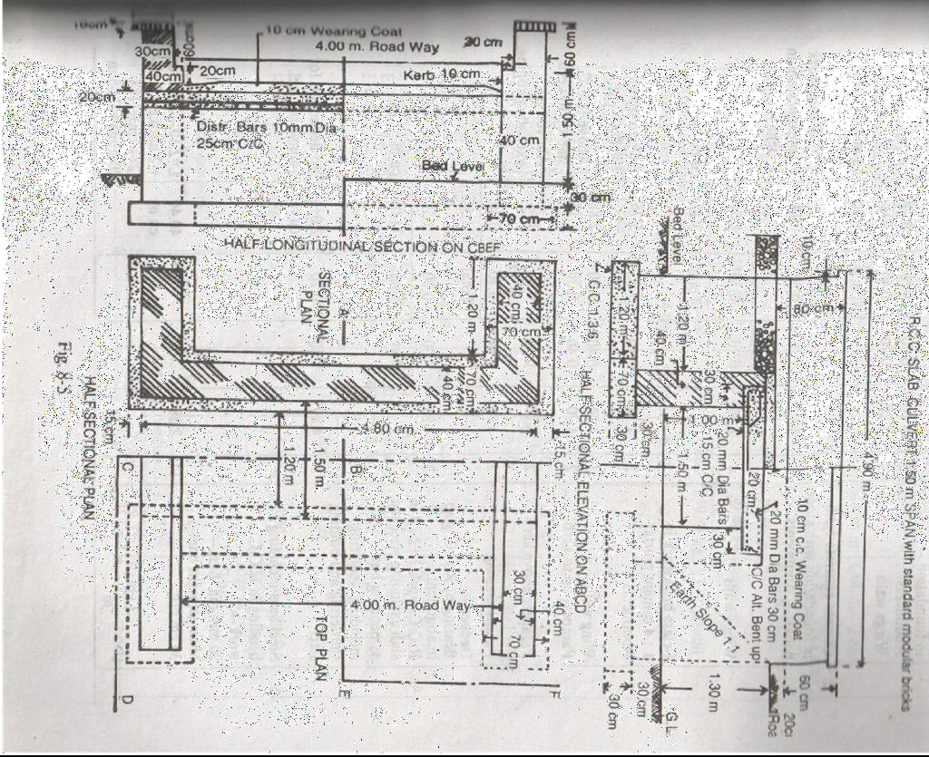

DetailsofMeasurementsandCalculationofQuantities.

S.No. | ParticularsofItems |  |  | No. | L | B | H | Q | Explanation
1 | Earthworkinexcavation  infoundation Abutments Wing walls |  |  | 2  4 | 5.10  1.20 | 0.70  0.70 | 0.60  0.60  Total | 4.28  2.02  6.30 | m3
2 | Cementconcrete1:3:6  Infoundationwith stone |  |  |  |  |  |  |  | (1/2)  earthwork | of  in
 | ballast-Abutments |  |  | 2 | 5.10 | 0.70 | 0.30 | 2.14 | excavation | in
 | Wingwalls |  |  | 4 | 1.20 | 0.70 | 0.30  Total | 1.01  3.15 | item1  m3
3 | I-classbrickwork  cementmortar-  Abutments Wingwalls | in | 1:4 | 2  4 | 4.8  1.2 | 0.4  0.4 | 1.5  1.5 | 5.76  2.88 | (UptotopofRCC slab)  (AboveRCCslab
 | Parapetsup to kerb |  |  | 2 | 4.7 | 0.4 | 0.3 | 1.13 | uptoKerb)
 | Parapetsabovekerb |  |  | 2 | 4.7 | 0.3 | 0.5 | 1.41 | (Above kerb
 | Parapetscoping |  |  | 2 | 4.9 | 0.4 | 0.1 | 0.39 | excludingcoping.)
 | Deduct |  |  |  |  |  | Total | 11.57
 | BearingofR.C.C.slabin abutment |  |  | 2 | 4.8 | 0.3 | 0.2  Total | 0.57  11.00 | M3
4 | R.C.C.work1:2:4in  Slabexcludingsteelandits bendingcenteringshuttering and binding steel |  |  | 1 | 4.8 | 2.1 | 0.2 | 2.016 | m3  no deduction volumeofsteel. | for
5 | Steelbarincludingbending  inRCCwork-  20mm dia.Bars- |  |  |  |  |  |  |  | L=2.10-2sidecovers  + 2hooks= 2.10- (2x4cm)+(18x20mm)
 |  |  |  | 17 | 2.38 | -- | -- | 40.46  m | =2.38m  Addingonedepth,16 cm for twobent ups
Mainstraightbars30cmc/c
{No=(4.8/0.30) +1=17}
 | Mainbentupbars30cmc/c |  |  | 16 | 2.54 | -- | -- | 40.64 | L=2.38+0.16=2.54m
 | {No.=(4.80/0.30)=16} |  |  |  |  |  |  | m | L=4.80-2endcovers+
 | 10mm Dia.Bars- |  |  |  |  |  |  |  | 3hooks= 4.80-
 | Distributingbottombars25 |  |  | 9 | 4.90 | -- | -- | 44.10 | (2x4cm)+(18x10mm)
 | cmc/c |  |  |  |  |  |  | m | =4.90m
 | Distributingtopbars |  |  | 4 | 4.90 | -- | -- | 19.60
 |  |  |  |  |  |  |  | m
 | Total63.70m@0.62kg= |  |  |  |  |  |  | 39.49
 |  |  |  |  |  |  |  | kg

6 | Cement concrete 1:2:4  wearingcoat | 1 | 4.00 | 2.30 | 0.10 | 0.92  cu.m | In between  parapets
7 | Cementpointing1:2 in

 | walls-
 | Facewallfrom
 | 10cmbelowG.L.upto | 2 | 4.70 | -- | 2.10 | 19.74
 | bottomofcoppinginnerside
 | ofparapetexcludingcopping | 2 | 4.70 | -- | 0.80 | 7.52 | Ht.=(20+10+50
 |  |  |  |  |  |  | )=0.80
 | Coping(inneredge,top,outer | 2 | 4.90 | .70 | -- | 6.86 | B=(10+40+10+
 | edgeandouterendside) |  |  |  |  |  | 10)cm=.70m
 | Endsof parapet | 4 | -- | .40 | .20 | .32 | Uptokerb.
 | Endsof parapet | 4 | -- | .30 | .50 | .60 | Abovekerb
 | Endof coping | 4 | -- | .40 | .20 | .32 | Edgeandunder
 |  |  |  |  |  |  | side
 | Deduct- |  |  |  | Total | 35.36
 | Rectangularopening | 2 | 1.50 |  |  |  | Including | 10cm
 |  |  |  |  | 1.30 | 3.90 | belowG.L.and
 |  | 2 | X1.3 |  |  |  | edgeofRCC
 | Triangularportionbelowearth |  |  | X1.3 |  | 1.69 | slab
 | slope |  |  | Tota | Dedu | N5.59
 |  |  |  | lof | ction
 |  |  |  | Net | Total | 29.77 | Sqm

AbstractofEstimatedcostofBridge

S.No | Descriptionofitem | Quantity | Unit | Rate | Per | Amount
 |  |  |  |  |  | Rs.P.
1 | Earthworkinexcavationinfoundation | 6.30 | Cum | 350.00 | Cum | 22.05
2 | Cementconcrete1:3:6infoundation | 3.15 | Cum | 400.00 | Cum | 1260.00
 | withstoneballast
3 | I-class brickworkin1:4cementmortar | 11.00 | Cum | 365.00 | Cum | 4015.00
4 | R.C.C.work1:2:4inslabexcluding | 2.016 | Cum | 775.00 | Cum | 1562.40
 | steelanditsbendingbutincluding
 | centering, shutteringandbindingsteel
5 | SteelbarincludingbendinginR.C.C | 2.398 | Quintal | 515.00 | Quintal | 1234.97
 | work
6 | Cementconcrete1:2:4inwearingcoat | 0.92 | Cum | 450.00 | Cum | 414.00
7 | Cementpointing1:2inwall | 29.77 | Sqm | 5.60 | Sqm | 166.71
 |  |  |  |  | Total | 8675.13
Add5%(3%forcontingenciesand2%forwork-chargedEstablishment) |  |  |  |  |  | 433.75
 |  |  |  | GrandTotal |  | 9108.88

12

CHAPTER-2

DRAINGESAYPSON

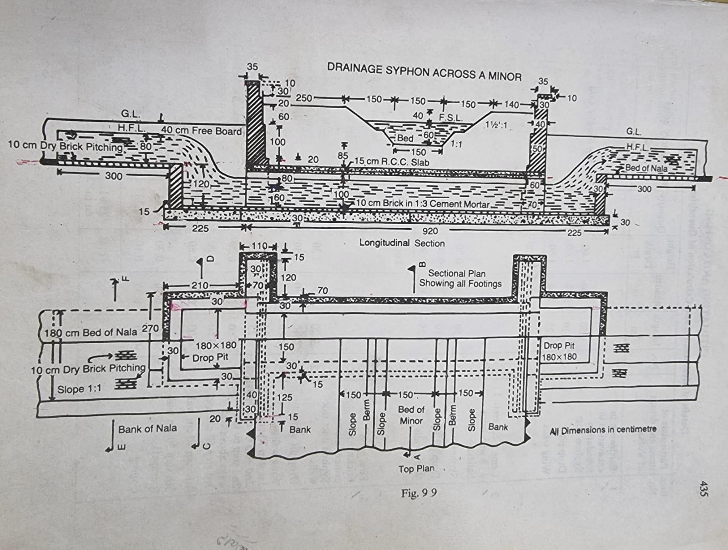

DETAILSOFQUANTITYCALCULATION

Itemno | Particulars of item | no | Length(m) | Breadth(m) | Height(m) | quantity | remark
1 | E/W excavation for foundation Siphon  duct
 |  | 1 | 9.5 | 2.4 | 1.6 | 36.48
 | Droppit | 2 | 2.1 | 2.7 | 1.6 | 18.14
 | Wingwall | 4 | 1.25 | 1.1 | 1.6 | 8.80
 |  |  |  |  | Total= | 63.42cum
2 | Cement concrete
 | Siphon duct | 1 | 9.5 | 2.4 | 0.3 | 6.84
 | Droppit | 2 | 2.1 | 2.7 | 0.3 | 3.4
 | Wingwall | 4 | 1.25 | 1.1 | 0.3 | 1.65
 |  |  |  |  | Total= | 11.89cum

3 | 1st class b/w Siphon duct side wall Drop pit wall Wing walls 1ststep70cm | 2 | 9.2 | 0.3 | 1.3 | 7.18
 |  | 2x2 2 | 2.1  1.8 | 0.3  0.3 | 1.3  1.3 | 3.28  1.40
 |  | 4 | 1.25 | 0.7 | 0.7 | 2.45
 | 2ndstep60cm | 4 | 1.25 | 0.6 | 0.6 | 1.8
 | 2nd step 60cmabove slab | 2 | 4.6 | 0.6 | 0.2 | 1.1
 | 3rdstep50cm wall | 2 | 4.6 | 0.5 | 1.00 | 4.6
 | 4thstep40cm wall | 2 | 4.6 | 0.4 | 0.8 | 2.94
 | 5th step 30 cm wall(parapet) | 2 | 4.6 | 0.3 | 0.3 | 0.83
 | coping | 2 | 4.7 | 0.35 | 0.1 | 0.33=25.91cum
4 | Rccslab including  reinforcement | 1 | 9.2 | 2.1 | 0.15 | 2.9cum
5 | Brick pitching

 | Floorofduct | 1 | 9.2 | 1.5 | - | 13.80
 | Floorofdrop pit | 2 | 1.8 | 1.8 | - | 6.48
 |  |  |  |  | Total= | 20.28sqm
6 | Cement pointing  Siphonduct inner face | 2 | 9.2 |  | 1
 | Drop pit 3 verticalfaces | 2x3 | 1.8 |  | 1.2
 | Droppit3top faces | 2 | 5.7 |  | 0.3
 | Parapet wall innerfacetop  and outer faceuptoGL | 2 | 4.6 |  | 2.3
 | Outerfaceof wing wall above slab | 2 | 1.8 |  | 1.2
 | Triangular portion of  outerfaceof wing wall | 2x2 | (1/2x0.8x0.8) | = |  | 1.28
 |  |  |  |  | Total= | 61.54cum
7 | Brick pitching
 | Bedofnala | 2 | 3 | 1.8 |  | 10.8
 | Side slope | 2x2 | 3 | 1.13 | Total= | 13.56  24.36sqm

Estimationofverticalfall
DETAILSOFQUANTITYCALCULATION
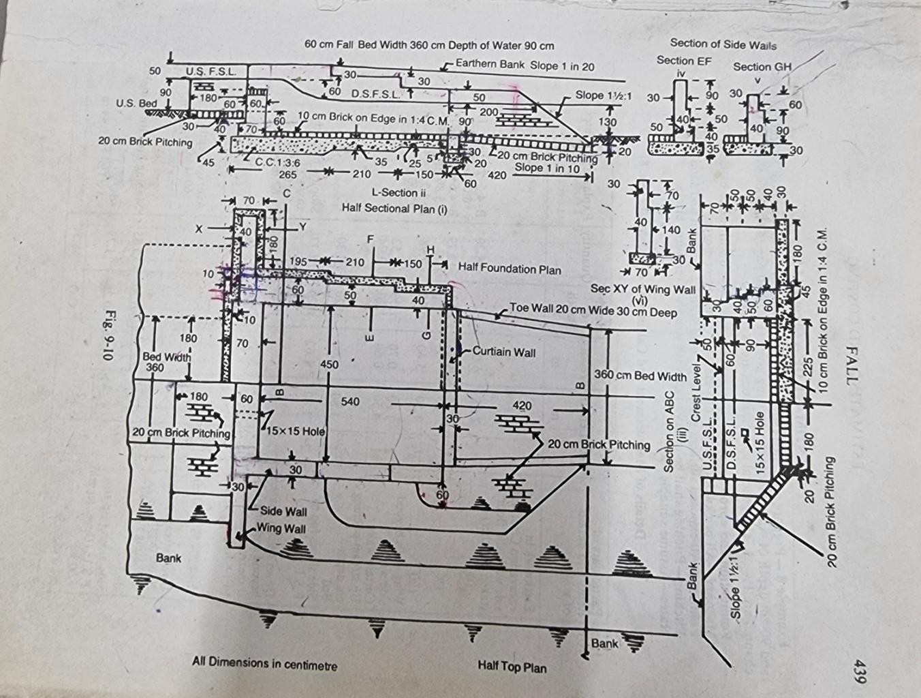

Sl  no | Particulars  ofitem | no | Length(m) | Breath(m) | Height(m) | quantity | remark
1 | E/W excavation Crest wall,side wall and floor(taken  together) (1) | 1 | 2.65 | 6.00 | 1.15 | 18.29

 | (2) | 1 | 2.1 |  | 5.8 | 1.05 | 12.79
 | (3) | 1 | 1.5 |  | 5.6 | 0.95 | 7.98
 | Wingwall beyond side wall | 2 | 1.8 |  | 0.7 | 1 | 2.52
 | Curtain  walls | 1 | 4.5 |  | 0.6 | 1.2 | 3.24
Upstream pitching 20cm
depth
 | bed | 1 | 1.8 |  | 3.6 | 0.2 | 1.3
 | Side  slopesup to FSL | 2 | 1.8 |  | 1.62 | 0.2 | 1.17
 | Down stream channel beyond curtain wall trapezium  section | (4.05x0.8+1.5x0.8²) | X3.9 |  | = |  | 16.38
 | Down stream pitching 20cm depth excluding toe wall Bed | 1 | 3.9x4.1+3.2 |  | X0.2 | = | 2.85
 |  |  |  | 2
 | Sideslope up to FSL | 2 | 4.2+2 2 |  | X1.44 | X0.2 | =1.79
 |  |  |  |  |  | Total | =68.31cum
 | Curved portion | 2 | Πx0.6² |  |  | X0.2 | 0.45
 | toewall | 2 | 3.9 |  | 0.2 | 0.3 | 0.47
 | Deductfor setbackof wing wall | 2 | 0.6 |  | 0.10 | 1.15 | 0.14
2 | Cement concrete in  foundation |  |  |  |  | Total= | 69.09cum
Crest wall,side wall and floor(taken
together)

 | (1) | 1 | 2.65 | 6.00 | 0.45 | 7.16
 | (2) | 1 | 2.1 | 5.8 | 0.35 | 4.26
 | (3) | 1 | 1.5 | 5.6 | 0.25 | 2.1
 | Wingwall  beyond sidewall | 2 | 1.8 | 0.7 | 0.3 | 0.76
 | Curtain  wall | 1 | 4.5 | 0.6 | 0.2 | 0.54
 |  |  |  |  | Total= | 14.82cum
 | Deductfor setbackof  wing wall | 2 | 0.6 | 0.1 | 1.15 | 0.14
3 | 1stclass b/w  1ststep  2ndstep | 1  1 | 4.5  4.5 | 0.7  0.6 | Total=  0.4  1.00 | 14.68cum  1.26  2.7
 | Sidewall  1)1ststep | 2 | 2.35 | 0.6 | 0.4 | 1.13
 | 2ndstep | 2 | 2.35 | 0.5 | 0.5 | 1.18
 | 3rdstep | 2 | 2.35 | 0.4 | 0.5 | 0.94
 | 4thstep | 2 | 2.35 | 0.3 | 0.7 | 0.99
 | 2)1ststep | 2 | 2.1 | 0.5 | 0.4 | 0.84
 | 2ndstep | 2 | 2.1 | 0.4 | 0.5 | 0.84
 | 3rdstep | 2 | 2.1 | 0.3 | 0.9 | 1.13
 | 3)1ststep | 2 | 1.5 | 0.4 | 0.9 | 1.08
 | 2ndstep | 2 | 1.5 | 0.3 | 0.6 | 0.54
 | Wingwall beyond side wall | 2 | 1.8 | 0.4 | 0.4 | 0.58
 |  | 2 | 1.9 | 0.4 | 0.5 | 0.76
 |  | 2 | 2.00 | 0.4 | 0.5 | 0.80
 |  | 2 | 2.1 | 0.3 | 0.7 | 0.88
 | Curtain wall | 1 | 4.5 | 0.3 | 0.4 | 0.54
 | Toewall | 2 | 3.9 | 0.2 | 0.3  Total= | 0.47  16.66cum
4 | Brick on edgefloor | 1 | 5.4 | 4.5 | - | 24.30sqm

CHAPTER-3
DETAILESTIMATIONOFROAD

CROSSSECTIONOFROAD

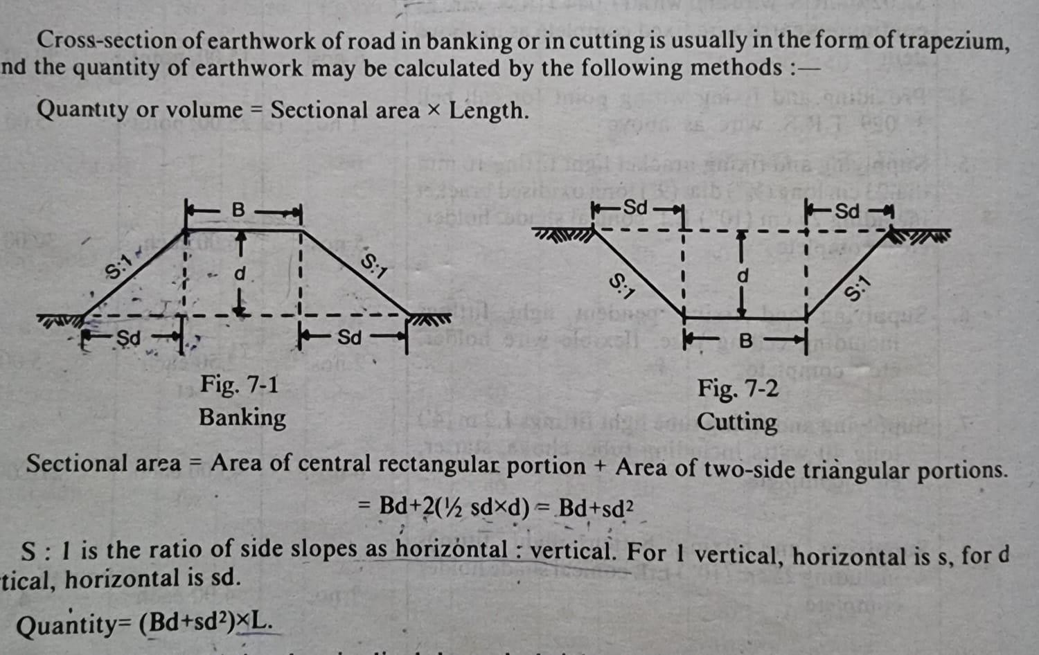

METHODSOFE/WFORROAD

1.mid sectional formula method 2.mean-sectionalformulamethod

3.prismoidalformulamethod

Problem:
Reduced level pf ground along the center line of a proposed road from chainage 10 to chainage 20 is given.theformationlevelatthe10th chainage is107 andthe roadis indownward gradientof 1 in 150up to the chainage 14 and then the gradient changes to 1 in 100 down ward.formation width is 10m and side slopes of banking are 2:1.length of chain is 30m.draw the longitudinal section and prepare the e
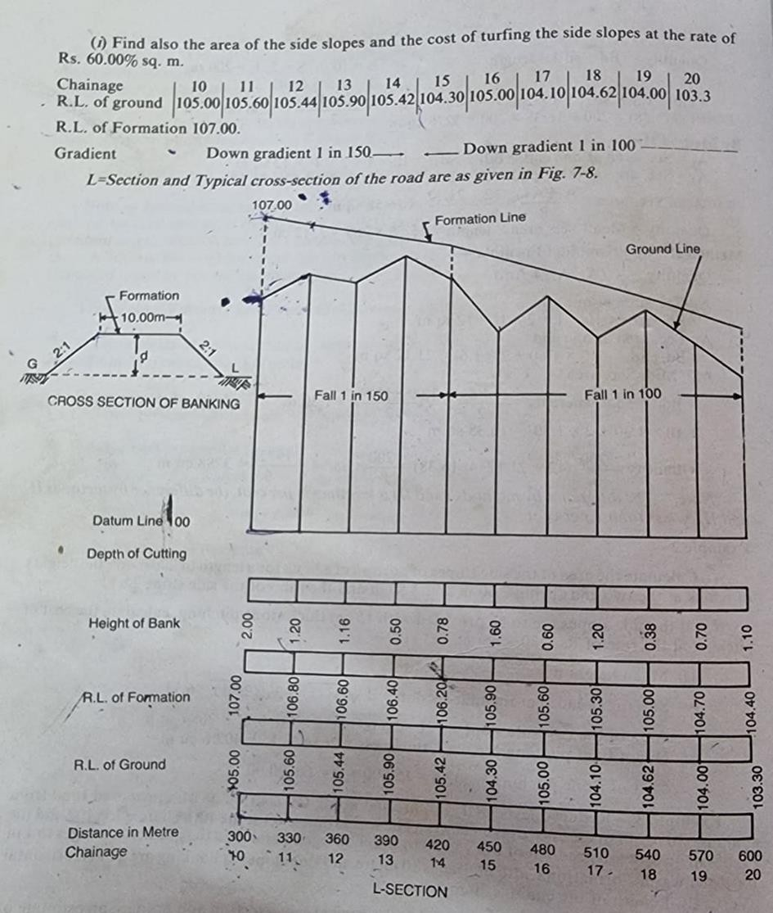

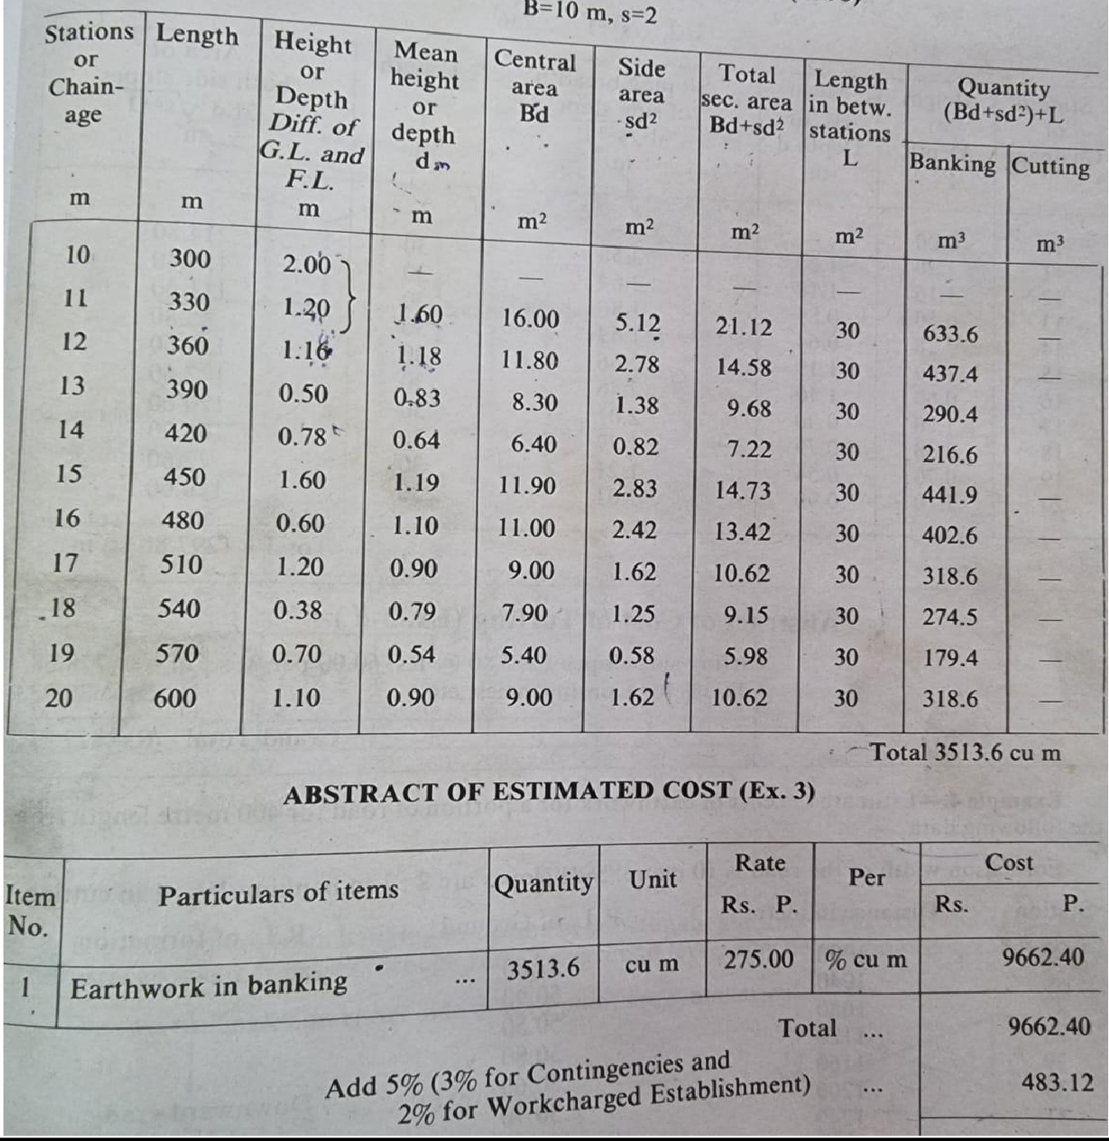

CHAPTER-4

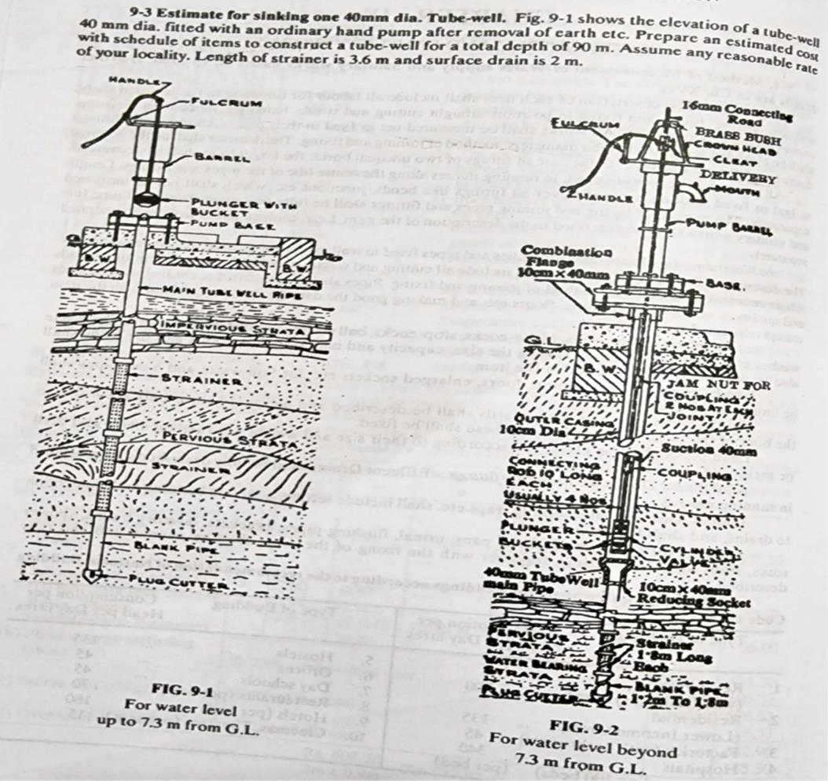

Item no | Descriptionofitem | Quantity | Rate | Unit | Amount
1 | a)Materials 40mmdia  Galvanisediron  (G.I) pipe ITC(medium) | 86.4m | 238.00 | Rm | 20563.2
2 | 40mmdia strainers | 2nos | 432.00 | Each | 864.00
3 | Handpumpno6 | 1no | 570.00 | Each | 570
4 | 40mmdiaC.Iplug cutter | 1no | 36.00 | Each | 36.00
5 | 40mmdiasteelplug  cutter | 1no | 78.00 | Each | 78.00
6 | Labourforboringtubewell of 40mm dia by water jet system through any of soil strata including hir and changel for boring  pipes,scaffolding. | 90rm | 200.00 | Each | 18000.00
7 | Constructionof1.2mx  1.2mmasonryplatformof  cementconcrete(1:2:4) base. | 1no | 1800.0 | Each | 1800
8 | Brick masonry surface drain15cmwide10cm  depthon8cmcement(1:3) surface finished. | 2m | 250.00 | Rm | 450
Total Rs.42361.20 Add5%forcontingency=Rs2118.06
2½forW.C=Rs. 1059.03
Grandtotal=Rs.4553829

Administrativeapproval

CHAPTER-5

"Administrativeapproval"isthe communication of formalacceptance of theproposalsbythecompetent authority of the Administrative Ministry/Department requiring the work.

Accordofadministrativeapproval
- The concurrence of the competent authority of the Administrative Ministry/Department requisitioningthe workshouldbe obtainedtothePreliminaryEstimateforthe work. However, no such concurrence is required for normal repairs and maintenance works.
- ThePreliminary Estimateshould beframed orcountersignedbythe authorityas specified ,and sent in triplicate to the Administrative Ministry/Department
requisitioningthe work.The requisitioningauthorityshallberequested to returnonecopyof the estimate, duly countersigned in token of acceptance, while communicating the administrative approval.
- OnecopyoftheadministrativeapprovalshallbeendorsedtotheconcernedAccountsOfficer.

Powersforaccordofadministrative approval
- VariousMinistries/Authoritieswho gettheirworksexecutedthroughthe CPWD,havebeen delegated specific powers to accord administrative approval to the works.
- Theamount ofadministrativeapprovalaccorded,inallcases, shallincludedepartmentalcharges, wherever it is leviable.
- In caseof estimatesfor residential accommodation, ithas to be seenby theauthority concerned before the issue of administrative approval that the scale of accommodation provided for therein does not exceed the one approved by the Ministry of Finance.
- If theestimated costof a workexceedsthe powersof any officer,theadministrative approvalof the Government of India in the Administrative Ministry must be obtained.
- TheDirectorGeneral, Special Director GeneralandAdditional Directors Generalhavebeen delegated powersasin Appendix-Itoaccord administrative approvalforconstructionof houses for CPWD project staff in major projects, as well as for CPWD maintenance staff.

Technicalsanction
A "technical sanction"amountstoaguaranteethat theproposalsaretechnically sound,andthatthe estimates are accurately prepared and are based on adequate data.

2.5.1Accordoftechnicalsanction
- Afterreceiptofadministrativeapprovalandexpenditure sanction,detailed estimatesare required to be prepared for technical sanction. The technical sanction should be accorded by the competent authority before a work is taken in hand. In case of revised estimates, it is not necessary to wait
forthe revised administrativeapprovalorthe revisedexpenditure sanctiontoaccord revised technical sanction.
- A copyof the technicalsanctionforthebuilding work shouldalsobeendorsed tothe concerned Senior Architect, Superintending Engineer (Elect)/Executive Engineer(elect) as well as the Director/Deputy Director of Horticulture for initiating action at the appropriate time on electrical,
airconditioning,horticulture andotherworks.Similarly,copiesof TechnicalSanctionofEstimate for Horticulture works shall also be forwarded to Senior Architect and CE(C)/SE(C)/EE(C) as
thecase maybe. Themunicipal/LocalBodiesandElectricalSupply Companies shouldalsobe approached by the Executive Engineer, Civil and Electrical, well in time for providing External Services including power supply.
- Beforeanestimateistechnicallysanctioned,thefollowingshallbedesirable:
  - Detailedarchitecturaldrawingsandspecifications.
  - Preliminarystructuraldrawingsforfoundations
  - Preliminarystructuraldrawingsofsuperstructureatleastuptoslabatlevel2
  - Preliminarydrawingsforinternalandexternalservices.

MEASUREMENT BOOKS(MBS)

General
- Expenditure on the construction or maintenance of a work may be divided broadly into two classes,viz. (i)Cash (ii)StockCharges. Inaddition to the main charges, thereareothercharges affecting the cost of work. For example, there may be charges incurred in other Divisions,

Departments or Government, materials received from them or services rendered by them, or there maybe cash receipts suchasaretakenin reductionof expenditure inaccordance withthe rules. To account for all these charges affecting the cost of work, separate accounts are maintained in Sub-Division/Divisional Offices for recording
- thecostofindividualworks,and
- the transactionsof individualContractors/Suppliers. Theseareknownasworksaccounts. The accounts of manufacture operations and non-government works are maintained in the same manner as for Government works. (Para 10.1.1 of CPWA code may be referred to).
- Cashcharges of worksconsistof payments to(i) labourers andmembers of the work-charged establishment of their wages, and (ii) contractors and others for work done or other services rendered. The cost of materials procured specially for work is charged to the accounts of worksby transfer credit to the "Material Purchase Settlement Suspense Account". The payments to suppliers are governed by the same rules as payments to contractors for work done (Para
10.2.1ofCPWAcodemaybereferredto).
- Thepayments to thework charged staff aremade monthlyin the same mannerasit is made to the regular staff but on a different bill form CPWA 29, and are charged direct to the work on
whichthelabourisactuallyemployed.
- The payments to contractors and othersforthe work done or otherservicesrendered are made on the basis of measurements recorded in the Measurement Book. Subsidiary instructions regarding maintenance of the measurement books including standard Measurement Books and review of measurement books are given in subsequent paras here under.

WritingofMeasurementBook
- Themeasurementbookis thebasisof allaccountsof quantities whetherof works doneby Contractors or by labourers employed departmentally, or materials received. It should be so written that the transactions are readily traceable.
- Thesebooks shouldbeconsideredasvery importantaccounts records andmaintained very carefully andaccurately asthese mayhavetobeproducedasevidence ina courtof law, if and when required.

RegisterofMeasurementBooks
- Allthe MeasurementBooksbelongingtoa Division,shouldbenumbered serially. Aregister should be maintained in form CPWA 92 showing the serial number of each book, on receipt,

Sub-Division to which itisissued, thedateof issue,dateof itsreturn to the DivisionalOfficeand date of its record after the required review in the Divisional Office has been completed.
- AsimilarregistershouldbemaintainedintheSub-DivisionalOfficeshowingthenamesofpersons,
i.e.AssistantEngineer/JuniorEngineer,to whomtheMeasurementBooksareissued.
CPWDWORKSMANUAL2014SECTION7
160YearsofEngineeringExcellence63

TransferofMeasurementBooks
- The Measurement Books that are no longer required to be used in the Sub-Division or with the JuniorEngineershouldbe withdrawnpromptlyeventhoughnot completely writtenup andreissued.
- When anAssistantEngineeror JuniorEngineer in chargeof the work or stores is transferredhe should hand over the Measurement Books issued to him to his successor and these should be shownas received back from him andre-issuedto therelieving Officer.The transfer should also be recorded in the Measurement Book after the last entry in each book under dated signature ofthe relieving Officer and relieved Officer.

Recordingofmeasurements
- Entriesatcommencementofmeasurements
Eachsetofmeasurementstoberecordedshouldcommencewithentriesstating:
  - Inthecaseof billsforworks done:
    - Fullnameofworkasgiven intheagreement/estimate.
    - Locationofwork.
    - Nameofcontractor.
    - Numberanddateofagreement.
    - Dateof writtenordertocommence work.
    - Dateofactualcompletionofwork.
    - Dateofrecordingmeasurements.
    - Referencetopreviousmeasurements.
  - Inthecaseofbillsforsupplyofmaterials:
    - Nameofsupplier.
    - Numberanddateof supplyorder/agreement.
    - Purposeofsupplyinoneofthefollowingformsasapplicableto thecase:
      - Stock(forallsuppliesforstockpurpose).

      - "Purchase"fordirectissue to the work (fullname of the work asgiven in theestimate shall be mentioned).
      - "Purchase"for(fullnameofworkasgiven inestimate)forissuetocontractor......on......:
    - Dateof writtenordertocommencethesupply.
    - Dateof actual supply.

STANDARDMEASUREMENTBOOKS(SMB'S)

Purpose
TheStandardMeasurementBooksaremaintainedtorecordthemeasurementsofpermanent standing
in abuilding, andare required to bebroughtupto datefromyearto yearonthe basisof additions,etc. that
are madetothebuildingduringa year.Theseareusedfor preparingthe repairsestimatesand contractors'
billsforsuchrepairssoastoavoidtakingdetailedmeasurementsoneachoccasion.

PreparationandaccountingofStandardMeasurementBooks
- TheStandard Measurement Books shallbepreparedafterthecompletionof the workbythe Construction Division that hasexecuted the work.The preparation of these books will ordinarily beundertaken in accordance with theprogramforeachSub-Divisionor suchother suitableunit as may be fixed by the Divisional Officer.
- Alldrawings,Standard MeasurementBooksetc.should beproperlydocumented beforehanding over the building.
- All the Standard MeasurementBooksshouldbe on Form CPWA23-A, andshould containpages in singleton. They should be numbered in an alphabetical series so as to be readily distinguishable from those assigned to ordinary Measurement Books.
- These willbeaccountedforinthe same mannerasordinary MeasurementBooks ina registerin Form No CPWA 92 (Part II).
- A similarregisterwillbe maintained in each Sub-Division showing the booksbelongingto it,and reviewed as done in case of the ordinary Measurement Books.

WritingofStandardMeasurementBooks
- TheStandard Measurement Booksshouldbewritten legiblyin ink,and certified ascorrect by the Executive Engineer. These should be maintained very carefully and accurately, as theymay

havetobeproducedasevidenceinaCourtof Law.
- TheStandard Measurement Booksshouldeitherbe writtenbytheAssistant Engineerhimself or a Junior Engineer under his orders. Each set of measurements taken by the Junior Engineer should, however, be fully checked by the Assistant Engineer, after which it should be examined
bytheExecutive Engineer. He shoulddeclare inwriting intheBookitself asfinallyapprovedby him for the purposes of preparing annual repair estimates and contractors' bills for the work done. Until this is done, the Book will not be assigned a number, and will not be entered in the Register of Standard Measurement Books.
- The Standard Measurement Books shall be brought upto date under the supervision of the AssistantEngineerwith referencetothebuildingorwork concerned within onemonthof closing of the accounts of the estimate thereof. All such corrections shall be attested by the Assistant Engineer, and approved by the Executive Engineer.

Preparationofbill
- On completionof theabstract, theMeasurement Bookshouldbe submitted to theSub-Divisional Officer, who after carrying out his test check should enter the word "Check and bill" with his
dated initials. The Sub-Divisional Clerk should then check the calculation of quantities in the abstract, and the bill in case of work carried out by contract, and should then place the MeasurementBook andthebillbefore theSub-DivisionalOfficerwho,aftercomparing thetwo, should sign the bill and the Measurement Book at the end of the abstract.
- Fromthe MeasurementBookallquantitiesshouldbe clearlytraceable intothe documentson whichpaymentsaremade.Whena bill ispreparedfor a work or supplies, everypage containing the detailed measurements must be invariably scored out by a diagonal red ink line. When the payment is made, an endorsement must be made in red ink, on the abstract of measurements, giving a reference to the number and date of the voucher of payment.

FormsofBillforpaymentand vouchers
Theauthorisedformsof bills tobeusedfor paymentof contractors/ suppliers andtheir utility are described below:

FirstandFinalBillForm
It should be used for making payments both to contractors for work and to suppliers, when a singlepayment is madefor a job or contractonitscompletion.A singleform maybeusedfor

makingpaymentsto severalpayees, if theyrelateto thesame work/sectionof work,orto the same head of account in the case of suppliers and re-billed for at the same time.

RunningAccountBillForm
This form should be used for all running and final payments to contractors and suppliers (other than those relating to lump sumcontractsforwhich Forms CPWA27Aand27Bareprescribed), including cases where advance payments are proposed to be made or are already outstanding in respect of the same work against the contractor. In case where secured advances are to be made or already outstanding in respect of the same work against the contractor, Account of Secured Advances Form CPWA 26A should be attached to the bill.

HandReceipt Form
    - This is a simpleform of voucher intendedtobeusedfor all miscellaneouspaymentsand advances for which none of the special forms mentioned above is suitable.
    - This form is nottobe usedfor refund of lapseddepositsfor whichForm TR62is to be used.

CashBook
The Cash Book is to be maintained in Form CPWA I. On the receipt side, an additional column is to beopenedwithaheading "Local Bank".On thepayment side,the column"Bankor Treasury" will be utilized as "Local Bank

References:Book. Estimatingandcostingincivilengg.(B.N Dutta)
Estimating,costing,specification&valuationincivil engineering(M.chakraborty)

